

SELF- EVALUATION REPORT

College “Pjetër Budi” – Prishtina

31 October 2012

- The mission and the strategic planning…………………………………………….5
  - History of the College
  - The mission, goals and objectives in teaching and research
  - College’s strategy
  - Monitoring of changes that occur in other institutions in our country and abroad
  - Changes aiming improvement
  - Adaptation of the new demands and dynamic action in relation with demands from Abroad
  - Drafting a strategic plan for the mission fulfillment
  - Mechanisms for quality assurance

- Organizing, managing and planning………………………………………………9
  - Introduction
  - Organizational Chart of the College –Organogram
  - Organizing of the decision making structures in administration
  - Organizing of the decision making structures on academic issues
  - Procedures for the personnel selection
  - Procedures for selection and nomination of professors (titles)
  - Nominations (titles) designed for the scientific personnel

- Quality Management……………………………………………………………….13
  - General overview
  - Board for the quality assurance in the College’s level
  - The function of the Board for quality assurance in the course level
  - Composition, mandate and selection mode of the Board for the quality assurance
  - Activities
  - Presentation of the appraisal instruments- the questionnaires
  - Following procedures on improvement and utilization of the appraisal outcomes
- Financing……………………………………………………………………………22
  - Budget and Finance Plan, financial sustainability and finance resources

- Working space and equipment…………………………………………………….26
  - General description of the working space
  - Lecturing halls and cabinet rooms for the lecturers
  - Library
  - Computer rooms

- Personnel…………………………………………………………………………….28
  - Overview – the situation with academic and non-academic staff
  - Academic staff
  - The total number of the academic staff and proportional rate with students
  - Administrative staff
  - Policies for the further development of staff
- Overview of academic programs…………………………………………………..33
7.1 Bachelor and Master Academic program in Customs and Freight Forwarding……………………………………………………………………………...34
  - Goal and profile of the study program
  - Orientation of the study programs according to management principals of the institution
  - The level and types of the study, the academic grades and diplomas
  - Duration and the volume (semesters, ECTS, hours for semester)
  - Goals and results of the studies (competences and qualifications, knowledge and skills)
  - Curricula /Academic program for the Customs and Freight Forwarding
  - List of academic staff in Customs and Freight Forwarding Bachelor (BA) level
  - Teaching and learning methodologies
  - International comparison of the study program and academic degree:
  - Literature and the rules and procedures for curricula development
  - Admission criteria for students, selection procedures; regulations for the students knowledge evaluation
7.2 Bachelor Academic program in Tourism and Hospitality Management…48
  - Goal and profile of the study program (description of the content)
  - Orientation of the study programs according to management principals of the institution
  - The level and types of the study, the academic grades and diplomas
  - Duration and the volume (semesters, ECTS, hours for semester)
  - Goals and results of the studies (competences and qualifications, knowledge and skills)
  - Academic program for the Tourism and Hospitality Management
  - List of academic staff in Bachelor (BA) working in Tourism and Hospitality Management program
  - Teaching and learning methodologies
  - International comparison of the study program and academic degree:
  - Literature and the rules and procedures for curricula development
  - Admission criteria for students, selection procedures; regulations for the students knowledge evaluation
  - Master Academic program in Management…………………………………63
  - Goal and profile of the study program (description of the content)
  - Orientation of the study programs according to management principals of the institution
  - The level and types of the study, the academic grades and diplomas
  - Duration and the volume (semesters, ECTS, hours for semester)
  - Goals and results of the studies (competences and qualifications, knowledge and skills)
  - Academic program for the Management
  - List of academic staff in Master (MA) working in Management program
  - Teaching and learning methodologies
  - International comparison of the study program and academic degree:
  - Literature and the rules and procedures for curricula development
  - Admission criteria for students, selection procedures; regulations for the students knowledge evaluation
7.4 Bachelor Academic program in Economics………………………………..…83
7.5 Bachelor Academic program in Management and Informatics…………….96

- Students………………………………………………………………………...…111
  - Students’ enrollment and their number as per courses/ years
  - Graduated students – Bachelor
  - Post-graduated studies –Master
  - Student’s structure according to the study program
  - The structure of students by gender
  - How many students are passing exams
  - Fees for students
  - Scholarship for students
  - Student’s Service (consults, guides, individual advices, etc)
  - Other offers for students

- Research, Co-operation and Evolution…………………………………………121
  - Research within the applicant institution as well as current research project and co- operations
  - Documentation of project involving international co-operation in researching and teachings
  - Participation in seminars, conferences, symposia (national and international) in the last three or five years;
  - Approaches/processes for linking research and teaching

- Recommendations of the experts team from the last accreditation procedure.125
  - Presenting of current implementation of recommendations and future plan for implementing recommendations

Addition
  - (one each) syllabus, work contract, questionnaire for students, CV

- Mission Statement
- History of the College
Private High Education Holding (hereinafter PHEH) "Pjetër Budi" was established and licensed in 2005 as the University "Pjeter Budi" - College for Studies in Prishtina. Its activity is designed by the Law on Higher Education and the Statute of "Peter Budi" itself.
College "Pjetër Budi" - College for Studies - Prishtina is a private institution of high education, which organizes and conducts undergraduate studies at the Bachelor and Master level, organizes scientific, research, and professional work, as well as the commercial and consulting activities. Organization of the College "Peter Budi", is conducting in accordance to the Law on Higher Education in Republic of Kosovo, Administrative Guidelines approved by the Ministry of Education, Science and Technology (MEST), Statute and internal regulations adopted by the governing bodies of College.

College Pjetër Budi “PHEH " Pjetër Budi" is accredited in July 2009 as the College for Studies of Organizational and Applied Sciences, covering two academic programs:

- Academic Program- Bachelor "Customs and Forwarding"
- Academic Program- Bachelor "Tourism and Hotel Management"

Two of the above-mentioned programs are accredited for the period October 1, 2009 - September 30, 2010.
In July 2010, PHEH "Pjetër Budi" is accredited as College "Pjetër Budi" and is re-accredited for the mentioned programs for the next three year period, from 1st October, 2010 – 30th September 2013 and it has gained accreditation for the following programs:

- Academic Program- Bachelor in Business Administration,
- Academic Program- Bachelor in Insurances, and
- Academic Program- Master in Customs and Freight Forward

These study programs are re-accredited for three-year period in 2011 and their accreditation is valid from October 1, 2011 - September 30, 2014.
Since establishment of this institution, in "Pjetër Budi", studies have finished the first, the second and the third generation of students in Customs and Freight Forward, as well as the first and the second generation of students in Insurance, in Human Resources and in Tourism and Hospitality. In addition, post-graduate studies have finished students of the first and the second generation in Customs and Freight Forward, in Insurance and in Human Resources, as well as the first generation in Tourism and Hospitality.
Currently, in "Pjetër Budi" at Bachelor studies are the four generations in Customs and Freight Forward, as well as the first generation of Study Program in Tourism and Hospitality Management at the end of the studies, whereas at Master studies the third generation in Customs and Freight Forward is at the end of the studies.

College Strategic Plan "Peter Budi", Pristina for the period 2013-2018

Main objectives of the development plan College "Peter Budi" for the next five years are:
- To be an autonomous scientific institution of higher education, which will conduct educational, scientific and applicable;
- To be an institution dedicated to international affirmation within traditional values;
- Be an open institution to all students on the basis of equality and quality, irrespective of their ideological, political, ethnic, cultural and social;
- To be an institution which adopts its academic offer his mid-social needs;
- To build a model concept and contemporary academic studies according to the principles of the Bologna Process through credit transfer system, implementation and evaluation system to ensure quality in higher education through self-assessment and evaluation activity and academic staff "Peter Budi";
- To intensify the activities for participation in international programs and projects, leading a process of Europeanization of higher education;
- Through its education and research activities to become a relevant player that creates discussion and influence in the political process.

- Mission Statement and strategic goals in teaching and research

Private provider of Higher Education College "Peter Budi" has the mission organization of university studies according to the standards of higher education and scientific research and professional combining theory and practice to actively participate in local economies, regional and global, which will 'contribute to the overall development of the Republic of Kosovo, but including also attract students from the region, to make possible joint economic development, the functioning of the legal system, and the society in general, as a precondition for reconciliation with Europe developed Western.
In this way the College "Peter Budi" aims to prepare cadres specialized in specific fields directly related to practice. This makes it possible for educated cadres affect the development of the economy and be competitive with the market strength of the European Union.

PURPOSE OF PROGRAMMES
- The purpose of the programs offered by the College "Peter Budi" is for students to obtain relevant studies that enables them a broadband understanding of theory and practice in accordance with the needs of the labor market and employment, taking into account Eastern Europe, more with the request to reach European Union standards. This is completed with a lot of activities that are provided to enhance knowledge, skills in the principles of the selected studies, and in the main functional areas of the field of certain specialists.
- Modular Work is attached with the possibility of expanding the areas of interest through supplementary works, and by the review and development of the student's choice special topicfor Decorative bachelor.

The College “Pjetër Budi” is committed to provide equal opportunities for all, without any discrimination in terms of gender, race, marital status, color, language, religion political orientation or nationality, ethnicity and social, wealth, birth status or any other, age and body or mental handicap.

The College is committed to the gender equality. In cases when male and female candidates have equal qualifications, the female candidate will be in advantage.

All individuals and bodies of the College will conduct in accordance with the highest standards of integrity, objectivity, dedication, accountability, honesty, truthfulness and leadership.

- College’s strategy
The development strategy, the Collegedevelops in accordance to its mission. In addition, the strategy is in accordance with the general developments in our country and wider- social, political and economical developments, especially in the general development European integrations.

- Monitoring of the changes that occur in other institutions in our country and abroad
College “Pjetër Budi” strives to follow the steps of the high education developments in the country, region and broader. Everything that is going on is in accordance with the policy to be the part of Bologna process, providing compatibility towards needed mobility in European zone of high education.

The monitoring process of the changes in the high education inside and outside the country is made by the bodies’ within the institution, respectively by the respective Boards, whereas the proposals are proceeding to the higher bodies of the Institution.
Nevertheless, the consulting sessions with external experts are almost on regular basis, especially with those of the relevant fields.

- Changes aiming improvement
College “Pjetër Budi” every year checks over the existing curricula, with the respective boards of the respective courses, building new programs and modules- depend from the development policies and in accordance with the needs of regional market of knowledge and work.

Everything is conducting in the spirit of being in trend with the developments and requirements of European working market. Of course, changes, adaptations, and developments of curricula require additional commitment of the academic staff and other human capacities for the successful implementation. In addition, the College is committed in the creation of the new working spaces, respectively the necessary conditions for the better teaching and scientific process.

- Adaptation of the new demands and dynamic action in relation with demands abroad

College for Studies “Pjetër Budi”, by all its structures, strives to fit to internal needs, intervening with the concrete projects for implementation of the decisions made, as well as to be in trend with the developments within and outside the country. The dynamic action to respond the requirements from outside is applying in proportion with the requirements, which the College checks over several times during the year.

The College, takes certain and emergency actions after the submission of the requests from various bodies, like Ministry of Education, Science and Technology, Kosovo Accreditation Agency and other institutions that are dealing with the high education inside and outside country.

- Drafting a strategic plan for the mission fulfillment
The strategic plan for fulfillment of the mission is conducted in certain steps and is approved by the bodies of “Pjetër Budi”, prior commencement of the academic year. But, this plan can be changed in accordance with the dynamics of the developments in the Institution, respectively with the dynamics of the fulfillment of the agreements with the institutions that mostly are abroad- always in function to fulfill the strategic plan in the benefit of the institution. The strategic plan is approved in accordance with the Statute and the internal regulation of the College.

- Mechanisms for the quality assurance

College for Studies of Organizational- Applied Sciences “Pjetër Budi” in Prishtina has Quality Assurance Office. Quality Office enjoys total institutional independence. The description of duties of the officers from the Quality Office is given below (see Chapter 5: Quality Management)

- Organization, Management and Planning

- Naming the Institution
College “Pjetër Budi”in Prishtina is a private institution of the higher education, which organizes scientific, research and professional activity as well as commercial consulting.

- Legal Form
Pursuant to Article 12 of the Statute of College, the bodies of the College for Studies “Pjetër Budi” are:
- Managing Board;
- Executive Director;
- Dean and the Vice-Deans;
- Scientific Teaching Council;
- Head of the study programs
- Coordinator
- Professional Council for Edition and Scientific Publications;
- Professional Council for Internationalization and Foreign Affairs

- Organizational Chart of College –Organogram
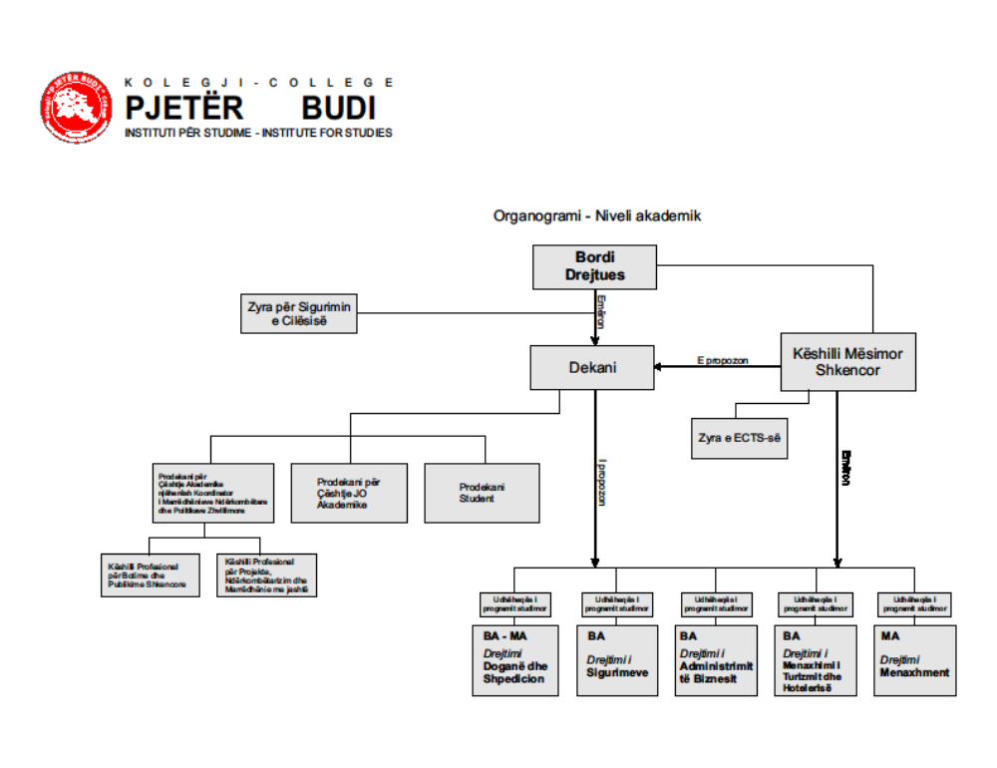

- Statute
Managing Board of College “Pjetër Budi” is appointed by the founder in accordance with the legal regulations. The Managing Board of the College is the main managing body of the College. The Managing Board consists of seven members with equal voting right, if the voting result is even, than the chairman’s vote is decisive.
The mandate of the Managing Board members is two years, with reelection right. The Managing Board is chaired and represented by the Chairman of the Board. The Chairman of the Board has full rights and is intact in decision making in terms of organizational and financial strategy of the institution in general. The Chairman is entitled to make the administrative decisions, whereas, for the academic and commercial process consults the Managing Board and Scientific Teaching Council.

The members of the Managing Board will be selected by the various College representatives, representatives from other institutions- organizations which deal with the studies in general. All decisions and other official documentation must be verified and signed by the Chairman of the Board, are presented as valid acts and official documents.

The Managing Board reports to the Founder and is responsible for the proper and effective utilization of funds that College allocates from the various sources. The Chairman of the Managing Board may transfer its rights and competencies to the other person by authorization or by special decision and on temporary basis.

The College Secretary has the following duties and responsibilities:
- is the chief administrative manager;
- is chief of central administration;
- is chief of administrative office;
- Is responsible for other issues required by the Managing Board and the Dean, which are not defined by this Statute.
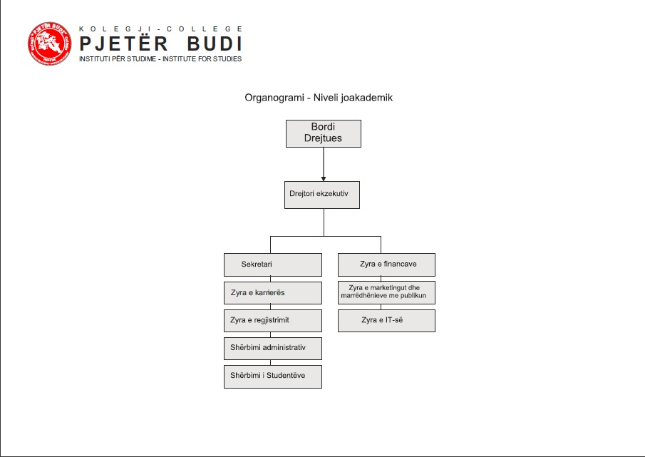

- Organizing of the decision making structures on academic issues

In the same manner the decision making structure on academic issues of the College for Studies “Pjetër Budi” is defined by the Statute of the College.

Scientific Learning Council is the main and decision making body on academic issues of the College which is managed by the Dean of the College.

The Dean of the College, along with the Vice-Dean for academic issues and development policies and the Vice-Dean for the Student’s issues as well as the four heads of the study programs (Customs and Freight Forward, Tourism and Hospitality Management, Insurance and Human Resources); lead the College in scientific-learning aspect.
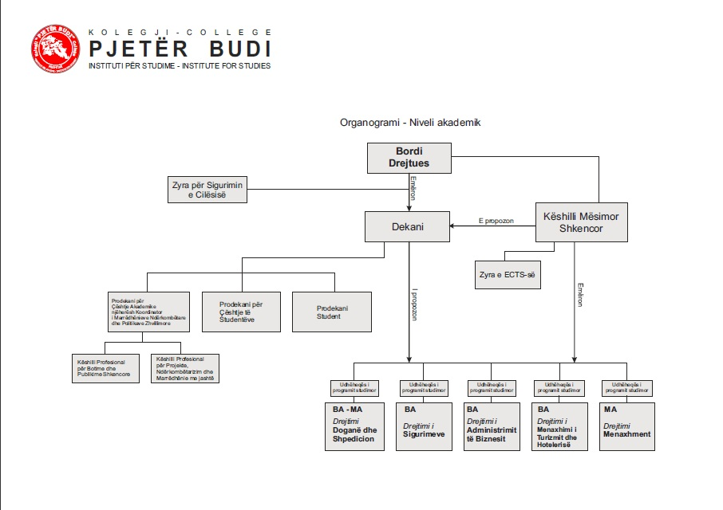

- Procedures for the personnel selection
According to the Statute for Governance of the College “Pjetër Budi” and the internal regulations of the College, the employees of the College are categorized into two groups: academic staff and non-academic staff (administrative staff).
The procedure of academic staff selection is conducted in accordance with the Regulation for Rules and employment procedure of the staff in the College “Pjetër Budi” (see Annex: Regulation for Rules and employment procedure of the staff in the College for Studies “Pjetër Budi”).

Employment of the academic staff in the College “Pjetër Budi” is conducted through the vacancy announcement, which is open for 15 days after the date of publication, and for emergency cases the deadline for application could be shorter. In the Vacancy Announcement are defined the requirements for the position. For academic staff, the Dean of the College for Studies, in cooperation with responsible persons of the study programs, establish a Board for the new staff, according to the needs for the scientific-learning process. The Board for the new staff makes the selection of the candidates who applied, based on the qualifications and relevant experience in the specific academic domain and presents to the Dean of the College “Pjetër Budi” for approval. After approval of the short-listed, by Dean’s proposal, the Scientific- Learning Council takes decision to nominate a staff for the respective subjects. After approval of the Decision for nomination, the academic staff signs the Employment Contract, which is drafted in compliance with the applicable law in Republic of Kosovo (Regulation 2001/27 for the Basic Law on Labor in Kosovo). By signing of the Contract, the academic staff is entitled to all rights and obligations according to the Law, Statute of the Institution for Studies “Pjetër Budi” and the Code of Conduct.

- Procedures for selection and nomination of professors (titles)
According to the decision from the Ministry of Education, Science and Technology, the private institutions are not entitled to give scientific titles, but, may remain in power the titles gaining earlier in the private institutions of the high education and in the Institution for Studies “Pjetër Budi”, prior approval of Ministry’s decision.

- Quality Management
- General Overview
Within the general processes in the changes of College “Pjetër Budi” in the past the special attention was paid to the appraisal activities, improving and assuring the quality in the high education, as a part of European program for the institutional appraisal.

The matter of the quality in the high education is closed connected to the creation of the common European area of high education, which is in function to provide the continuous mobility of the students and the staff in the European academic market with the recommendations appear from the Bologna Declaration.

The common European area of high education needs to build academic values, in order to anticipate demonstrating quality. Anyhow, the quality should be taken into consideration during the Institution’s goal and mission and the curricula. It requires a balance between tradition and innovation, academic excellence and social-economic relevance, as well as the curricula coherence and the freedom of selection of the student.

It includes teaching and the scientific research as well as the governing and administration, responsibilities towards the student’s needs and the cooperation with the non-educational services. The inherent quality is not a request but a necessity, which should be demonstrated and ensured in order that students, partners and the society of the country, Europe and the world, have to be familiar with and to be cultivated. The quality is the elementary condition for the building the confidence, relevance, mobility, compatibility and attraction in the European zone of high education.

The assurance of the quality is conducting in the institutional, national and European level. At this point, is affirming the need for development of the mutual criteria and methodology for quality assurance. Respecting the principle of institutional autonomy, the main bearer of the

Primary responsibility for quality assurance in the high education is every institution, which establishes the base for the real competences of the academic system within the quality national framework.

Systems for quality assurance should be and are transparent and in accordance with the systems of other European countries, due to the familiarity and appraisal of the learning processes and scientific-research, that leads up to the recognition of the diplomas and certificates as well as the increasing of employment rate in the European market.

Monitoring the self-appraisal and preparation of the Self-appraisal report, in 2007 and 2008 Kosovo Accreditation Agency has included “Pjeter Budi” in the external appraisal program that was part of the accreditation process.

During implementation of the Action plan for the development strategy of the high education “Pjetër Budi” for the period 2008-2012 and having into consideration the commitment to the continuous verification, the appraisal and quality assurance in the all domains of its activities, “Pjetër Budi” with its seat in Prishtina has started the process of self-appraisal, which includes period 2005-2009. This is from the very importance and has some main goals:

- identification of the changes since the foundation of the institution “Pjetër Budi” – in 2005;
- scan of the existing situations and problems and necessity for changes;

Board (Commission) for the quality assurance in College’s level

The Board for the quality assurance is the competent body for the continuous and systematic follow up as well as the collection of information on the quality, through the periodic research in all fields that require quality.

By process of the assurance and self-appraisal of the quality, we understand implementation of the regular and special appraisal, or ad hoc, organized in the particular periods. The Board for the quality assurance prepares the plans for implementation of all appraisal aspects, including research, commitment of the subjects and working plan as well as reports to the Scientific Learning Council for the outcomes of the self-appraisal, with the concrete proposals to take preventive measures, if necessary.

The self-appraisal process is made based on the analysis of the important documents and information, comparison of the acting plan and collection of the attitudes and information of the subjects in the quality assurance system and the quality through the questionnaire.

The Board for quality assurance prepares report on the appraisal results and proceeds to the Scientific Learning Council, which evaluates the work quality in the certain sector of the College by proposing of the measures for the removal of the obstacles for the enhancement of the quality of work. Regular appraisal is at least once a year during the academic year and includes the main fields:

- Study programs;
- Learning Process;
- Educational and scientific- research work;
- Human resources (academic and non-academic staff);
- Students;
- Textbooks, literature, library and informatics cabinet rooms
- Management and organization and non-educational support;
- Environment (educational space) and equipment;
- Financing;
- Inclusion of the students into the process of work quality assurance and enhancement.

The Board for quality appraisal can organize the particular assessment, by proposal of the Scientific Learning Council, in order to assess the quality in the particular fields of the quality assurance, which is estimated of a special importance for quality assurance of the work in general.

The function of the Board for quality assurance in the course level

In order to assure the quality, organization and preparation techniques of the learning process include definition before the commencement of the semester (lectures and exercises) work plan for each subject that is included in that semester as well as the organization plan for exams. Such plans will be given to the students to see it, latest the first day of the semester, except the organization plan for exams, which can be prepared latest 8 days before the exam period.

The plan for the learning process as well as the plan for the organizing of exams for each course is prepared by the Dean, having in consideration the student’s opportunities and requirements, subject’s load, efficient utilization of the institution’s space and other factors. The Student’s Service has to update the plan for the learning process and the lecture’s and exam’s schedule as well as the Institution’s web page.

Composition, mandate and the selection mode of the Board for quality assurance

Based on the Administrative Instruction no 2/2009 of Republic of Kosovo, Article 10, Section 1.8 the Institution of the high education should have an internal system of quality assurance. The Board for the quality assurance is composed of 5 members and the structure of the Board members has to express these features: introducing of every main structure of the institution (academic staff, students and administration) in order to provide the maximal participation of all interested subject in the self-appraisal process, to represent the broad views of the Institution and the board members to be able to assess weak and good side of the College.

Board Members are elected with the secret ballot in the meeting of the Scientific Learning Council, from among the Office of Quality Assurance, lecturers and students, for the four years period. After the election of the board members follows the constitution of the Board, one from them will be elected as a president and another one as a vice-president.

Board President for self-appraisal:
-Plans, organize and coordinate the performance of the Board;

-Takes care to make possible the broad discussion for self-appraisal, in order to establish an acceptable for self-appraisal;
-Realize the official announcement with the bodies of the College as well as with the body for appraisal in Republic of Kosovo, and;
-Accomplish other tasks regarding conduct of self-appraisal.
-It’s practice that in Board to be included at least two students’ representatives and two external experts.

Board members for the appraisal are entitled and obliged to participate actively in the Board activities, as much as possible to make contacts and to present the opinions to the members of academic community, as well as to be able to assess the weak and good sides of the College’s performance.

Board for the College’s appraisal can establish its own working groups with representatives of students to which can confide some particular tasks and issues, like: assessment of specific learning programs, control over the resources and finance, training of the academic staff and cooperators and their enhancement, external cooperation, international activities and similar.

Board for appraisal is obliged to participate in the organized trainings from the Board for appraisal of the College, as well to organize the training for the self-estimation for other participants in the self-appraisal process.

Activities of the Office for Quality Assurance

Based on the Article 92 of the Statute of College “Pjetër Budi” and the Regulations for the procedures of quality assurance, at the beginning of 2007 is established Office for Quality Assurance. This office is competent to monitor and asses the scientific work of the institution, teaching quality assurance, defining of the quality assurance procedures and quality assessment of the lecturer’s work.

The mission of the office is the achievement of the perfection, equality, transparence and efficiency. “Pjetër Budi” strives for the higher quality in any course and department, asserting that the quality is individual and collective responsibility. Since the quality is in the center of any process that institution is undertaking, we as office are developing quality culture, working together for quality assurance and management.

Quality assurance concentrates into the academic, teaching and learning issues, and is closed connected with the services, which directly support students. “Pjeter Budi” and Regulation for the quality assurance procedures, according to this Institution, in order to maintain the quality and achievement of the objectives of educational activity and scientific research, office for quality assurance, develops its own system of quality assurance. The assessment of the lecturer’s performance, is made through the own internal system of quality assurance. Lecturer’s performance appraisal, is made through the own self-appraisal and from the students, as well as from the former students through the anonymous appraisal questionnaires. College “Pjeter Budi” uses and implements during the quality appraisal the mechanism for realization of the measures for quality assurance means the procedures of quality assurance.

The subject of the quality assurance and appraisal in College “Pjeter Budi” is all academic and non-academic staff of the College means professors, experts-lecturers, demonstrators, professional cooperators, students, administrative services etc. Mechanisms for implementation of the measures for quality assurance are appraisals through the anonymous questionnaires, compiled in accordance to the international standards of appraisal. Appraisals for quality assurance have effects into:

-Motivation and public assessment in case of positive outcome;
-Application of the appropriate measures in order to improve the performance in case of negative outcome.
-Self-appraisal, as a first step in the quality assurance process, has some main objectives:
Presents a brief and essential overview of the learning process of the institution and the study programs;
-analyses the link of the learning-educational process and scientific-research activity of the institution;
-analyses the structure, quality and the progress of the academic staff;
-Analyzes the good and bad sides of the high education institution, which performs the high --+education activities, by application of SWOT analysis;
-provides the ground which will be used for the performance appraisal that College is conducting.
-provides the ground which will be used for the performance of external appraisal;
-Self-appraisal mission is the College’s determination of what staff will educate, for what needs and the field of the society, for the high educated personnel market in the country and abroad, as well as defines the directions of the scientific and research activity.
Whereas the subject of quality assurance of the College “Pjetër Budi”, that are the subjects of the quality assurance, according to the Bologna Declaration are as follows:

● Academic staff;
● Non-academic staff;
● Curricula;
● Library;
● Institutional organization and institution management, respectively the decision making processes.

- Compatibility of the College’s legislation with European standards

Based on the Regulation on quality assurance procedures, assessments are performed to achieve the objectives, adapt the performance and economization of the undertaken measures.

Appraisals are performed on these directions:

Appraisal of management measures in all organizational levels;
Appraisal of the study programs and study organization;
Appraisal of the teaching quality;
● Performance appraisal of the teachers by students;
● Appraisal of colloquium results;
● Appraisal of exam results;
● Commitments, presentations and activities;

● Practical work;
● Presentation of the final marks;
● Outline of the students with general results.
Appraisal of the research, and scientific activities (seminars);
Appraisal of the student’s attendance;

Presentation of the appraisal instruments- the questionnaires

In the College “Pjetër Budi” is performing mostly the quantitative appraisal researches. But, in order to prepare in the most professional mode of the questionnaires are organizing focus groups (qualitative research method), where the results of these discussion from the focus groups are used as instruction for questionnaire compilation and for sure we refer to the various documents, materials and literature about the subject of research. Hence, we follow the pattern that is used by the modern researchers for the development of the quantitative researches:

Pult research (Browsing through the documents, materials)

Focus groups Questionnaire

Collection of the information in the quantitative researches mostly is performed by the structured interviews- questionnaires. Mainly, the interview has to deal with self administration from the respondent, is understandable, because of the research’s character (students, academic staff), but we also make the interview by the phone.

In the quantitative researches, depend from the researcher’s subject and the target group that we aim to interview, usually is selected the simple occasional samplings because is considered from the researchers as the highly accurate beside other samplings. Target groups differ by the size and type of group (students, academic staff- teachers, etc.)

Compiled questionnaires by the Board for quality assurance of the College “Pjetër Budi” mostly are closed questions, semi-opened questions, Liker scale, tables etc. Therefore, always is trying that questionnaire to be compiled based on the approved international standards for questionnaire compilation. In addition, the researches that are conducted in our institution are built having in consideration five international ethic principles, to which researcher should comply.

- Follow up, improvement and utilization of the appraisal report outcomes

After conducting of the self-appraisal in the College, the Board for self-appraisal prepares the report on self-appraisal opened to the public including all deficiencies. During preparation of the report, Board for self-appraisal has in consideration that in the report should take into consideration all facts for the program studies and subject’s programs.

Initial point of the analyze are the mission and the objectives of the College, the place where are confirmed and assessed.

The analyses enlighten the weak and good sides of each component that is subject of self-appraisal. Analyses are followed with the proposals and correction plan of the activities for elimination of the deficiencies and quality improvement.

Conclusions and recommendations that result from the general institutional appraisal serve as the identification of our deficiencies and weakness and are taken into the consideration for creation of development policies to overpass these obstacles towards general improvement of our further work in all aspects of the College.

One of the reports done by the Quality Assurance office is the report for Pass-Rate, GPA (Grade Percentage Average) and students’ Attendance. Below is presented this report for academic year 2011-2012

In institutional level, during the academic year 2011-2012 for the exam period in January and June Pass-Rate was 78%, GPA 7.7 out of 10 and students’ attendance 7.3 out of 10. The following report will present the detail results for each study program.
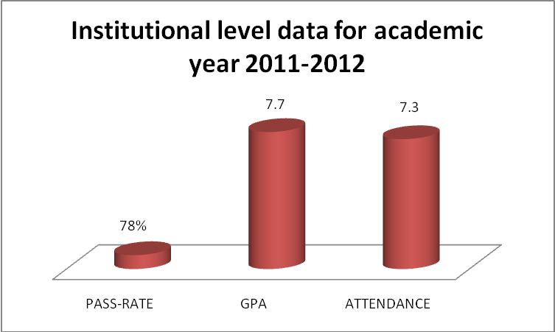

In the study program Customs and Freight Forwarding during academic year 2011-2012 in Bachelor level, the general data for three study years are: Pass-Rate: 74%, GPA 7.7 out of 10 and students’ attendance 6.6 out of 10.
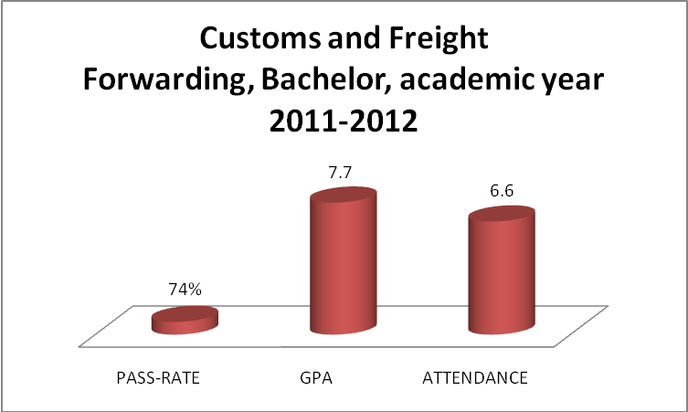

In the study program Customs and Freight Forwarding, during academic year 2011-2012, Master level are shown these results: Pass-Rate: 84% and GPA: 8.2 out of 10.
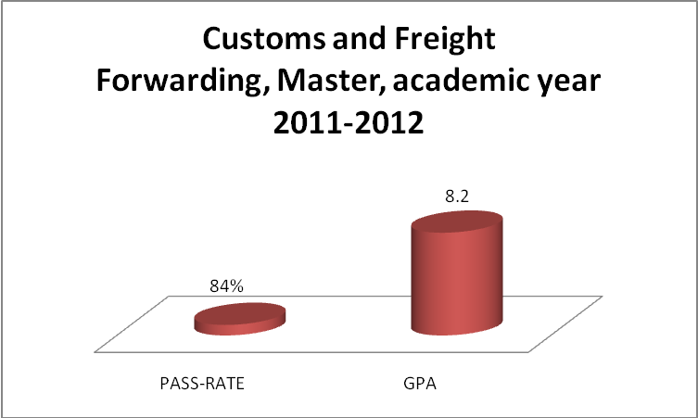

In the study program Tourism and Hospitality Management, during the academic year 2011-2012 in Bachelor level, the general data for three study years are: Pass-Rate: 76%, GPA: 7.2 out of 10 and students’ attendance: 7.3 out of 10.
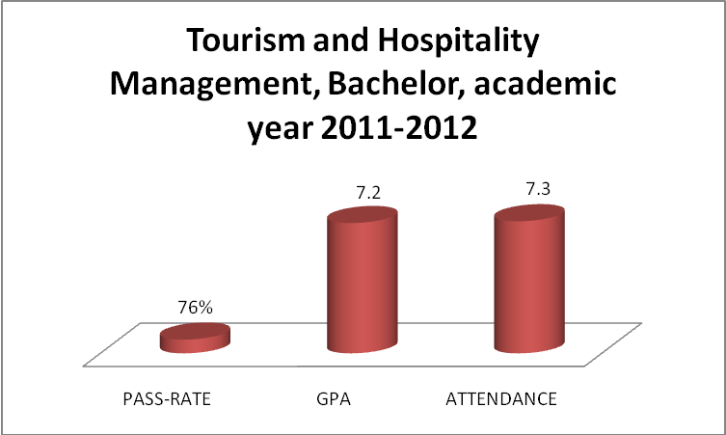

In the study program Business Administration, during the academic year 2011-2012 in Bachelor level, the general data for three study years are: Pass-Rate: 80%, GPA: 7.7 out of 10 and students’ attendance: 8.7 out of 10.
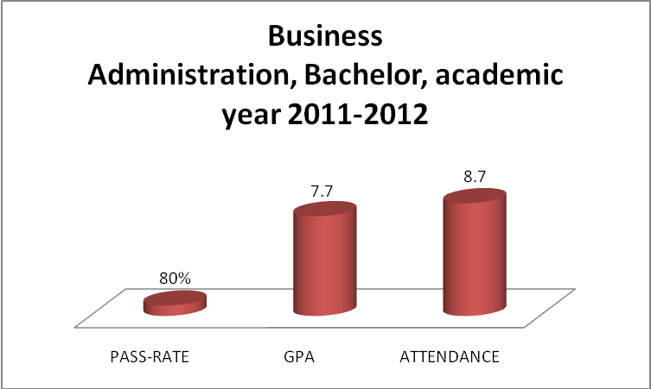

In the study program Insurance, during the academic year 2011-2012 in Bachelor level, the general data for three study years are: Pass-Rate: 76%, GPA: 7.7 out of 10 and students’ attendance: 6.5 out of 10.
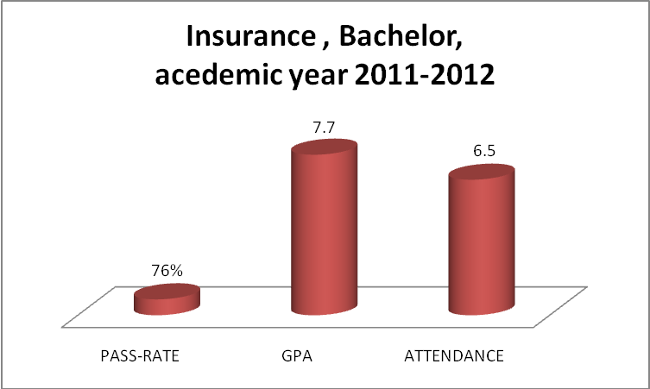

- Financing

- Budget and Finance Plan
The main financing of the activities of College “Pjetër Budi”, according to the statute and annual programs for realization of the activity program of high education, is through the self-finance. Study courses are financed by student’s payments, whereas a part of students are financed by the institutions where are employed, in accordance to the cooperation agreements 5+5 years with the College “Pjetër Budi”.
Students have opportunity to pay study fee in 12 installments. “Pjeter Budi” has provided other mitigating circumstances for its students, through the agreements with the banks, where students can get loan with convenient conditions for study fee payment.

- Budget and Finance Plan, financial sustainability and finance resources
For the ended fiscal year as of 31.12.2011 "Pjeter Budi“achieved the profit of 208.732.46Euro
Wages were 35.11% out of occurred expenses. Based on Income Statement (P&L) for the year 2011 it’s obvious that there are positive results even though the number of students was limited and during the past academic year it wasn’t registered students.
The college achieved to be financially sustainable and positively concluded ended fiscal year.

For the year 2012 and 2013 the college is planning to increase revenues and to add directions for the bachelor and master studies.For the year 2012 it is planning to achieve the net profit in the amount of 228.300.00Euro, while for the year 2013 it is planning to be a net profit in the amount of 239.770.00 Euro.

INCOME STATEMENT
 | 2011 | % | 2012 | 2013
Revenues | 573,849.27 |  | 640,000.00 | 704,000.00
Gross Profit | 573,849.27 |  | 640,000.00 | 704,000.00
 |  |  | - | -
Salaries & Wages | 201,471.95 | 35.11 | 230,000.00 | 270,000.00
Pension Contribution | 10,144.42 | 1.77 | 14,000.00 | 16,000.00
Rents | 13,800.00 | 2.40 | 13,800.00 | 9,000.00
Office Expenses | 12,783.70 | 2.23 | 25,000.00 | 27,500.00
Communications Costs | 8,645.50 | 1.51 | 10,000.00 | 11,000.00
Representation - Marketing | 18,524.20 | 3.23 | 20,000.00 | 22,000.00
Electricity Costs | 7,596.36 | 1.32 | 9,000.00 | 9,900.00
Insurance Costs | 8,845.60 | 1.54 | 5,000.00 | 5,500.00
Fuel Consumptions | 3,825.47 | 0.67 | 5,500.00 | 6,050.00
Repairs & Maintenance | 14,624.21 | 2.55 | 15,000.00 | 16,500.00
Library Costs | 8,896.32 | 1.55 | 3,000.00 | 3,300.00
Conferences/meetings costs | 5,840.63 | 1.02 | 6,000.00 | 6,600.00
Other expenses | 6,520.00 | 1.14 | 12,000.00 | 13,200.00
Interest | 1,033.26 | 0.18 | - | -
Depreciation | 33,114.42 | 5.77 | 33,000.00 | 36,300.00
Total Expenses: | 355,666.04 | 61.98 | 401,300.00 | 452,850.00
 |  |  | - | -
Profit before taxes | 218,183.23 | 38.02 | 238,700.00 | 251,150.00
Taxes on Profit | 9,450.77 | 1.65 | 10,400.00 | 11,380.00
Net Profit | 208,732.46 | 36.37 | 228,300.00 | 239,770.00
BALANCE SHEET
 | 2011 | 2012 | 2013
Current Assets
Cash and Bank accounts | 117,092.67 | 112,500.00 | 123,750.00
Account Receivable | 218,248.32 | 260,000.00 | 286,000.00
Total Current Assets: | 335,340.99 | 372,500.00 | 409,750.00
 |  | - | -
Non Current Assets: |  | - | -
Machinery / Equipment / Inventory | 86,541.12 | 125,000.00 | 137,500.00
Depreciation | (17,308.22) | (20,000.00) | (22,000.00)
Buildings | 377,455.10 | 380,000.00 | 418,000.00
Depreciation | (71,037.48) | (80,000.00) | (88,000.00)
Ground |  | 400,000.00 | 400,000.00
Total Non Current Assets: | 375,650.52 | 805,000.00 | 885,500.00
 |  | - | -
Total Assets: | 710,991.51 | 1,177,500.00 | 1,295,250.00
 |  | - | -
Liabilities: |  | - | -
Short term liabilities: |  | - | -
Other liabilities | 24,439.14 | 36,000.00 | 39,600.00
Total short term liabilities: | 24,439.14 | 26,883.05 | 29,571.36
 |  | - | -
Long term liabilities |  | - | -
Long tem loans | 10,437.84 | 400,000.00 | 340,000.00
Total long term liabilities: | 10,437.84 | 400,000.00 | 340,000.00
 |  | - | -
Total liabilities: | 34,876.98 | 426,883.05 | 369,571.36
 |  | - | -
 |  | - | -
Equity |  | - | -
Owner Capital | 346,047.21 | 346,000.00 | 346,000.00
Retained earnings | 121,334.86 | 176,316.95 | 339,908.64
Annual Profit | 208,732.46 | 228,300.00 | 239,770.00
Total Equity: | 676,114.53 | 750,616.95 | 925,678.64
 |  | - | -
Total Liabilities & Equity | 710,991.51 | 1,177,500.00 | 1,295,250.00

- Space and Equipment

- General overview of the working space
The total area of the building of College “Pjetër Budi” is 1.460 m of the building where will be held the teaching process and 740 m² of parking space. Approximate space is 4.8 square meters per student.

Within the area where is conducted the teaching, “Pjeter Budi” posses an amphitheatre with 97 m² and 6 teaching classrooms, two of them are a laboratory type and an informatics hall. The halls are equipped with necessary equipment for the learning process, as: video beam, computers that have internet access etc.

In addition, “Pjetër Budi” possesses a certain number of the cabinet rooms dedicated to the lecturers (see below) as well as the adequate halls for the administrative services and the hall of the Student’s Union. Within the College “Pjeter Budi” is the Dormitory with recreation space, situated in Fushe Kosova, with area of 3.400 m².

- Lecturing hall and cabinet rooms for the lecturers
Regarding halls dedicated for the academic staff, College “Pjetër Budi” has in its disposal engaged learning hall, that is situated into the first floor of the building, and 13 cabinet rooms where are special cabinets for the pedagogues, than 4 cabinets for the leaders of the study courses, means for each academic program is one separated cabinet room. Among other things, exist rooms dedicated for the Deanery, Quality Assurance Office as well as the cabinet rooms for development policies, Office for publishing and similar.

- Library
The library of the College “Pjetër Budi” in Prishtina, operates in the special area within the College, where are placed the books- literature for all courses with learning program of this College.

The library posses about 10.000 titles of various books from all fields, but dominant are the professional books of the courses of this College.

The library of the College “Pjetër Budi” has agreement with the Kosovo National and University Library- Consortium of Kosovo Electronic Libraries (agreement no.45/1734, on 07.05.2009), through which the College “Pjetër Budi” is membership of KBEK, which gives opportunity to use the electronically resources, provided by KBEK through e-IFL.

In addition, students of the College “Pjetër Budi” can use all science books and magazines through EBSCO and JSTORE Library.

EBSCO electronic Library is one of the most distinguished international libraries, which possess thousand of projects and scientific magazines as well as the professional literature from all the fields.
The College has prepared a ‘Request Letter’ for book donation. A potential donator is contacted. There is one organization in Manchester ‘Manchester Aid to Kosovo’ which promised us a great help on donating latest edition of books and of course in English language. In addition, a person from Kosovo that lives in Austin, Texas is contacted for another book donation. The request is sent, now the College is waiting for second faze.

- Computer rooms

In the College “Pjetër Budi” are two information technology premises (which in the same time are utilized as the laboratories):

a) First information and technology premise is located on the first floor, and there are placed 40 computers.

b) TIMS Laboratory is a second technology information premise and it has 13 computers.

Among other in the building where is holding the lectures exist Student’s Corner which is equipped with three computers, meantime on the ground floor is the corner where can be used the electronic Library- corner which contains 5 computers.

Otherwise, the entire space of “Pjeter Budi” is equipped with almost 100 computers. All computers have internet access.

- Staff

- Description- the situation with academic and non-academic staff
According to the Statute for the governing of College for Studies “Pjetër Budi” and internal regulations of College, the personnel of College is categorized in two groups: academic staff and non-academic staff (administrative personnel).

Academic staff in the College for Studies “Pjetër Budi” is composed by the engaged personnel into: academic teaching and professional scientific researches. In academic staff are included:

The Dean, as a highest academic body of the College for Studies “Pjetër Budi”, vice-deans, study program leaders and teachers: professors, lecturers and assistants.

In non-academic staff of the College are engaged the persons in: maintaining and professional duties, administration and technical work.

- Academic staff according to the statute are:
- full-time contracted and
- Part-timecontracted.

From the total number of 47, 30 are full-time contracted staff and 17 part-time.
The list of the total number of academic staff is presented below according to their scientific level, academic title and their statute.

Nr. |  | Name and last name | Scientific level/ specialization | Academic title | Full time/ part time
1 |  | Nuhi Rexhepi | PhD in Albanology | Ordinary Professor | Full time
2 |  | Ibish Mazreku | PhD in Economics | AssistantProfessor | Full time
3 |  | Blerim Halili | PhD in Economics | Assistant Professor | Full time
4 |  | Muhamet Bicaj | PhD in Chemistry | Ordinary Professor | Full time
5 |  | Zija Zimeri | PhD in Tourism and Hospitality | Assistant Professor | Full time
6 |  | Sherif Gashi | PhD Candidate in Insurance | Lecturer | Full time
7 |  | Nehat Maxhuni | PhD in Economics | Assistant Professor | Full time
8 |  | Sulltane Ukaj | PhD in History | Ordinary Professor | Full time
9 |  | Nerimane Bajraktari | PhD in Economics | Lecturer | Full time
10 |  | Sejdullah Mahmuti | PhD in Psychology | Lecturer | Full time
11 |  | Bektesh Bekteshi | PhD in Economics | Ordinary Professor | Full time
12 |  | Sofronija Miladinoski | PhD in Economics | Ordinary Professor | Part time
13 |  | Jovan Stojanovski | PhD in Economics | Assistant Professor | Part time
14 |  | Sreten Miladinoski | PhD in Economics | Assistant Professor | Part time
15 |  | Snezhana Miranovska | PhD in Economics | Assistant Professor | Part time
16 |  | Ivica Smilkovski | PhD in Economics | Assistant Professor | Part time
17 |  | Cane Çapragoski | PhD in Law | Assistant Professor | Part time
18 |  | Naume Marinovski | PhD in Tourism and Hospitality | Ordinary Professor | Part time
19 |  | Gabriela Rakiqeviq | PhD in Tourism and Hospitality | Assistant Professor | Part time
20 |  | Irina Majovska | Master in Economics | Lecturer | Part time
21 |  | Cvetko Andreeski | PhD in Insurance | Assistant Professor | Part time
22 |  | Alifeta Selimi | PhD in Economics | Assistant Professor | Part time
23 |  | Qashif Bakiu | PhD in Law | Lecturer | Part time
24 |  | Selver Hoda | PhD in Chemistry | Assistant Professor | Part time
25 |  | Ulpiana Lama | PhD in philosophy | Lecturer | Full time
26 |  | Naser Gjinovci | Master in Human Resources | Lecturer | Full time
27 |  | Imer Mushkolaj | Master in Human Resources | Lecturer | Full time
28 |  | Orhan Çeku | PhD Candidate in Law | Lecturer | Full time
29 |  | Emira Limani | Master in Communication Sciences | Lecturer | Full time
30 |  | Hashim Rexhepi | PhD Candidate in Insurance | Lecturer | Full time
31 |  | Fekri Iseni | Master in Economics | Lecturer | Part time
32 |  | Aheron Bobaj | Master in Sociology and Criminology | Lecturer | Full time
33 |  | Lulzim Shabani | PhD Candidate in Computer Sciences | Lecturer | Full time
34 |  | Florim Maqani | Master in Criminology | Lecturer | Full time
35 |  | Evliana Berani | Master in EU Law | Lecturer | Full time
36 |  | Vahidin Qerimi | Master in Customs and Freight Forwarding | Lecturer | Full time
37 |  | Ilir Bytyqi | PhD Candidate in Economics | Lecturer | Full time
38 |  | Hysen Sogojeva | Master Tourism and Hospitality | Lecturer | Full time
39 |  | Idriz Ismajli | Master in Customs and Freight Forwarding | Lecturer | Full time
40 |  | Berat Çupi | Master in Customs and Freight Forwarding | Lecturer | Full time
41 | Naim Huruglica |  | Master in Management | Lecturer | Part time
42 |  | Gresa Shabani | Master Math | Lecturer | Full time
43 |  | Adem Hasani | Master Candidate in Customs and Freight Forwarding | Assistant | Part time
44 |  | Zyhdi Axhemi | Lawyer | Assistant | Part time
45 |  | Shyqri Thaqi | English Language Professor | Lector | Full time
46 |  | Albana Beqiri | Albanian Language Professor | Assistant | Full time
47 |  | Hale Maksutaj | BA in English Language | Assistant | Full time

- Administrative staff
College for Studies “Pjetër Budi” has dived deep into the reforms of high education activity addressed towards integration into the European knowledge fields.

Their succesful implementation greatly is conditioned by the volume and structure notes of administrative staff, obliged for the administrative professional tasks. In this sense, is important to identify the changes in the administrative staff in the College “Pjetër Budi”.

In academic year 2012/13 the number recruited in the professional administrative services in College “Pjetër Budi” marks a rapid increasing trend what presents the logic result of the development and size of the academic institution.

Having into consideration the development dynamics of the College, expressed through the increasing number of students and our College’s objective to increase the number of program studies, is needed continuously to held accountable about the adequate number of administrative staff, which will be assigned to the growing needs.

In addition, the full implementation of ETCS increases the need for bigger administration of student activities, the thing that will have impact in increasing need to recruit additional professional administrative staff.

Nr. | Name and surname | Position | Qualification | Current studies
1 | Nuhi Rexhepi | Dean of the College | Prof. Dr.
2 | Evliana Berani | Vice-dean for academic and development issues  Coordinator of Development Policies | Mr.
3 | Imer Mushkolaj | Vice-Dean for non-academic issues  Offices for external affairs | Mr.
4 | Ludvik Kerquku | Vice-Dean for student affairs | Student
5 | Zija Zimeri | Leader of study program Tourism and Hospitality Management | Prof.Dr.
6 | Hysen Sogojeva | Co- Leader of study program Tourism and Hospitality Management | Dr.
7 | Orhan Çeku | Leader of the study program Customs and Freight Forwarding | Mr.
8 | Jovan Stojanovski | Co- Leader of the study program Customs and Freight Forwarding | Prof. Dr.
9 | Blerim Halili | Leader of the study program Business Administration | Prof. Dr.
10 | Florim Maqani | Co- Leader of the study program Business Administration | MA
11 | Hashim Rexhepi | Leader of the study program Insurance | Dr.
12 | Sreten Miladinoski | Co- Leader of the study program Insurance | Prof. Dr.
13 | Sofronija Miladinovski | Leader of the study program Master in Management | Prof. Dr.
14 | Ibish Mazreku | Co- Leader of the study program Master in Management | Prof. Dr.
15 | Naser Gjinovci | ECTS coordinator | Prof. Dr.
16 | Fatmir Halili | Secretary | MS
17 | Fitim Maqani | Manager | Marketing Management
18 | Agron Mustafa | Finance Director | Economics
19 | Fiqrete Haliti | Finance Offices | BA
20 | Vlora Limani | Chief of Administrative Services | MSc
21 | Saranda Halimi | Administrative Offices | BA
22 | Klime Poposki | Quality Assurance Coordinator | Prof. Dr.
23 | Emira Limani | Qualitz Assurance Officer | MA in comm studies
24 | Premtim Gashi | IT officer | Secondary S | BA student
25 | Burim Ajeti | Dormitory manager | BA
26 | Mexhait Ristemi | Translator | Mr.
27 | Melakzate Hoxha | Translator | BA
28 | Valon Selmoni | Translator | BA
29 | Adnan Hagjolli | translator | Student
30 | Sami Aliu | Driver | Secondary S
31 | Vllade Nedevski | Driver | Secondary S
32 | Sevdije Kajtazi | Cleaner | Primary S

- Policies for staff development
Provide with and increasing of the quality of teachers in College “Pjetër Budi” is paying a special attention – whether in advancement in the academic field as well as in their scientific and professional development.
For advancement in the academic fields, “Pjetër Budi” has organized trainings in cooperation with the Quality Office and academic partners abroad, which mostly have had to deal with the acquaintenance of the modern trends regarding methodology of teaching, new strategies and techniques, in spirit of Bologna process.
In addition, teachers have participated into various seminars and conferences in the country and abroad, by “Pjeter Budi” assistance, whereas the cooperation with the other institutions abroad, especially with “St. Clement” in Ohrid, has made that they on regular basis exchange their academic, scientific and professional experiences with their colleagues there.

Also, to the teachers of the College “Pjetër Budi” is given opportunity that their scientific and research activity to publish into the scientific magazine of the College, to make presentations into the round tables, forums, discussions and conferences organized by College “Pjetër Budi” and in the other forms, like through the publication of the work in the scientific magazines.

- Academic Programs and Student Management

College “Pjetër Budi” – Prishtina, currently has these programs:

Accredited fro three years (from 1 October 2011 – 30 September 2014):
- Business Administration – Bachelor
- Insurance – Bachelor and
- Customs and Freight Forwarding – Masters.

“Pjetër Budi” is filling a request to the Kosovo Agency for Accreditation (KAA) to have its study programs undergo the process of reaccreditations of its academic programs, as follows:

For re-accreditation:
- Customs and Freight Forwarding – Bachelor
- Tourism and Hospitality Management – Bachelor
- Management – Masters

For accreditation:
  - Economy
  - Management and Informatics

7.1 Bachelorin Academic Program Customs and Freight Forwarding

- Person in charge:
Orhan Ceku, PhD
Prof. Dr. Sreten Miladinoski

- Goal and profile of the study program
Taking into account the need for profilization of the staff with superior education, high education and specialized staff, in accordance with the new changes that marked the Kosovo’s economy of in recent years, “Pjetër Budi” in 2005 opened the coruse on Customs and Freight Forwarding. This programhas been licensed by Kosovo Ministry of Education in 2005. The course on Customs and Freight Forwarding produces academics and professionals that are an asset for Kosovan society. Programme has been designed in such way that it serves to the Kosovo needs and Kosovo market. In accordance with the concept of contemporary education it has been designed to utilize direct linkage of theory and practice, to help students gain knowledge and skills for working in customs, freight forwarding, external trade, international transport enterprises, public institutions (customs service, economic sectors in respective ministries etc.), in different associations of entrepreneurs etc.

- The level and types of the study
In the College “Pjeter Budi” the part and full time studies are taking place. Regarding the levels of the studies, they are divided in bachelor and master degree studies (3 + 2 academic years).
BA – Bachelor (6 semesters)
MA- Master (4 semesters)
The Bachelor degree is based on the Bologna system. The duration of studies for this degree is three (3) years, respectively six (6) semesters. After finishing the exams and the Bachelor Thesis, the student gains 180 credits (ECTS) and receives a Bachelor degree diploma:

Bachelor (BA) Diploma in Customs and Freight Forwarding

Besides a regular Diploma, student receives a Supplement Diploma. It is an annex to the diploma which is given to the student upon his/her graduation, following the model developed by the European Commission, Council of Europe and UNESCO/CEPES and it is in compliance with the Administrative Instruction of MEST, Nr. 38/2008, and dated 04.11.2008.

- Duration and the volume
Master studies duration is four (4) semesters or two academic years, each semester is containing of 30 ECTS credits. The structure of the load of students with working hours can be seen in the Program where the engagements of students aresegregated by lectures, exercises,etc. The fourth semester of this level of academic studies is envisaged for the preparation of Master.

- Goals and results of the studies (competences and qualifications, knowledge and skills)
This study program is designed for the people who are interested to broaden their knowledge in the field of Customs and Freight Forwarding, such as:

• Learning of contemporary knowledge in the field of Customs and Forwarding according to internationally accepted standards for higher education.
• Learning of general knowledge in the field international circulation of goods and services that have a direct connection with customs clearance and international transportation system,
• Learning and knowledge in the field of legal regulation in the customs and freight.
• Learning multidisciplinary character knowledge in the application of knowledge in the field of Customs and Forwarding.
• Ability to manage processes in the Customs and freight, in all spheres of its activities.
• Training for Customs and Forwarding market access in line with the requirements of the labor market at home and abroad,
• Learning and knowledge in the process of entrepreneurship in customs consultancy and start (opening) of customs agencies, businesses,
• Preparation for the labor market in the country and abroad.

This study program shall optimally meet the needs of the society for an educated labor force in order to tackle the problems in all levels in the country and abroad. With this program, the needs for professionals in the fields of international cooperation and more will be fulfilled.
In Customs and Freight Forwarding, these skills dominate: 1) communication in writing, 2) ability to organize and plan, 3) knowledge of a foreign language, and 4) ability to work in an international context. The aforementioned issues in the field of insurances are the priorities which are required in international trade.

- Academic program Customs and Freight Forwarding
Bachelor (BA) Academic Program of the Customs and Freight Forwarding
First academic year
Semester 1
 |  |  | Subject | Number of classes |  |  |  |  |  |  |  |  | Credits |  |  | Load | Lecturer
 |  |  | Subject | L |  |  | E |  |  | T |  |  | ECTS |  |  | Load | Lecturer
1 |  |  | Economics | 45 |  |  | 15 |  |  | 60 |  |  | 6 |  |  | 180 | Blerim Halili
2 |  |  | Fundamentals of Management | 45 |  |  | 15 |  |  | 60 |  |  | 6 |  |  | 180 | Ibish Mazreku
3 |  |  | English language I | 45 |  |  | 15 |  |  | 60 |  |  | 6 |  |  | 180 | Shyqri Thaqi  Ass. Hale Maksutaj
4 |  |  | Fundamentals of Law | 45 |  |  | 15 |  |  | 60 |  |  | 6 |  |  | 180 | Orhan Çeku
5 |  |  | Optional Subject(1 of 2):  - Introduction to academic writing  - Information Technology | 30 |  |  | 30 |  |  | 60 |  |  | 6 |  |  | 180 | Imer Mushkolaj  Lulzim Shabani
 |  |  | Total | 210 |  |  | 90 |  |  | 300 |  |  | 30 |  |  | 900
 | Semester II
 | Subject |  |  |  | Number of classes |  |  |  |  |  |  | Credits |  | Load |  |  | Lecturer
 |  |  |  |  | L |  | E | T |  |  |  | ECTS |  |  |  |  | Lecturer
1 | Communication and Public Relations |  |  |  | 45 |  | 15 | 60 |  |  |  | 6 |  | 180 |  |  | Imer Mushkolaj
2 | Customs Law |  |  |  | 45 |  | 15 | 60 |  |  |  | 6 |  | 180 |  |  | Orhan Çeku
3 | Customs System |  |  |  | 45 |  | 15 | 60 |  |  |  | 6 |  | 180 |  |  | Bashkim Arifi
4 | English language II |  |  |  | 45 |  | 15 | 60 |  |  |  | 6 |  | 180 |  |  | Shyqri Thaqi  Ass. Hale Maksutaj
5 | Optional Subject(1 of 2):  - EU policies and law  - Statistics |  |  |  | 30 |  | 30 | 60 |  |  |  | 6 |  | 180 |  |  | Evliana Berani  Bektesh Bekteshi
 | Total |  |  |  | 210 |  | 90 | 300 |  |  |  | 30 |  | 900
Second academic year
Semester III
 |  | Subject |  | Number of classes |  |  |  |  |  |  | Credits |  |  |  | Load |  | Lecturer
 |  |  |  | L |  | E |  |  | T |  | ECTS |  |  |  |  |  | Lecturer
1 |  | Customs Recognition of Goods |  | 45 |  | 15 |  |  | 60 |  | 6 |  |  |  | 180 |  | Muhamet Bicaj
2 |  | Customs Information Systems |  | 45 |  | 15 |  |  | 60 |  | 6 |  |  |  | 180 |  | Vahidin Qerimi
3 |  | International Freight forwarding |  | 45 |  | 15 |  |  | 60 |  | 6 |  |  |  | 180 |  | Snezhana Mironovska
4 |  | English Language III |  | 45 |  | 15 |  |  | 60 |  | 6 |  |  |  | 180 |  | Shyqri Thaqi  Ass. Hale Maksutaj
5 |  | Optional Subject(1 of 3):  - Sociology  - Principles of Public Administration |  | 30 |  | 30 |  |  | 60 |  | 6 |  |  |  | 180 |  | Aheron Bobaj  Naser Gjinovci
 |  | Total |  | 210 |  | 90 |  |  | 300 |  | 30 |  |  |  | 900
 | Semester IV
 | Subject | Number of classes |  |  | Credits | Load | Lecturer
 | Subject | L | E | T | ECTS | Load | Lecturer
1 | International Transport | 45 | 15 | 60 | 6 | 180 | Jovan Stojanovski
2 | Development and Management of Human Resources | 45 | 15 | 60 | 6 | 180 | Hashim Rexhepi
3 | International Business | 45 | 15 | 60 | 6 | 180 | Sreten Miladinovski
4 | Crime Psychology | 45 | 15 | 60 | 6 | 180 | Sejdullah Mahmuti
5 | Optional Subject(1 of 2):  -Customs Practice (internship) I  - Freight forwarding Practice (internship) I | 30 | 30 | 60 | 6 | 180 | Sofronija Miladinovski  Sofronija Miladinovski
 | Total | 210 | 90 | 300 | 30 | 900
Third academic year
Semester V
 |  | Subject |  | Number of classes |  |  |  | Credits | Load | Lecturer
 |  |  |  | L | E | T |  | ECTS | Load | Lecturer
1 |  | Customs Administrative Procedure |  | 45 | 15 | 60 |  | 6 | 180 | Naser Gjinovci
2 |  | Academic Writing |  | 45 | 15 | 60 |  | 6 | 180 | Imer Mushkolaj
3 |  | Cultural Heritage |  | 45 | 15 | 60 |  | 6 | 180 | Sulltane Ukaj
4. |  | International Marketing |  | 45 | 15 | 60 |  | 6 | 180 | Sofronija Miladinoski
5 |  | Optional Subject(1 of 2):  -Customs Practice (internship) II  - Freight forwarding Practice (internship) II |  | 30 | 30 | 60 |  | 6 | 180 | Adem Hasani  Zyhdi Azemi
 |  | Total |  | 135 | 180 | 300 |  | 30 | 900
 | Semester 6
 | Subject |  | Number of classes |  |  |  |  | Credits | Load | Lecturer
 |  |  | L |  | E |  | T | ECTS | Load | Lecturer
1 | Fiscal system and policies |  | 45 |  | 15 |  | 60 | 6 | 180 | Ivica Smilkovski
2 | Insurance and International Trade |  | 45 |  | 15 |  | 60 | 6 | 180 | Blerim Halili
3 | Financial Management |  | 45 |  | 15 |  | 60 | 6 | 180 | Nehat Maxhuni
 | Bachelor Thesis |  |  |  |  |  | 120 | 12 | 360
 | Total |  | 135 |  | 45 |  | 300 | 30 | 900

YEAR I, semester I
CODE | DDSH 101
SUBJECT | Economic
DESCRIPTION | The main purpose of this subject is that students gain fundamental theoretical knowledge on the economy in order to follow the curricula dealing with economical issues. Economy as a science, market economy, micro-economy, production factors and revenue allocation, state and economy, macro-economy, fundamentals of the international economy
LITERATURE | Dr. Sc. Baki Koleci: Fundamentals of Economy, Pjetër Budi, 2007;  Risto Gogoski , Economy, FTU-Ohrid,2004

CODE | DDSH 102
SUBJECT | Fundamentals of Management
DESCRIPTION | The purpose of this subjectis that students acquirebasicknowledgeintheareaofmanagementof the economicentities. Management–as thenotion, essence andimportance; historicaldevelopmentand the management principles; Management,managers andcareermanagement; Leadership, managing; Managementand the environment; The environment and the small business management; ethicsmanagementandthe socialresponsibility;managerfunctions-planning, organizing, coordinating, motivating, controlling, setting.
LITERATURE | V.Mojsoski, Fundamentals of Management, FTU-Ohrid , 2001  L.Simonceska, Management processes, FTU-Ohrid, 2002  B.Ramosaj, Fundamentals of Management, University of Prishtina

CODE | DDSH 103
SUBJECT | Fundamentals of Law
DESCRIPTION | The purpose of this subject is that students acquire knowledge about the basicinstitutionsof law,governmentregulationsandcontractualrelations. Basicknowledgeof the stateandlawandorderlaw,individualactsandlegalrelations, thesubjectsof law,the principle of legality, justice systemandlegalsystemelements, as the processofimplementationoflegalnorms.
LITERATURE | N.Krleski, Fundamentals of Law, Studentski zbor-Skopje, 2001  Osman Ismaili, The Basics of Law, UP, Faculty of Law, Prishtina, 2004  Orhan Çeku, Fundamentals of Law, Pjetër Budi, Authorized Lectures, Prishtina 2012

CODE | DDSH 104
SUBJECT | English Language I
DESCRIPTION | Second level of English language. Advancing the level of knowledge and skills in English language, advanced grammar and vocabulary.
LITERATURE | American Headway 1: Workbook by Liz Soars and John Soars

CODE | DDSH 105
SUBJECT | Introduction to the academic writing
DESCRIPTION | The aim of thesubjectis that students obtainbasicknowledgeinthefieldofacademic writing. Thesubjectprovideslearning of thebasicfundamentalsof academic writing: writinganessayand drafting aseminarpaper, aresearchwork andother projects todrawthe reader's attentionby analyzingmaterialstoreach the responseand writing.
LITERATURE | I.Mushkolaj, Introduction to the academic writing, Authorized lectures, the College “Pjetër Budi”, Prishtina.  Musai, Bardhyl, How to write an essay. (2004). CDE, Tirana.  E. Boce, How to write a research project, Center for Democratic Education Tirana, 2004

CODE | DDSH 106
SUBJECT | Information Technology
DESCRIPTION | The purpose of this subjectis that students gain knowledge about thebasicbehavior about computingandusageofsmallapplications on accounting. The termforcomputing; computing resources;computersystemsarchitecture; computersystemssoftware; internet; the smallapplications on accounting; operatingsystemMSWindowsXPProfessional.
LITERATURE | N. Braha, Basics of computing, Pjetër Budi, Prishtina,  I.Nedelkovski, Computing for students; Skopje, 2002

Year I, semester II
CODE | DDSH 107
SUBJECT | Customs law
DESCRIPTION | The purpose of this course isthat studentsgain the knowledgeofcustomsrightwhichcouldbe used during performance of the customsprocedures. The termcustoms right; organization of the customsdirectorate; grounds on defining of the importingandexporting taxes; procedures when importing ofgoodsinthe customsarea; calculationanddefining ofcustoms; typesof customs; draftingcustomsregulations.
LITERATURE | Orhan Çeku, “ Customs right ”, Authorized lectures, Pjetër Budi, 2012  M. Krstanoski, Customs right , FTU-Ohrid, 2005

CODE | DDSH 108
SUBJECT | Customs system
DESCRIPTION | Customs System-term and types; Panels in the customssystem-customsareas, customslinescustomsgoods, customsborder zone, border crossing etc. Customssysteminstruments, customs-term, types, impacts, customsvalue, etc.; customs supervision,customs clearance, customsproceduresinspecificcases, etc.
LITERATURE | J.Biljanoska, Carinski sistem i carinsko rabotewe, CNIR, FTU-Ohrid, 2003,  Ylber Rraci, Basics of the customs system in Kosovo, Prishtina, 2011

CODE | DDSH 109
SUBJECT | English Language II
DESCRIPTION | The constructionof knowledge andskills, begginer level of English language. Learning vocabulary and grammar.
LITERATURE | American Headway 2: Workbook by Liz Soars and John Soars

CODE | DDSH 110
SUBJECT | Communication and the Public Relations
DESCRIPTION | The purpose of this subjectis that students gain knowledgeintheareaofobject, developmentand the businesscommunicationmethodsinthe processmanagement.Communicationand the workplace; communicationenvironmentin the firm; businessmeetings; correspondence; Quality andcustomerneeds; businessethics; successfulmanagerscommunicationskills; employees motivation skills;oralpresentationskills; negotiationskills; conflictsand overcoming;stress management.
LITERATURE | Batkoska, L. (2004), Business communication  Berisha, I. (2007): Media, communication agents, PEN Qendra e Kosovës, Prishtina.  Useini, I. Public relations, authorized lectures, ISSHOA “Pjetër Budi”, Prishtina, 2007

CODE | DDSH 111
SUBJECT | EU policy and legislation
DESCRIPTION | The purpose of this subjectis that students gain knowledge about EUpolicies and legislation. EUpolicies; EU pillars, functioning of the EUinstitutions, EUlegislation, primary and secondary sourcesof EU, policy on integration of the countries
LITERATURE | Fonten, Paskal: “Europe in 12 Lessons”, Luxemburg: Office for the official EU publications, 2006  Pinder, John: “European Union- the brief introduction “, OXFORD – University Press, 2001,  Zahiti, Bashkim: “E Drejta Evropiane”, Tybingen, shkurt 2000

CODE | DDSH 112
SUBJECT | Statistics
DESCRIPTION | The purpose of this subject isthat studentsgain knowledge about theusageofstatisticalmethodsineconomicanalysis. Statisticalresearchsystem; statisticalseriesand analysis, timeseriesanalysis; correlationandregression.
LITERATURE | S.Velkoski, Statistics, FTU-Ohrid, 2003

Viti II, semestri III
CODE | DDSH 113
SUBJECT | International freight forwarding
DESCRIPTION | The purpose of this subjectis that students gain knowledgeinthefieldofInternationalFreight Forwardersactivities. Division ofFreight Forwarders, paperworkandcosts, receipt, delivery, general workingconditionsofFreight Forwarders, internationaltakeoverofgoods.
LITERATURE | Sofronija Miladinoski & Ivica Smilkovski, International transport and freight forwarding, Pjetër Budi, Prishtina 2006  A.Nikoloski, Soobra}aj, Skopje, 1999  A.Nikoloski, Me|unarodna spedicija, Skopje, 2000

CODE | DDSH 114
SUBJECT | Customs Information Systems
DESCRIPTION | The purpose of this subject isthatstudentsbecomefamiliarwithpractical aspects incustoms procedures, paperwork, etc. Drafting ofthe project oncustomprocedure: customsprocedures, filling out of the documents, customssupervision andcontrolexecution, customs clearance, applicationmethods of the customsprocedures etc.
LITERATURE | TIMS, “Crown Agents” 2007, ASCYDA 2012

CODE | DDSH 115
SUBJECT | Customs Recognition of Goods
DESCRIPTION | The purpose of this subject isthat students be familiar andlearntomanipulatewith the goodsimported in andexported out fromKosovo. Inthis subject is learning the customs recognition of goods, theirfeatures, technological process of production, manipulation, classifyingintosectionsandchapters, tariff numbers in accordance with the customs tariff. Termand the importance ofgoods, classification of goods, quality ofgoods, standards, packaging, signs ofthegoods, including sections from ItoXXIof customs rate.
LITERATURE | Integrated Tariff of Kosovo TARIK  Reqska G.: Carinsko poznavaëe na stokata I i II del, Ohrid, 1997  Rekoska G.: Poznavawe na stokata-metodi za ispituvae na prehranbenite stoki, Ohrid, 1995

CODE | DDSH 116
SUBJECT | Professional English
DESCRIPTION | Understanding of general and professionaltexts; Conducting theconversations on business; necessarystructuresforunderstandablecommunication; professionallanguage(vocabulary andwording); grammaticalstructureandprofessionalvocabulary.
LITERATURE | I.Petrovska, International Business English I, FTU-Ohrid, 1998

CODE | DDSH 117
SUBJECT | Sociology
DESCRIPTION | The main purpose of this subject is that students acquirebasicknowledgein the area ofsocietyandsocialrelations. The general thoughtthroughout history; constitution ofsociology; Stagesofdevelopmentofsociologicalthought; factorsandtheprocessofhumanbehavior; sociologyasaspecialscience; Politics as a specificscience; Ethics; Culture; Religion.
LITERATURE | Gjergj Rrapi, Sociologjia, Universiteti i Prishtinës, Prishtinë, 2000  Gj. Tonovski, Sociologjia, FTU- Ohrid, 2000.

Year II, semester IV
CODE | DDSH 118
SUBJECT | International Transport
DESCRIPTION | The purpose of this subjectis that students gain knowledgeinthefieldofspecificsanddifferent types ofinternational transport, aswellasthe role and importanceoffright forwardingininternationaltrade. Traffic, types and expenses of transport;moderncommunicationsystems, tools and trafficfees, divisionofFreight Forwarders, paperworkandcosts.
LITERATURE | Sofronija Miladinoski & Ivica Smilkovski, International transport and the freight forwarding, Pjetër Budi, Prishtina 2006  A.Nikoloski, Soobra}aj, Skopje, 1999  A.Nikoloski, Osiguruvane i aktuarska analiza, Skopje, 2000

CODE | DDSH 119
SUBJECT | Human Resources Management and Development
DESCRIPTION | The purpose of this subject isthatstudentsgain knowledgeinthefieldofhumanresourcesmanagement. The role ofhumanresourcemanagement, education, trainingonhumanresourcesintheenterprise operations, staff selection, recruitmentand selection, staff management, organizationalculture, ethics andethicalnorms, humanresourcesand law on labor, organizational forms, etc.
LITERATURE | G.Rakiqeviq, Human resources management , Un “Pjeter Budi” 2006.  Human resources management, Dr Patricia Buhler Adams, Media corporation, 2002, Avon, USA Human resources management, By Bernardino H. Johan ISBN: 0072432357, McGraw-Hill/Irwin

CODE | DDSH 120
SUBJECT | International business
DESCRIPTION | The purpose of this subjectis that students familiarizewiththeory, policyandpracticeofinternationaltrade. Internationaltrade-term, benefits andanalysis;theoreticalconceptsfortrade,liberalization, tradeprotection, liberalization; regionaleconomicintegrationandinsuranceservices; WorldTradeOrganization, tradepolicytools, workin the foreign tradeentities, markets, documents, procedures, risksetc.
LITERATURE | Jovanka Biljanoska, International business, IRIS Struga, 2001  Ilia Kristo, International business , Tirana, 2002

CODE | DDSH 121
SUBJECT | Crime Psychology
DESCRIPTION | Crime psychology is a course which aims to provide students with knowledge about the psychology of people with criminal predispositions in order to combat crime.
LITERATURE | Sejdullah Mahmuti, Psychologyof crime. Authorized lectures Universiteti “Pjetër Budi”, Prishtina, 2007,  Liliana Batkoska, Psikologijata na Rabota , FTU Ohrid, 2005

CODE | DDSH 122
SUBJECT | Customs practice I
DESCRIPTION | The purpose of this subject isthat studentsbecomefamiliarwithpractical work inthefieldof customs, customsprocedures, customspaperwork, etc.  Drafting the project incustoms operation: customsprocedures, paperwork, checking performance andcustomssurveillance, customs clearance, customsprocedures implementation skillsetc.
LITERATURE | Sofronija Miladinoski & Adem Hasani, Customs practice, authorized lectures. U. Pjetër Budi, Prishtina 2007,  J.Biqanoska, Carinsko raboteëe, IRIS Struga, 2000,

CODE | DDSH 123
SUBJECT | Freight forwarding practice I
DESCRIPTION | The aim of thecourseis that students obtainpracticalknowledgeonspecific areas in fright forwardingwork. Drafting the projectworkin the field of freight forwarding operations: paperwork, extradition, differenttypesof contracts.
LITERATURE | Sofronija Miladinoski & Jeton Vokshi, Freight forwarding practice, authorized lectures. Pjetër Budi, Prishtina 2012,  A.Nikoloski, International freight forwarding, Skopje, 2000

Year III, semester V
CODE | DDSH 124
SUBJECT | Administrative Procedures in Customs
DESCRIPTION | The purpose of this subject is that students gain knowledge in the field of customs procedures in all types of international communications, the organization of the customs service, etc. Administrative Procedures in Customs -term, principles; Administrative Procedures in Customs in different types of traffic; customs rules.
LITERATURE | M.Krstanoski, Carinsko pravo so carinska postapka, Studentski zbor-Skopje, 2003  M.Krstanoski, Zbirka propisi od carinskoto pravo, Studentski zbor-Skopje, 2002

CODE | DDSH 125
SUBJECT | Academic writing
DESCRIPTION | The aim of thecourseis that students obtainpracticalknowledgeinthefieldofacademic writingand communication. Thecourseteachesorganization, composition,typesof report,memoranda,project proposals, research paperand papermade​​toattractthe reader's attentionthroughvariousresearches, analysisof materials in order toachieve the response andaccurateanalysiswriting. Drafting the projectworkin the field ofacademic writing, aswellaspracticalworkin communication.WorkingMethodology of the Bachelor thesis will bethe main focusofthecourse.
LITERATURE | Mushkolaj I., Academic Writing (authorized lectures), ISSHOA “Pjetër Budi”, Prishtina  Boce, Elona. How to write a research project. (2004), QAD, Tirana.  Musai, Bardhyl. How to write an essay. (2004). QAD, Tirana.  Nishku, Majlinda. How to write– the process and the functional writings. (2004) QAD, Tirana.  Shamiq, M. How to write scientific project,  Business communication, By Sherron Bienvenu, ISBN -0130386073  business communications with writing improvement exercises :6/e  Phyllis Hemphill Donald McCormick Robert Hemphill 2001*

CODE | DDSH 126
SUBJECT | Protection of cultural heritage
DESCRIPTION | The aim of the subject is that students gain from domestic and world cultural heritage. The general part; General history of the art: Integral protection of cultural heritage; security of the special cultural products. Normative acts on the cultural heritage area, customs duty on protection from the smuggling of the historic cultural heritage etc.
LITERATURE | Piksel G., General history of artI-III,  Celakoski N. dhe Kounovski S., (1999), Cultural heritage,  Cultural heritage protection Law,  Group of authors, (1984), Artistic wealth of Kosovo.

CODE | DDSH 127
SUBJECT | International Marketing
DESCRIPTION | The purpose of this subject is that students gain knowledge in the area of marketing in the international business. International Marketing- term and importance; Analysis of the international marketing; International marketing environment; International marketing program; research process in the international marketing; methods and models of the business decision making.
LITERATURE | S.Miladinoski, Me|unaroden marketing, FTU-Ohrid, 2000

CODE | DDSH 128
SUBJECT | Customs practice II
DESCRIPTION | The purpose of this subject is that students be familiar with the practices in the customs, customs procedures, customs paperwork. The aim of the subject is that students after the studies be able to work in the customs system. Drafting the project of the customs process: customs procedures, paperwork, customs check and surveillance, customs clearance, applying of the customs procedures techniques etc.
LITERATURE | Sofronija Miladinoski & Adem Hasani, Customs Practice, Authorized lectures. U. Pjetër Budi, Prishtina 2007,  J.Biqanoska, Carinsko raboteëe, IRIS Struga, 2000,

CODE | DDSH 129
SUBJECT | Freight forwarding practice II
DESCRIPTION | The aim of thecourseis that students obtainpracticalknowledgeonspecific areas in fright forwardingwork. The purpose of the subject is that student to know to operate in the freight forwarding or customs agencies and eventually start their own businesses in the domestic or international freight forwarding. Drafting the projectworkin the field of freight forwarding operations: paperwork, extradition, differenttypesof contracts.
LITERATURE | Sofronija Miladinoski & Jeton Vokshi, Practice in freight forwarding, authorized lectures. Pjetër Budi, Prishtina 2012,  A.Nikoloski, Me|unarodna {pedicija, Skopje, 2000

Year III, semester VI
CODE | DDSH 130
SUBJECT | Fiscal system and policy
DESCRIPTION | The aim of this subject is that students gain knowledge of the fiscal system and policy in general and in particular in our country. In addition, this subject will deal with tax policies and system, contributions, budgetary system etc, as part of the fiscal system and policy.  Public expenses- classifying, principles, public expenses restrictions and expansion, public revenues- taxing, taxing principles, impacts, public debt and budgetary deficit.
LITERATURE | @.Risti}, B.Krsti} i dr., Monetaren i fiskalen menaxment, Ekonomski fakultet-Ni{, 2001  Mario Lecisotti, Lessons on financial science, Elite,  Harvy Rosen, Public Finances,

CODE | DDSH 131
SUBJECT | International business insurance
DESCRIPTION | The aim of this subject is that students gain knowledge on management during activities in the international business. Fundamentals of the theory and practices of the Insurance and the International trade; Insurance and the International business and the comparative management study; Functions of the insurance and trade in the international business; International movement of the capital and management of the multi national companies, implementation of the functions of the Insurance and the international business; implementation of the functions in Insurance and International Insurance and International business.
LITERATURE | Ivica Smilkovski, Insurance and the International business, FTU Ohrid, 2005

CODE | DDSH 132
SUBJECT | Financial Management
DESCRIPTION | The aim of this subject is that students gain knowledge regarding finances. Introduction, corporative financial management, financial analysis, financial planning, worthiness determination, long term financing resources, financial management in the bank system, risk and banking management, capital market, money and financial derivate tools, international financial management, international markets audit and credit.
LITERATURE | Sini{a Spasov, Finansiski menaxment, Unija, Skopje 1997  Dragoqub Arsovski, Rizici vo bankarsko raboteëe, Ekonomski pres, Skopje 1988

- List of academic staff in Customs and Freight Forewarding Bachelor (BA) level
Nr. |  | Name and last name | Scientific level/ specialization | Academic tittle | Full time/ part time
1 | Sulltane Ukaj |  | PhD | Ordinary Professor | Full time
2 | Muhamet Bicaj |  | PhD | Ordinary Professor | Full time
3 | Sofronija Miladinoski |  | PhD | Ordinary Professor | part time
4 | Bektesh Bekteshi |  | PhD | Ordinary Professor | Full time
5 | Blerim Halili |  | PhD | Asistant Professor | Full time
6 | Ibish Mazreku |  | PhD | Asistant Professor | Full time
7 | Jovan Stojanovski |  | PhD | Asistant Professor | part time
8 | Nehat Maxhuni |  | PhD | Asistant Professor | Full time
9 | Shyqri Thaqi |  | MSc. | Lecturer | Full time
10 | Orhan Çeku |  | Mr.sc. | Lecturer | Full time
11 | Imer Mushkolaj |  | Mr.sc. | Lecturer | Full time
12 | Lulzim Shabani |  | Mr.Sc. | Lecturer | Full time
13 | Vahidin Qerimi |  | MSc. | Lecturer | Full time
14 | Aheron Bobaj |  | MSc. | Lecturer | Full time
15 | Naser Gjinovci |  | Mr. Sc. | Lecturer | Full time
16 | Bashkim Arifi |  | MA | Lecturer | Full time
17 | Adem Hasani |  | Ass. | Assistant | Part time
18 | Zyhdi Axhemi |  | Ass. | Assistant | Part time

- Teaching and learning methodologies
Contemporary teaching methods will be used in order to boast interactive teaching process and active learning which, has a crucial importance in the teaching process. The students can choose different activities according to their interests, which would enable them to get new knowledge and to increase their potentials. It is clear the broad professional character of this profile and the flexibility of the study program and the goal to meet the compatibility with the European study programs of the same field.
A special attention is given to the issues, such as: teaching, case studies, work in small groups; solving problems in groups; role playing and simulation; presentations by the students; guest lecturers (in the role of experts in the respective field), etc. Process of the lecturing implies the use of audio visual technology what makes entire process more attractive for the students.

- International comparison of the study program and academic degree:
This study program is compatible with similar study programs in the countries of the region and Europe. College “Pjetër Budi”, can be transferred without any problem in other institutions of higher education in the countries of the region and Europe. Academic degrees (Bachelor and Master) offered by the College “Pjetër Budi” are in compliance and correlate with European Area of Higher Education, as well as with the relevant documents of Bologna Process.

- Literature and the rules and procedures for curricula development
The curricula is developed in a joint meeting by team of academics, experts and practicioners. Application of the criteria for curricula development in “Pjetër Budi” College is based on international standards. Study programs correspond with the needs of labour market. Special attention is given to cooperation with other institutions of higher education such as cooperation with the “St. Clementi of Ohrid” University in Ohrid.
The literature is decided in cooperation with the course lecturer which is ensured by College “Pjetër Budi”. The same is distributed to the student in electronic form; however it can be found in hard copy as well in the College’s library.

- A dmission criteria for students, selection procedures; regulations for the students knowledge evaluation
Admission criteria and selection procedures for students are subject to valid regulations issued by our institution.Therefore; all these procedures are based in regulations.
College “Pjetër Budi” has its exams regulation that can be provided upon the request.

7.2Bachelor in Academic Program Tourism and Hospitality Management

- Responsible person:
Prof. Dr. Zija Zimeri
Prof. Dr. Jovan Stojanovski

- Goal and profile of the study program (description of the content):
Republic of Kosovo has a huge touristic potential, which is based on natural and historical sites of the country. Tourism as an economic field has been marginalized in decades with the minimal participation in GDP.

On the other hand, there is a great interest of the foreign and national tourists, who want to explore the touristic potentials of Kosovo. Kosovo is a well known destination in the world map also because of the actual political events. College “Pjetër Budi”, one of the first institutions of higher education in Republic of Kosovo, offers study program in the field of tourism and hospitality.

Hospitality from Ohrid, Republic of Macedonia, which presents one of the leading institutions of higher education in the field of tourism in Southeastern Europe, has contributed significantly in establishing a qualitative study program.

Learning in the study program of Tourism and Hospitality Management is realized in 6 semesters. Completion of the regular studies is foreseen after passing all the exams the thesis.

- The level and types of the study, the academic grades and diplomas
In the College “Pjeter Budi” the regular (full time studies) and correspondence studies are taking place. Regarding the levels of the studies, they are divided in bachelor and master degree studies (3 + 2 academic years).

BA – Bachelor ( 6 semesters)

The Bachelor degree is based on the Bologna system. The duration of studies for this degree is three (3) years, respectively six (6) semesters. After finishing the exams and the Bachelor Thesise, the student gains 180 credits (ECTS) and receives a Bachelor degree diploma :

Bachelor (BA) Diploma in Tourism and Hospitalit Management

- Duration and the volume
In accordance with the proposed study program, the duration of the basic or Bachelor studies is six (6) semesters or three academic years. The total ECTS credits for a semester are 30, which corresponds with the 900 hours load for students (per semester). When finishing this level of study student gets overall number of 180 ECTS credits. One ECTS credit contains 30 hours work for the students which contain: lectures, exercises, seminary work, preparation for exams and independent work.

Throughout the course, emphasis is placed on the acquisition of strategic planning skills for tourism development, management and marketing.
The programme begins with compulsory modules and then allows the students to specialise as they develop their interests throughout the programme. It combines a mixture of tourism-specific and more generic management subjects, to reflect the fact that is expected to move into senior management roles within the tourism industry.
- Goals and results of the studies (competences and qualifications, knowledge and skills):
This study program is designed for the people who are interested to broaden their knowledge in the field of Tourism and Hospitality Management, such as:

- Gaining the recent contemporary knowledge in the field of tourism, according to internationally accepted standards for the higher education.
- Gaining a general knowledge in the field of spatial, socio-economic, cultural and artistic values.
- Gaining knowledge in the field of touristic regulations in all the domains where tourism can be applied.
- Gaining the skills of a multi-disciplinary nature for the application of the knowledge in the field of tourism.
- Gaining management skills in all areas of tourism.
- Preparation for market of tourism.
- Preparation for the local and international labour market.

Career opportunities
There is great demand for Tourism Management graduates in all related service sector industries. Graduates of our degree have proven to be highly employable across a range of organisations, not just within tourism.
Some of our graduates choose to go into operational management roles, developing and managing companies and resorts around the world. Others specialise in marketing, human resources, IT and other head-office positions in large tourism corporations. Many find excellent career opportunities in tourism consultancy businesses.

This study program shall optimally meet the needs of the society for an educated labour force in order to tackle the problems in all levels in the country and abroad. With this program, the needs for professionals in the fields of international cooperation and more will be fulfilled.
In the field of Tourism and Hospitality Management, the following skills are dominant: 1) communication in writing, 2) ability to organize and plan, 3) knowledge of a foreign language, and 4) ability to work in an international context. The aforementioned issues in the field of insurances are the priorities which are required in international trade.

Academic program in Tourism and Hospitality Management
Bachelor (BA) Academic Program of the Tourism and Hospitality Management”

Year I
Semester I
 | Subject | Number of classes |  |  | The number of credits | Load | Lecturer
 | Subject | L | E | T | ECTS | Load | Lecturer
1 | Fundamentals of Management in Tourism and Hospitality | 45 | 15 | 60 | 6 | 180 | Ibish Mazreku
2. | Travel and Tourism Law | 45 | 15 | 60 | 6 | 180 | Orhan Çeku
3. | Economicsof Tourism | 45 | 15 | 60 | 6 | 180 | Blerim Halili
4. | English language I | 45 | 15 | 60 | 6 | 180 | Shyqri Thaqi  Ass. Hale Maksutaj
5 | Optional Subject(1of 3):  - Information Technology  - Entrepreneurship  - French language I | 30 | 30 | 60 | 6 | 180 | Lulzim Shabani  Ilir Bytyqi
 | Total | 210 | 90 | 300 | 30 | 900

 | Semester II
 | Subject | Number of classes |  |  | The number of credits | Load | Lecturer
 | Subject | L | E | T | ECTS | Load | Lecturer
1 | Hotel Management | 45 | 15 | 60 | 6 | 180 | Hysen Sogojeva
2. | Introductionto Tourism | 45 | 15 | 60 | 6 | 180 | Zija Zimeri
3. | Accounting | 45 | 15 | 60 | 6 | 180 | Nehat Maxhuni
4. | English Language II | 45 | 15 | 60 | 6 | 180 | Shyqri Thaqi  Ass. Hale Maksutaj
5 | Optional Subject(1 of 3):  -Public Finances  - Statistics  -French language II | 30 | 30 | 60 | 6 | 180 | Fekri Iseni  Bektesh Bekteshi
 | Total | 210 | 90 | 300 | 30 | 900

Year II
Semester III
 | Subject | Number of classes |  |  | The number of credits | Load | Lecturer
 | Subject | L | E | T | ECTS | Load | Lecturer
1 | Tourism Fiscal Policy | 45 | 15 | 60 | 6 | 180 | Fekri Iseni
2. | HRManagement in T & H | 45 | 15 | 60 | 6 | 180 | Hashim Rexhepi
3. | Marketing for Tourism and Hospitality | 45 | 15 | 60 | 6 | 180 | Sofronija Miladinovski
4. | English Language III | 45 | 15 | 60 | 6 | 180 | Shyqri Thaqi  Ass. Hale Maksutaj
5 | Optional Subject(1 of 3):  - Tourism Geographies  -Product Quality Management  - Cost Accounting | 30 | 30 | 60 | 6 |  | Sherif Gashi  Muhamet Bicaj
 | Total | 210 | 90 | 300 | 30 | 900

 | Semester IV
 | Subject | Number of classes |  |  | The number of credits | Load | Lecturer
 | Subject | L | E | T | ECTS | Load | Lecturer
1 | Travel Agencies | 45 | 15 | 60 | 6 | 180 | Zija Zimeri
2. | Management Information System in T&H | 45 | 15 | 60 | 6 | 180 | Sejdullah Mahmuti
3. | Marketing Research | 45 | 15 | 60 | 6 | 180 | Sofronija Miladinovski
4. | English Language IV | 45 | 15 | 60 | 6 | 180 | Shyqri Thaqi  Ass. Hale Maksutaj
5 | Optional Subject(1 of 3):  -Safetyand Security in Tourism  -Tourist Destinations  -Management Controling | 30 | 30 | 60 | 6 | 180 | Sherif Gashi  Sherif Gashi
 | Total | 210 | 90 | 300 | 30 | 900

Year III
Semester V
 |  | Subject |  | Number of classes |  |  |  |  |  | The number of credits |  | Load |  | Lecturer
 |  |  |  | L |  | E |  | T |  | ECTS
1 |  | Cultural Tourism and Cultural Heritage |  | 45 |  | 15 |  | 60 |  | 6 |  | 180 |  | Sulltane Ukaj
2. |  | International Trade |  | 45 |  | 15 |  | 60 |  | 6 |  | 180 |  | Sreten Miladinovski
3. |  | Academic Writing |  | 45 |  | 15 |  | 60 |  | 6 |  | 180 |  | Emira Limani
4. |  | Sustainable Tourism Practice and Planning |  | 15 |  | 45 |  | 60 |  | 6 |  | 180 |  | Nuhi Rexhepi
5 |  | Optional Subject(1 of 3):  -Strategic Management  -International Marketing  - Ecotourism |  | 30 |  | 30 |  | 60 |  | 6 |  | 180 |  | Ibish Mazreku  Sofronija Miladinovski  Sherif Gashi
 |  | Total |  | 180 |  | 120 |  | 300 |  | 30 |  | 900
 | Semester VI
 | Subject |  | Number of classes |  |  |  |  |  | The number of credits |  | Load |  | Lecturer
 |  |  | L |  | E |  | T |  | ECTS
1 | Leisure in Tourism |  | 45 |  | 15 |  | 60 |  | 6 |  | 180 |  | Zija Zimeri
2. | International Tourism Destinations Management |  | 45 |  | 15 |  | 60 |  | 6 |  | 180 |  | Sreten Miladinovski
3. | Financial Management |  | 45 |  | 15 |  | 60 |  | 6 |  | 180 |  | Nehat Maxhuni
4. | Bachelor Thesis |  | 45 |  | 15 |  | 60 |  | 12 |  | 180
 | Total |  | 210 |  | 90 |  | 300 |  | 30 |  | 900

Year I, semester I
CODE | MTH 101
SUBJECT | Fundamentals of Management in Tourism and Hospitality
DESCRIPTION | Purpose of this subjectis that students acquirebasicknowledgeintheareaofmanagementof the economicentities. Management–as thenotion, essence andimportance; historicaldevelopmentand the management principles; Management,managers andcareermanagement; Leadership, managing; Managementand the environment; The environment and the small business management; ethicsmanagementandthe socialresponsibility;managerfunctions-planning, organizing, coordinating, motivating, controlling, setting. Contemporary managementtrends, contemporarytrendsin tourismandhospitality managementfunctions.
LITERATURE | B.Ramosaj, Fundamentals of Management, University of Prishtina  Dana V.Tesone, Principles of Management for the Hospitality Industry (The Management of Hospitality and Tourism Enterprises) (2009)

CODE | MTH 102
SUBJECT | Travel and Tourism Law
DESCRIPTION | The purpose of this subject is that students acquire knowledge about the basicinstitutionsof law,governmentregulationandcontractualrelations. Basicknowledgeof the stateandlawandorderlaw,individualactsandlegalrelations, thesubjectsof law,the principle of legality, justice systemandlegalsystemelements, as the processofimplementationoflegalnorms. Subjectandtasksofthestudyoftourism, definitionoftourism, tourismfactors, the functions of tourism, types of tourism, touristfuturology.
LITERATURE | Osman Ismaili, The Basics of Law, UP, Faculty of Law, Prishtina, 2004  Orhan Çeku, Fundamentals of Law, Pjetër Budi, Authorized Lectures, Prishtina 2012

CODE | MTH 103
SUBJECT | Economics of Tourism
DESCRIPTION | Tourism Economics operates with a singular objective: combine a deep understanding of the tourism sector with proven economic tools to answer the most important questions facing destinations, strategic planners, and investors. Tourism Economics designs market strategy models, tourism policy recommendations, tourism forecasting models, and tourism economic impact studies.
LITERATURE | Dr. Sc. Baki Koleci: Fundamentals of Economics, Pjetër Budi, 2007;  Bull A., (1998) The Economics of Travel and Tourism, Longman;

CODE | MTH 104
SUBJECT | English Language I
DESCRIPTION | Second level of English language. Advancing the level of knowledge and skills in English language, advanced grammar and vocabulary.
LITERATURE | American Headway 1: Workbook by Liz Soars and John Soars

CODE | MTH 105
SUBJECT | Information Technology
DESCRIPTION | The purpose of this subjectis that students gain knowledge about thebasicbehavior about computingandusageofsmallapplications on accounting. The termforcomputing; computing resources;computersystemsarchitecture; computersystemssoftware; internet; the smallapplications on accounting; operatingsystemMSWindowsXPProfessional.
LITERATURE | N. Braha, Fundamentals of computing, Pjetër Budi, Prishtinë (2009)

CODE | MTH 106
SUBJECT | Entrepreneurship
DESCRIPTION | The subjectprovides the knowledge on the Entrepreneurship. Conceptand involvement of the methodologyunitsrepresentsan innovationinthefieldofentrepreneurship, whichwill beof great benefittoall regarding strengtheningof the entrepreneurship andcreationofapositive environment inthe country’sentrepreneurship, either for better understanding orbetteroperating in practice.This courseincludesthe following topics: basicstartingof entrepreneurship, right on business, infrastructureandbusinessenvironment, management, marketing in entrepreneurship,financing ofsmall enterprises and entrepreneurialaccounting
LITERATURE | H.Shabani, Entrepreneurship, Pjetër Budi, Prishtinë 2009

CODE | MTH 107
SUBJECT | French Language I
DESCRIPTION | The main purpose of this course is for students to gain knowledge that will help students of foreign literature konsulltojnë and easy kominukojnë. Grammar, vocabulary, oral and written expression, civilization, phonetics etc.
LITERATURE | Glavin~eva M.,Le Francais sans frontieres, FTU-Ohrid,

Year I, semester II
CODE | MTH 108
SUBJECT | Hotel Management
DESCRIPTION | The purpose of this course is that studentsacquire knowledge in the hotelorganization. Termandtheimportanceofthehospitality, theorganizing ofthehospitality, featuresof the hospitality facilitiesforaccommodation, thehotelasthe largestunitin the hotelbusiness, organizing specialfunctionsin the hotel.
LITERATURE | Michael J. O'Fallon and Denney G. Rutherford,Hotel Management and Operations (2010)

CODE | MTH 109
SUBJECT | Introduction to Tourism
DESCRIPTION | The purpose of this subject is that students acquire knowledge on the tourism area that enables to follow the professional subjects dealing with tourism. Subjectandtasksofthestudyoftourism, definitionoftourism, tourismfactors, the functions of tourism, types of tourism, touristfuturology.
LITERATURE | Leonard J Lickorish and Carson L Jenkins,Introduction to Tourism (1997)

CODE | MTH 110
SUBJECT | Accounting
DESCRIPTION | The purpose of this subject isa guide towards accounting processes. Theoretical and methodologicaltheoriesof accounting,doubleaccountingfundamentals; information process, key financialreports, implementation of doubleaccounting, accountingerrors, periodic and annualaccount.
LITERATURE | Penne Ainsworth and Dan Deines, Introduction to Accounting: An Integrated Approach(2010)

CODE | MTH 111
SUBJECT | English Language II
DESCRIPTION | The constructionof knowledge andskills, begginer level of English language. Learning vocabulary and grammar.
LITERATURE | American Headway 2: Workbook by Liz Soars and John Soars

CODE | MTH 112
SUBJECT | Public Finances
DESCRIPTION | Curriculum goals (competencies): Students gain knowledge of public finance as a major tool of macroeconomic policy as a fundamental instrument for the functioning of a national economy as a whole and as a subsystem of a country's economic system. Students gain knowledge of public benefits and expenses, eksternaliet, distribution of revenues, allocation and reallocation of income, comparative aspects of public finance in developing countries and those in transition. Students gain knowledge and funds off budget as the main instruments of fiscal policy, procedures for the preparation, adoption, implementation and control of the budget and budget techniques both locally and in the center.
LITERATURE | Sabri Kadriu, Financa Publike, 2012, Universiteti i Prishtinës.  Ambylmenaf Bexheti, Financa Publike, 2002, Universiteti i Evropës Juglindore

CODE | MTH 113
SUBJECT | Statistics
DESCRIPTION | The purpose of this subject isthat studentsgain knowledge about theusageofstatisticalmethodsineconomicanalysis. Statisticalresearchsystem; statisticalseriesand analysis, timeseriesanalysis; correlationandregression.
LITERATURE | John Lennon, Tourism Statistics: International Perspectives and Current Issues, Cengage Learning EMEA, 2003

CODE | MTH 114
SUBJECT | French Language II
DESCRIPTION | The main purpose of this course is for students to gain knowledge that will help students of foreign literature konsulltojnë and easy kominukojnë. Grammar, vocabulary, oral and written expression, civilization, phonetics etc.
LITERATURE | Glavin~eva M.,Le Francais sans frontieres, FTU-Ohrid,

Year II, semester III
CODE | MTH 115
SUBJECT | Tourism Fiscal Policy
DESCRIPTION | The aim of this subject is that students gain knowledge of the fiscal system and policy in general and in particular in our country. In addition, this subject will deal with tax policies and system, customs system and policies, tax system and policies, contributions, budgetary system etc, as part of the fiscal system and policy.  Public expenses- classifying, principles, public expenses restrictions and expansion, public revenues- taxing, taxing principles, impacts, public debt and budgetary deficit.
LITERATURE | Mario Lecisotti, Lessens in the financial science, Elite (2010)  Harvy Rosen, Public finances (2008)

CODE | MTH 116
SUBJECT | Human Resources Management in T&H
DESCRIPTION | The purpose of this subject isthatstudentsgain knowledgeinthefieldofhumanresourcesmanagement. The role ofhumanresourcemanagement, education, trainingonhumanresourcesintheenterprise operations, staff selection, recruitmentand selection, staff management, organizationalculture, ethics andethicalnorms, humanresourcesand law on labor, organizational forms, etc.
LITERATURE | Human resources management, Dr Patricia Buhler Adams, Media corporation, 2002, Avon, USA Human resources management, By Bernardino H. Johan ISBN: 0072432357, McGraw-Hill/Irwin

CODE | MTH 117
SUBJECT | Marketing in Tourism and Hospitality
DESCRIPTION | The purpose of this subjectis that students gain knowledgeofmarketingthatwillbe able to useinthemarketingactivities offoreign commerce. Definition ofmarketing; marketingdevelopment; historicalconceptsfor the marketing role; consumer’s psychologyandbuyer’s behavior; analysis ofmarketpotentialand participation inthe market; Market segmentation; marketing researches; purchasingpatterns; product in the marketingconcept;pricingpolicy, distribution and promotion; deploymentmodels; internationalmarketing.
LITERATURE | Miladinoski S., (2000), Marketing,  Kotler, Bowen, Makens, Marketing for Hospitality and Tourism, Prentice Hall, 1996  Dibb S., Simkin L., Pride Ë. and Ferrell O.C., (1995), Marketing.

CODE | MTH 118
SUBJECT | English Language III
DESCRIPTION | Understanding of general and professionaltexts; Conducting theconversations on business; necessarystructuresforunderstandablecommunication; professionallanguage(vocabulary andwording); grammaticalstructureandprofessionalvocabulary.
LITERATURE | I.Petrovska, International Business English I, FTU-Ohrid, 1998

CODE | MTH 119
SUBJECT | Tourism Geographies
DESCRIPTION | Tourism geographies will examine tourism as a global and local phenomenon.The purpose of studying this subject isthe spatialrelationsbetweentourismandenvironment, as well as the importance ofspatialspheres of the touristactivity. Factors of the tourists moves, regionalization of the tourism, tourism intheworld, tourism inEurope, Kosovo.
LITERATURE | Alan Lew, Colin Michael Hall and Dallen Timothy,World Regional Geography: Human Mobilities, Tourism Destinations, Sustainable Environments (2011)

CODE | MTH 120
SUBJECT | Cost Accounting
DESCRIPTION | Separated into four parts including an introduction to food, beverage, and labor cost controls followed by separate sections each devoted to food, beverage, and labor, In this module, key terms, key concepts, review questions, and spreadsheet exercises reinforce and support students understanding. It also features increased discussion and examples of technology use in food and beverage operations, a running case study, and a separate chapter on menu analysis and engineering. This text is well suited for classroom, professional training, and on-the-job use.
LITERATURE | Paul R. Dittmer and J. Desmond Keefe,Principles of Food, Beverage, and Labor Cost Controls (2008)

CODE | MTH 121
SUBJECT | Product Quality Management
DESCRIPTION | The purpose of the course is for students to gain knowledge about food and mountain; rrat used in food. Technological process for the production of food, methodological and theoretical aspects study eshqimit, qualitative and quantitative analysis, caloric value of food commodities, food energy value, the coefficient of nutrients.
LITERATURE | G. Reckoska, Poznavanje na stokata so nauka za ishrana, FTU -Ohrid,1999.  TIAN LI, Travel product quality management research (2000)

Year II, semester IV
CODE | MTH 122
SUBJECT | Travel Agencies
DESCRIPTION | The purpose of this courseis that students acquire knowledgefromintermediariesin tourismactivity. Thescopeandimportance ofthe cultural heritage, culture prehistoric levels,ancientart, theartofthe last half of the 19th century and20thcentury, themostimportantmonumentsin the Republic ofKosovo, cultureand tourism.
LITERATURE | I. D. Martin and Jessica E. Guzman, The Travel Agency (2013)

CODE | MTH 123
SUBJECT | Management Information System in Tourism and Hospitality
DESCRIPTION | The purpose of this course is for students to gain knowledge in the field of information systems management function in the enterprise. Theoretical foundations of information systems; information systems and information technology. Types of information systems and their application to business systems; modeling of management information systems.
LITERATURE | Laudon, Management Information Systems, Prentice Hall, 2001

CODE | MTH124
SUBJECT | Marketing Research
DESCRIPTION | The purpose of this subjectis that students gain knowledge about theimplementationofthe necessary marketresearches in order toadvancethebusinessdecisionmakingprocess. Marketing Research-definition, needs and knowledge; marketinginformationsystem; marketing researchprocess; institutionsand functions of the marketing research ; nature ofqualitative research ; data resources;data processing; quantitative data analysis;Testingof the marketingandproductlaunchanalysis; marketingresearchinspecificareas; international marketing research ; casualstudies.
LITERATURE | Kumar V., (2000), International Marketing Research,  Bryman A., (2001), Social Research Methods.

CODE | MTH 125
SUBJECT | English Language IV
DESCRIPTION | Understanding of general and professionaltexts; Conducting theconversations on business; necessarystructuresforunderstandablecommunication; professionallanguage(vocabulary andwording); grammaticalstructureandprofessionalvocabulary.
LITERATURE | I.Petrovska, International Business English I, FTU-Ohrid, 1998

CODE | MTH126
SUBJECT | Safety and Security in Tourism
DESCRIPTION | The main purpose of this subjectis that students gain knowledge on security in order to be able toapplyitin tourism.Termand types, basics of safety,factorsfor delinquentbehavior, the definition of securityintourism, endangeringof the tourismvalues​​, endangeringhuman potentialintourismby war,thethreatoftourists andtouristvalue by terrorism.
LITERATURE | Tourism, Security and Safety: From Theory to Practice, Edited by YoelMansfeld and Abraham Pizam, Butterworth Heinemann (2005)

CODE | MTH127
SUBJECT | Tourist Destinations
DESCRIPTION | Acquiring knowledge about thecreation oftouristicofferwhichshouldbeconductedanddevelopedinaccordancewiththe changing of the environment. Touristdestinationinthe regionaltourismdevelopment, destinationasacenter oftourism, strategicdirection by the offer of the touristdestination, internationaltourismorganizations.
LITERATURE | Guido Candela and Paolo Figini,The Economics of Tourism Destinations (Springer Texts in Business and Economics) (2012)

CODE | MTH128
SUBJECT | Management Controling
DESCRIPTION | It is an important function because it helps to check the errors and to take the corrective action so that deviation from standards are minimized and stated goals of the organization are achieved in a desired manner.  According to modern concepts, control is a foreseeing action whereas earlier concept of control was used only when errors were detected. Control in management means setting standards, measuring actual performance and taking corrective action.
LITERATURE | James Keiser, Fredrick J. DeMicco and Robert N. Grimes, Contemporary Management Theory: Controlling and Analyzing Costs in Foodservice Operations (4th Edition) (2000)

Year III, semester V
CODE | MTH 129
SUBJECT | Cultural Tourism and Cultural Heritage
DESCRIPTION | The aim of the subject is that students gain from domestic and world cultural heritage. The general part; General history of the art: Integral protection of cultural heritage; security of the special cultural products. Normative acts on the cultural heritage area.
LITERATURE | Piksel G., General history of artI-III,  Celakoski N. dhe Kounovski S., (1999), Cultural heritage,  Cultural heritage protection Law,  Group of authors, (1984), Artistic wealth of Kosovo.

CODE | MTH 130
SUBJECT | International Trade
DESCRIPTION | The purpose of this subject is that students gain knowledge from the theoretical, practical and policy scope of the international trade and tourism as the service in the international trade.
LITERATURE | Robert C. Feenstra and Alan M. Taylor, International Trade (2010)

CODE | MTH 131
SUBJECT | Academic writing
DESCRIPTION | The aim of thecourseis that students obtainpracticalknowledgeinthefieldofacademic writingand communication. Thecourseteachesorganization, composition,typesof report,memoranda,project proposals, research paperand papermade​​toattractthe reader's attentionthroughvariousresearches, analysisof materials in order toachieve the response andaccurateanalysiswriting. Drafting the projectworkin the field ofacademic writing, aswellaspracticalworkin communication.WorkingMethodology of the Bachelor thesis will bethe main focusofthecourse
LITERATURE | Mushkolaj I., Academic Writing (authorized lectures), ISSHOA “Pjetër Budi”, Prishtina  Boce, Elona. How to write a research project. (2004), QAD, Tirana.  Musai, Bardhyl. How to write an essay. (2004). QAD, Tirana.  Nishku, Majlinda. How to write– the process and the functional writings. (2004) QAD, Tirana.  Shamiq, M. How to write scientific project,  Business communication, By Sherron Bienvenu, ISBN -0130386073

CODE | MTH 132
SUBJECT | Sustainable Tourism Practice and Planning
DESCRIPTION | Providing practical knowledge in the scope of the tourism and hospitality. Students are obliged to work and do the practical part in the hotels, restaurants, touristic villages etc.
LITERATURE

CODE | MTH 133
SUBJECT | Strategic Management
DESCRIPTION | The purpose of this course istobecomefamiliarwithmodernstrategicmanagementanalysisand understanding of thematterin which they areinvolvedinnovativelearningfeatures. Strategicmanagement character, managersandstrategicmanagement, externalandinternalenvironmentassessment, strategyformulation, analysisandselectionofthe strategy, strategy implementation, evaluationand control ofstrategy, internationalstrategicmanagement.
LITERATURE | John Pearce and Richard Robinson, Strategic Management (2010)

CODE | MTH 134
SUBJECT | International Marketing
DESCRIPTION | The purpose of this subject is that students gain knowledge in the area of marketing in the international business. International Marketing- term and importance; Analysis of the international marketing; International marketing environment; International marketing program; research process in the international marketing; methods and models of the business decision making.
LITERATURE | S.Miladinoski, Medjunaroden marketing, FTU-Ohrid, 2000

CODE | MTH 135
SUBJECT | Ecotourism
DESCRIPTION | Obtaining knowledge aboutthe link betweenliving spaceand tourism.The notion ofscienceforthe environmental protection. Pollutionand air protection, pollution and waterprotection, pollution andprotectionofresources, physical pollution of the living space, ecologicalcrises, ecological monitoring etc.
LITERATURE | Jaime Seba,Ecotourism and Sustainable Tourism: New Perspectives and Studies (2011)

Year III, semester VI
CODE | MTH 136
SUBJECT | Leisure in Tourism
DESCRIPTION | Definition of the importance, place andtheroleofanimationsinthe substantialsystem of the tourist offer; definition ofanimationasanactivitywhichhas an important roleincreation of the content ofthe tourist offer; definition ofthebasicsof termsandcontentoftheanimation; opportunity to apply it of the theoretical knowledge into practice. Thebasicsofthetermsand contents; Tourism andanimation; animation as segment of the moderntouristoffer; anthropological, socio-cultural andcommunicativeaspects ofanimation; connection of the animationwiththe recreation;animationstypes anddivision. Contentof theanimationin thehotel-tourist offer; touristic animation
LITERATURE | John Tribe,The Economics of Recreation, Leisure and Tourism(2011)

CODE | MTH 137
SUBJECT | Financial management
DESCRIPTION | The content of this subjectis intendedforthe studentstogetacquaintedwiththe mainprinciplesofthe financemanagementof the enterprise.Marketsandfinancialtools.  The time value of the moneyandthe obligations and stock characteristics, risk, capitalbudgeting, capitalpriceandcapitalstructure, Dividends, management with the workingcapital, financialplanning, company restructuring
LITERATURE | Eugene F. Brigham, Joel F. Houston, " Fundamentals of Financial Management", 10 ed. Thomson South-Ëestern, 2004.

CODE | MTH 138
SUBJECT | International Tourism Destinations Management
DESCRIPTION | Factors of the touristmovements, tourist regionalization, tourism intheworld, tourism inEurope, enhancement of the touristcapacityin linewiththeneedsoftheinternationalmovementofthe people, synchronization of the legislationwithcontemporarystandardsoftourism, adaption of the needs with the growing internationaltourism, etc.
LITERATURE | Yvette Reisinger, International Tourism: Cultures and Behavior  Marie Françoise Lanfant John B. Allcock, Eward Bruner, International Tourism, Identity and Change, SAGE Studies in International Sociology, 1995

- List of academic staff in Bachelor (BA), working in Tourism and Hospitality Management programme

Nr. |  | Name and last name | Scientific level/ specialization | Academic tittle | Full time/ part time
1 | Nuhi Rexhepi |  | PhD | Ordinary Professor | Full time
2 | Sulltane Ukaj |  | PhD | Ordinary Professor | Full time
3 | Sofronija Miladinoski |  | PhD | Ordinary Professor | Part time
4 | Bektesh Bekteshi |  | PhD | Ordinary Professor | Full time
5 | Zija Zimeri |  | PhD | Asistant Professor | Full time
6 | Blerim Halili |  | PhD | Asistant Professor | Full time
7 | Sreten Miladinoski |  | PhD | Asistant Professor | Part time
8 | Nehat Maxhuni |  | PhD | Asistant Professor | Full time
9 | Sherif Gashi |  | Dr. | Lecturor | Full time
10 | Orhan Çeku |  | MSc. | Lecturor | Full time
11 | Emira Limani |  | MA | Lecturor | Full time
12 | Fekri Iseni |  | Mr.Sc. | Lecturor | Part time
13 | Ilir Bytyqi |  | PhD Candidate in Economics | Lecturor | Full time
14 | Lulzim Shabani |  | Mr.Sc. | Lecturor | Full time
15 | Hashim Rexhepi |  | Mr.Sc. | Lecturor | Full time
16 | Shyqri Thaçi |  | Lector | Lecturor | Full time
17 | Hale Maksutaj |  | BA | Assistant | Full time
18 | Jovan Stojanoski |  | PhD | Assistant Profesor | Part time

- Teaching and learning methodologies
Contemporary teaching methods will be used in order to boast interactive teaching process and active learning which, has a crucial importance in the teaching process. The students can choose different activities according to their interests, which would enable them to get new knowledge and to increase their potentials. It is clear the broad professional character of this profile and the flexibility of the study program and the goal to meet the compatibility with the European study programs of the same field.

A special attention is given to the issues, such as: teaching, case studies, work in small groups; solving problems in groups; role playing and simulation; presentations by the students; guest lecturers (in the role of experts in the respective field), etc. Process of the lecturing implies the use of audio visual technology what makes entire process more attractive for the students.

- International comparison of the study program and academic degree:
This study program is compatible with similar study programs in the countries of the region and Europe. Students of College “Pjetër Budi”, can be transferred without any problem in other institutions of higher education in the countries of the region and Europe. Academic degrees (Bachelor and Master) offered by the College “Pjetër Budi” are in compliance and correlate with European Area of Higher Education, as well as with the relevant documents of Bologna Process.

- Literature and the rules and procedures for curricula development
The curricula is developed in a joint meeting by team of academics, experts and practicioners. Application of the criteria for curricula development in “Pjetër Budi” College is based on international standards. Study programs correspond with the needs of labour market. Special attention is given to cooperation with other institutions of higher education such as cooperation with the “St. Clementi of Ohrid” University in Ohrid.
The literature is decided in cooperation with the course lecturer which is ensured by College “Pjetër Budi”. The same is distributed to the student in electronic form; however it can be found in hard copy as well in the College’s library.

- Admission criteria for students, selection procedures; regulations for the students knowledge evaluation
Admission criteria and selection procedures for students are subject to valid regulations issued by our institution.Therefore; all these procedures are based in regulations.
“Pjetër Budi” College has its exams regulation that can be provided upon the request.

7.3 Master in Management

- Head of the Program:
Sherif Gashi, PhD
Ibish Mazreku, PhD
Master in Management for four profiles:
- Insurance Management
- Tourism and Hospitality Management,
- Human Resources Management,
- Bank, Finance and Accounting Management

From the last accreditation only two profiles were allowed only two profiles: Insurance and Tourism and Hospitality Management. We are reapplying for two other profiles: Human Resources Management and Bank, Finance and Accounting.

- The purpose and the profile of the Course (substantial content)

Study Program-Master in Management is provided for four profiles:
- Incurrence Management,
- Tourism and Hospitality Management,
- Human Resources Management,
- Bank, Finance and Accounting Management.

The program is designed to be divided into abovementioned profiles in the third (3) semesters of Master studies, where students will have opportunity to select one of the available profiles.

Having into consideration the demand for the high qualified and specialized skilled staff, in accordance with the new modifications in the economy of the Republic of Kosovo, “Pjetër Budi”, for the academic year 2011-2012, applies for the re-accreditation for the Study Program-Master in Management.
This profile generates profiled staff, in accordance with the modern education concept, for the direct conjunction of the theory with the practice, the students will acquire knowledge and skills for the activities in: a- as employee or manager in the small, medium or large business; b- marketing, selling, advertising and promotion specialists and managers; d – manager in businesses and institutions; c- accounting and finance experts; d- human resources and career manager in businesses and public institutions; e- experts of European economy and business; f- manager in the insurance company, in the management of hospitality and touristic agencies, in the various entrepreneur associations etc.
The purpose of the program is to provide master studies, through which can be advanced the academic understanding and knowledge of business and the main functions of the managing, along with transferable skills and its appliance. This includes independent learning and scientific research in a level where is required integrated approach for the managing and practices associated with them. The fields of studies give opportunity to the students to specialize in a specific program field (International Business, Finance, and Management).

Shaping the high quality experts and specialists in theoretical aspects and practical applicative skills in the field of business management and administration. Providing them with basic theoretical, contemporary international practices and by new experiences in the field of building, operation and management of small, medium and large business, rules and ways of the operation of the international business, project and investment management, expanding and increasing of the competences in the field of marketing and sales, managing of career and human resources, good orientation into the strategic markets home and abroad, in the line with the public institutions. More specifically, students, depending on the preferences and the strategy of their career have opportunity to select and be oriented in more specialized courses in the fields of “Insurance Management”, “Human Resources Management” or “Tourism and Hospitality Management.

- Orientation of the study courses in accordance with the managing principles of the institution
This study program is oriented towards local, regional and global market giving opportunity to the young people that after the acquired knowlwdge, to find job easier and in the same time to be able to provide the high quality professional service when will be hired in the future.

- Study level and type, academic degrees and diplomas
In the college “Pjetër Budi” are conducted studies for regular and irregular students. In regard to the study level, they are conducted into two levels (3 +2 academic years):
- BA-bachelor ( 6 semesters)
- MA-Master (4 semesters)

Master Level of studies lasts 4 semesters or 2 years. This study cycle contains 12 exams and Master thesis. Master Study Diploma and in the same time obtains the scientific title:

Master in Management

Besides a regular Diploma, student receives a Supplement Diploma. It is an annex to the diploma which is given to the student upon his/her graduation, following the model developed by the European Commission, Council of Europe and UNESCO/CEPES and it is in compliance with the Administrative Instruction of MEST, Nr. 38/2008, and dated 04.11.2008.

- Duration and the volume (semesters, ECTS, hours for semester)
Master studies duration is four (4) semesters or two academic years, each semester is containing of 30 ECTS credits. The structure of the load of students with working hours can be seen in the Programwhere the engagement of students is segregated by lectures, exercises, etc. The fourth semester of this level of academic studies is envisaged for the preparation of Master.

- The learning objective and results (competencies and qualifications, knowledge and skills)
In the study program- Master in Management, are entitled all those who are interested to expand their knowledge in the field of managing. In order to obtain this knowledge will:
  - Learn the contemporary knowledge in the fields of Management according to the international approved standards for the high education.
  - Multidisciplinary learn of the knowledge in the fields of Management and innovations.
  - Increase the level of enterprise administration and management and development of the contemporary management;
  - Train and build the modern managers; entrepreneur, willing to take actions, but also the risks associated with each initiative, flexible, decisive and courageous people;
  - Educate the high quality managers with leadership abilities and willing to face with the challenges of the new century;
  - Create the managers with new way of thinking and new outlook, development of visionary skills and acceptance of the challenges and opportunities that offers business in the 21st century.
  - Have leadership and management training with processes in the various firms and enterprises and other institutions.
  - Have ability to easy access into the labor market in the Republic of Kosovo and beyond, because we intend by this program to provide multidisciplinary knowledge and access to the regional as well as to the European market.
  - Program for Master in Management aims to prepare qualified staff for the labor market having into consideration that the demand for the qualified staff in this field is increased significantly and is expected to increase more in the future.

This study program optimally responds to the demands of the society for the qualified staff for solving the problems in all system levels home and abroad.
By this study program will tend to meet requirements for the international cooperation in in institutional level and more.

Study Program Master in Management is designed to provide profound knowledge from all fields of management. Within this study program is aimed to provide learning managing skills, strategic management, subjects on financial management, international management etc. and other professional subjects. Graduated students in this program will be able to work in the various private domestic and international firms, enterprises or cooporations, gain knowledge in economical legislation, enterprise management etc.

- Study Program Master (MA) in Management
First year of Master studies ( 4thacademic year of study)
7th Semester
 | Subject | Number of Classes |  |  |  |  |  |  | Credits | Load |  | Lecturer
 | Subject | L |  |  | P |  | T |  | ECTS |  |  | Lecturer
1 | Scientific research working methodology | 45 |  |  | 15 |  | 60 |  | 6 | 180 |  | Nuhi Rexhepi
2. | Decision making in Finance | 45 |  |  | 15 |  | 60 |  | 6 | 180 |  | Nehat Maxhuni
3. | Operations Management | 45 |  |  | 15 |  | 60 |  | 6 | 180 |  | Naser Rahimi
4. | Human resources in the organizations | 45 |  |  | 15 |  | 60 |  | 6 | 180 |  | Ibish Mazreku
5 | Optional subject (1 of 2):  - International Marketing Management  - Global economy | 30 |  |  | 30 |  | 60 |  | 6 | 180 |  | Sofronija Miladinoski  Blerim Halili
 | Total | 210 |  |  | 90 |  | 300 |  | 30 | 900
 | 8th Semester
 | Subject | Number of Classes |  |  |  |  |  |  | Credits | Load |  | Lecturer
 | Subject | L | P |  |  | T |  |  | ECTS |  |  | Lecturer
1 | Innovations Management | 45 |  | 15 |  |  | 60 | 6 |  |  | 180 | Gabriela Rakicevic
2. | Brand Management | 45 |  | 15 |  |  | 60 | 6 |  |  | 180 | Blerim Halili
3. | International financial markets | 45 |  | 15 |  |  | 60 | 6 |  |  | 180 | Nehat Maxhuni
4. | Investment project management | 45 |  | 15 |  |  | 60 | 6 |  |  | 180 | Naser Rahimi
5 | Optional subject (1 of 2):  - E-Business  - Strategic Marketing Management | 30 |  | 30 |  |  | 60 | 6 |  |  | 180 | Cvetke Andreeski  Sofronija Miladinoski
 | Total | 210 |  | 90 |  |  | 300 | 30 |  |  | 900

The second year of Master studies (5th academic year of studies)
9th Semester
 | Subject | Number of classes |  |  |  |  |  | Credits |  | Load |  | Lecturer
 | Subject | L |  |  | P | T |  | ECTS |  |  |  | Lecturer
1 | Intercultural management | 45 |  |  | 15 | 60 |  | 6 |  | 180 |  | Gabriela Rakicevic
2 | Accounting management | 45 |  |  | 15 | 60 |  | 6 |  | 180 |  | Nehat Maxhuni
3 | International Human Resources Management | 45 |  |  | 15 | 60 |  | 6 |  | 180 |  | Ibish Mazreku
4 | Advanced Management Theory | 45 |  |  | 15 | 60 |  | 6 |  | 180 |  | Sofronija Miladinovski
5 | Optional subject (1 of 3):  - Corporate management  - Information System Management | 30 |  |  | 30 | 60 |  | 6 |  | 180 |  | Ibish Mazreku  Cvetko Andreeski
 | Total | 150 |  |  | 150 | 300 |  | 30 |  | 900
 | 10th semester
 | Subject |  | Number of classes |  |  |  |  |  | Credits |  | Load | Lecturer
 |  |  | L | P |  |  | T |  | ECTS |  | Load | Lecturer
1 | Master Thesis |  |  |  |  |  |  |  | 30 |  | 900

The second year of Master studies (5th academic year of studies) Insurance Management
9th Semester
 | Subject | Number of classes |  |  |  |  |  | Credits |  | Load |  | Lecturer
 | Subject | L |  |  | P | T |  | ECTS |  |  |  | Lecturer
1 | Financial Analysis in Insurance | 45 |  |  | 15 | 60 |  | 6 |  | 180 |  | Ibish Mazreku
2 | Risk and insurance | 45 |  |  | 15 | 60 |  | 6 |  | 180 |  | Klime Poposki
3 | Quantitative research and insurance | 45 |  |  | 15 | 60 |  | 6 |  | 180 |  | Sreten Miladinoski
4 | Strategic planning in insurance | 45 |  |  | 15 | 60 |  | 6 |  | 180 |  | Blerim Halili
2 | Optional subject (1 of 3):  - The market and the insurance institutions  - Modern financial systems | 30 |  |  | 30 | 60 |  | 6 |  | 180 |  | Klime Poposki  Nehat Maxhuni
 | Total | 150 |  |  | 150 | 300 |  | 30 |  | 900
 | 10th semester
 | Subject |  | Number of classes |  |  |  |  |  | Credits |  | Load | Lecturer
 |  |  | L | P |  |  | T |  | ECTS |  | Load | Lecturer
1 | Master Thesis |  |  |  |  |  |  |  | 30 |  | 900

Second year of master studies (5thyear of academic studies) in Tourism and Hospitality Management
9th semester
 | Subject | Number of classes |  |  |  |  |  | Credits |  | Load |  | Lecturer
 | Subject | L |  |  | P | T |  | ECTS |  |  |  | Lecturer
1 | Security and the risk management in tourism and hospitality | 45 |  |  | 15 | 60 |  | 6 |  | 180 |  | Zija Zimeri
2 | Selective types of tourism | 45 |  |  | 15 | 60 |  | 6 |  | 180 |  | Sherif Gashi
3 | International Marketing | 45 |  |  | 15 | 60 |  | 6 |  | 180 |  | Sofronija Miladinoski
4 | Inter cultural relations and strategic communication | 45 |  |  | 15 | 60 |  | 6 |  | 180 |  | Gabriela Rakicevic
5 | Optional subject (1 of 3):  - International tourists right  - Strategic management in tourism and hospitality  - History of tourism | 30 |  |  | 30 | 60 |  | 6 |  | 180 |  | Qashif Bakiu  Ibish Mazreku
 | Total | 150 |  |  | 150 | 300 |  | 30 |  | 900
 | 10th semester
 | Subject |  | Number of classes |  |  |  |  |  | Credits |  | Load
 |  |  | L | P |  |  | T |  | ECTS |  | Load
1 | Master thesis |  |  |  |  |  |  |  | 30 |  | 900

Second year of the Master studies (5th academic year of studies) in Human Resources management
9th semester
 | Subject | Number of classes |  |  |  |  |  | Credits |  | Load |  | Lecturer
 | Subject | L |  |  | P | T |  | ECTS |  |  |  | Lecturer
1 | Corporate Social Responsibility and ethics | 45 |  |  | 15 | 60 |  | 6 |  | 180 |  | Ibish Mazreku
2 | Human Rights | 45 |  |  | 15 | 60 |  | 6 |  | 180 |  | Gabriela Rakicevic
3 | Quantity research and human resources | 45 |  |  | 15 | 60 |  | 6 |  | 180 |  | Blerim Halili
4 | Leadership | 45 |  |  | 15 | 60 |  | 6 |  | 180 |  | Sofronija Miladinoski
2 | Optional subjects (1 of 3):  - Strategic planning in human resources  - Human resources recruitment, evaluation and performance | 30 |  |  | 30 | 60 |  | 6 |  | 180 |  | Gabriela Rakicevic  Sejdullah Mahmuti
 | Total | 150 |  |  | 150 | 300 |  | 30 |  | 900
 | 10th semester
 | Subject |  | Number of classes |  |  |  |  |  | Credits |  | Load
 |  |  | L | P |  |  | T |  | ECTS |  | Load
1 | Master thesis |  |  |  |  |  |  |  | 30 |  | 900

The second year of Master studies (fifth academic study year) in Bank, Finance and Accounting Management
Ninth semester
 | Subject | Number of classes |  |  |  |  |  | Credits |  | Load |  | Lecturor
 | Subject | L |  |  | P | T |  | ECTS |  |  |  | Lecturor
1. | Bank Management | 45 |  |  | 15 | 60 |  | 6 |  | 180 |  | Ibish Mazreku
2. | Corporate Financial Management | 45 |  |  | 15 | 60 |  | 6 |  | 180 |  | Nehat Maxhuni
3. | Financial Accounting | 45 |  |  | 15 | 60 |  | 6 |  | 180 |  | Klime Poposk
4. | Banking Information Systems | 45 |  |  | 15 | 60 |  | 6 |  | 180 |  | Blerim Halili
5 | Optional subjects (1 out of 2):  - International Finance  - Database management | 30 |  |  | 30 | 60 |  | 6 |  | 180 |  | Ivica Smilkovski  Cvetko Andeeski
 | Total | 150 |  |  | 150 | 300 |  | 30 |  | 900
 | Tenth semester
 | Subject |  | Number of classes |  |  |  |  |  | Credits |  | Load
 |  |  | L | P |  |  | T |  | ECTS |  | Load
 | Master Thesis |  |  |  |  |  |  |  | 30 |  | 900
7th semester
Code
Subject | Scientific research working methodology
Curriculum | This subject will teach students in details about the scientific research methods, the path of the research up to the outcome of the scientific research, types of the research methods, than to draft a scientific project as well as a diploma project in all levels.
Literature | Hajdin Abazi Hyrje ne shkrimin akademik  Research Writing using traditional and electronic sources by Nancy Joseph ISBN: 013633-584 . Batkoska L., (2007) Methodology of the scientific research  Midhad Shamiq, Si punohet nje veper shkencore, 2011, Dukagjini

Code | DDSH 202
Subject | Decision making in Finance
Curriculum | This course is designed for the graduated students, in order to be familiar with philosophy and the principles of decision making in Finance. This course will support students in their motivation to enhance critical analysis on financial decision and financial resources needed to achieve organizational targets and efficient management of the finanicial resources.
Literature | Halit Xhafa; Beshir Cicerri Drejtimi Financiar Tirane 2006  Isa Mustafa Menaxhmenti Financiar Prishtinë 2007

Code
Subject | Operation Management
Curriculum | The course on operation management has purpose to increase the apprehension of students on historical development of the operations and production management, input of the concept of administration operations as well as the definition of the scope of the operation management into practice, consolidation and integration of all activities within every economical subject, the best forms and practices in application of proper modalities as well as the modification into our circumstances.
Literature | Nukiqi V. Cepani A. panariti S. Gjika I. Menaxhimi i operacioneve Tiranë 2002  L.Simonçeska, Management process, FTU-Ohrid, 2004
Code
Subject | Human resources in the organization
Curriculum | This course intends the apprehension of the management theory, from the human and organization management point of view. This course emphasizes the importance and the role of the managerial skills in achievement of the strategic objectives of the organization. In addition, this course intends to equip the students with knowledge on determinants of the organization performers.
Literature | Gabriela Rakicevic: Human Resources management, Pjetër Budi, Prishtinë 2006

Code
Subject | International Marketing Management
Curriculum | The main objective of this course is to develop a managerial sense of international marketing. This course will help students to increase their analytical, decisionmaking skills, and implementation skills into an intensive project, very challenging for development of an actual marketing plan. The course will be conducted in the similar mode as in the lot of parts of the world in regard to the management and marketing.
Literature | Sofronija Miladinoski, International marketing, Pjetër Budi, Prishtinë 2006  Douglas S., and Craig S., (1997), Global Marketing Strategy,  Doole I., and Lowe R., (1999), International Marketing Strategy  Kotler P., (2003), Marketing management

Code | DDSH 206
Subject | Global economy
Curriculum | This is a course in the international macro-economics, the field that is dealing with the performance of the countries and their interaction. We will study such issues as is the economic growth (why some countries are more productive than others?), international economy, employment, trade and unemployment, inflation, interest rate and monetary policies, exchange rates and international flows of the capital.
Literature | Sreten Miladinoski, International business, authorized lectures, Pjetër Budi, Prishtinë 2007

8thsemster
Code
Subject | Innovations management
Curriculum | Change management will equip the students with the opportunity to increase their knowledge and skills during studies in the first year of MA program, and to gain new elements of apprehension and the management of impact in an environment that is prone to change. The course will include the literature that is in internet and other analysis along with the discussions in fields like management, social sciences, technology, public policies and personal management style.
Literature | R. Gogoski, Strategija na MEO, FTU Ohrid, 2003,www.europa.eu.int

Code
Subject | Brand Management
Curriculum | Knowledge about brand management has become increasingly important for companies around the globe. The purpose of this course is to provide a thorough understanding of branding processes in the 21st century. The role of brands and branding will be examined both from a managerial and a consumer perspective. More specifically the course will outline the history of branding and review current frameworks that guide managers how to build strong brands in the marketplace. Examples of managerial issues that will be covered include concepts such as brand equity, brand identity, corporate branding, brand extensions, and co-branding.
Literatura | Brand Management: Research, Theory and Practice, Tilde Heding, Charlotte F. Knudtzen, Mogens Bjerre

Code
Subject | International financial markets
Curriculum | This course aims to recall and process the operation of the financial global system combined with the implementation of the finance theory in an advance level. The course has intention to inform students with the world of the international finance system, international financial markets and institutions, as well as to familiarize with the samples of the work in the financial markets.
Literature | Safet Merovci: Tregjet dhe Institucionet Financiare, Prishtinë 2006  Fredrik S. Mishkin, Stenly G. Eakins Tregjet Financiare pjesa e I dhe pjesa e II  Fadil Govori Tregjet Financiare Instutucionet dhe Instrumentet Prishtinë 2006

Code | DDSH 210
Subject | Investment project management
Curriculum | This subject focuses into management and management methods in the large projects, managing process with similar projects etc. Planning and arrangement form and method of a project, how should be supported by management, how to form a team in drafting of the project and its implementation as well as the implementation timing of each project, the timing of project trial and test etc. Also, project planning and controlling methods such as the Critical Path Method (CPM) or similar techniques to survey progress in terms of time, costs and consumption of resources
Literature | Muhamet Mustafa: Menaxhimi i projekteve investive, Prishtinë, 2002

Code
Subject | E-Business
Curriculum | The module has aim to offer a picture the importance of strategic e-business and to give opportunity to students to be able to assess and develop e-business strategies in the various industrial fields. From students is expected to discuss from the general management point of view. How a company within its practices and policies implements and applies all technical and information technology opportunities in order to improve and advance the operational processes, than to provide service to the clients in this dynamical environment which is changing.
Literature | M.Sekuloska, Mocev, E-biznis, FTU Ohrdi, 2005  e-Business Essential: Successful e-Business Practices: 1/e 2000 ISBN: 078972474x  e-Business and e-Commerce: 2/e Dave Chaffey 2004 ISBN: 0273683780  e-Business Marketing 1/e Terri Albert William Sanders 2003 ISBN: 0130352918

Code
Subject | Strategic Marketing management
Curriculum | The principles of management of the strategic marketing, concepts, idea of the strategic marketing, role of the management of the strategic marketing for the businesses,how to draft a strategy for a dynamical marketing adapting to the environment where is applicable, than implementation and analyze of that strategy as well as the managing of all changes that occur during implementation of each strategy and its impacts etc.
Literature | Douglas S., and Craig S., (1997), Global Marketing Strategy,  Doole I., and Loëe R., (1999), International Marketing Strategy  Kotler P., (2003), Marketing management

Code
Subject | Hystory of Tourism
Curriculum | Travel and tourism are not just ways of escaping the trivialities of everyday life. In fact, they can also be tools to understand and navigate a world defined by mobility, restlessness, and displacement. In the modern world, travel and tourism have become fundamental social and cultural practices by which people construct ideas about themselves and others, about society, nation, and the world – both in the past and in the present.  In the process of this class, students will become more critical of their own roles as European travelers in addition to problematizing the categories of tourist, traveler, and local.
Literature | Travel in the Ancient World, Casson, L. John Hopkins Univ.Press, 1994

9th semester: MANAGEMENT
Code
Subject | Intercultural management
Curriculum | To introduce the field of cross-cultural management, identifying the importance of cultural issues in organizational and management processes and practices in different national and international contexts. This will be achieved through a multi-disciplinary perspective drawing on social anthropology, social psychology, organizational behavior and management theory.  Main themes explored in the module are:  1. Introduction to cross-cultural management - issues and themes, the main theoreticians;  2. nature and meaning of culture from different theoretical perspectives  3. Management issues in a cross-cultural context - including motivation and leadership in HRM and managing international labor workforce, multicultural team; cross-cultural communication and negotiation, issues of language, culture and diversity management  4. Ethics and values ​​in cross-cultural management.
Literature | Intercultural Management: MBA Masterclass (MBA Masterclass Series) by Nina Jacob

Code
Subject | Accounting management
Curriculum | The goal of the program is for students to gain knowledge of accounting, which are used by managers to make decisions. In particular, the aim is to introduce students to accounting concepts and managers with the necessary tools for making management decisions. Prerequisite to record this subject: Accounting Principles
Literature | Skender Ahmet, Kontabilitetit Menaxherial, Fakultetit Ekonomik, Universiteti i Prishtinës, 2008  Management Accounting Change: Approaches and Perspectives Danture Wickramasinghe, Chandana Alawattage, 2007 by Rutledge

Code
Subject | International Human Resources Management
Curriculum | International Human Resource Management (International HRM) includes access to the critical issues facing the organization, and at the same time managing their human resources at home and abroad. The course focuses on the relationship between corporate strategies and effective management of human resources, which in time, may request a change of policy in all countries. The course is based on the notion that competitive firms and the economy require appropriate structures, policies, and strategies for their management and employees at every level of the enterprise. This is especially true to multinational enterprises (MNEs) and transnational corporations (KT) involved in a global environment.
Literature | International human resource management: AW Harzing, J Ruysseveldt, second edition 2004  International Human Resource Management: Peter Dowling, Marion Festing & Llen Engel, Thomson Learning 2008

Code
Subject | Advanced management theory
Curriculum | An overview of the context in which they operate organizations ndërkombëatre including management, problems mjetidit, ethics, the role of technology, diversity and business strategy and service quality. The focus will also include job analysis, personnel selection, individual differences, motivation and training, the role of perception and attributes, and productivity management.
Literature | Teoritë e Avancuar të menaxhimit : Management Theory and Practice, Gerald Cole &Phil Kelly Cengage learning EMEA 2011

Code
Subject | Corporate Management
Curriculum | The purpose of the course is to equip students with knowledge about the overall corporate management flows tend contemporary world theoretical knowledge related to stock associations functioning reality in Kosovo. In the context of this course will include aspects such as: general theoretical framework for corporations and corporate types, ownership and sharing their corporations, the functioning of the board of directors, the role and duties of the board of directors in the process of bringing key decisions within the corporation, the functioning of the board of directors within the corporate management system in the Republic of Kosovo
Literature | Menaxhimi I Korporatave, Corporate Management By B.narayan, 1999  Corporate Management, Governance, and Ethics Best Practices By S. Rao Vallabhaneni, New Jersey 2008

Code
Subject | Information System in Management
Curriculum | This course focuses on the critical issues of personal and organizational information systems management. Exposure is provided to important technical topics related to computer software hardwaredhe. This course presents pikëpaje orgnizative how to use information technologies to create competitive firms, world The organization manage and deliver products and services useful to customers.
Literature | Sisteme Informacioni të Menaxhmentit : “Informatika e biznesit”, Dr. Edmond Beqiri, Universiteti i Prishtinës, Prishtinë, ribotimi i tretë, 2006  - Interneti-komunikimet kompjuterike, IOM, Prishtinë, 2002  - Bazat e informatikës, Universiteti i Prishtinës, ribotimi 2006  Data Base Management: Theory and Applications edited by Clyde Holsapple, A.B. Whinston

9thsemester: Insurance Management
Code
Subject | Financial analysis in insurance
Curriculum | Analysis of financial reports. Financial indicators of performance in the insurance company. General indicators. Macroeconomic indicators. Stability indicators. Productivity indicators. Safety indicators. Analysis of premiums realized. Damage ratio analysis. Report rezhisë costs, personnel, administrative and other operating expenses. Marginal cost analysis - impact on the price of insurance. Distribution of operating expenses - insurance products. Analysis of threshold of risk for insurance companies. Combined ratio. Report income from investments. General Report of the operation. Ratio of capital and surplus to gross premium. Ratio of capital and surplus to technical reserves. Liquidity ratio. Solvency ratio. Solvency margin. Safety indicators. Indicators of profitability: return on total assets ratio (ROE), return on equity ratio (ROA), asset turnover, debt ratio. New measures for the performance of an insurance company. Economic value added. Balancing cards. SWOT analysis. benchmarking analysis.
Literature | Sherif Gashi Analiza e Tregut te Sigurimeve 2011  Radoje Llukic Racunovodtsvo u Osiguravajucih Kompanija 2008  Ilir Hoti Industria e Sigurimeve dhe Menaxhimi i Rrezikut 2008  Borisllav Matijevic Osiguranje- menagement, Zadar 2010

Code
Subject | Risk and insurance
Curriculum | The subject provides terms of the risk in business of the insurance companies as well as the nature and the management of all insurances within the framework of an insurance industry system, types of risk and how to face them, how a company should manage and treat all risks that is facing as well as all risks that are part of the daily operations.
Literature | Ibish Mazreku: Roli I menaxhmentit në implementimin e solvencës II si model integrative I risk menaxhmentit, Prishtinë 2011  Nevruz Koci; Sherif Bundo; Zenel Shallari Pasiguria dhe Sigurimet 2002  George E. Rejda Principles of Risk Management and Insurancs 2007

Code
Subject | Quantitative research and the insurance
Curriculum | Research method is an advanced course which has purpose to provide to the graduated students the high level of skills and those who have skills to undertake qualitative and quantitative researches in a business project and the insurance company. Here will be specifically explained and taught the quantitative methods in the field of insurance in order to improve and analyze all risks that the company will face with in the future. In creation of these methods will help and will have a very important role the usage of lot of actuarial, statistical and mathematical methods.
Literature | Batkoska L., (2007) Businesspsychology,

Code
Subject | Strategic planning in isurance
Curriculum | Principles of the strategical planning in insurances, concepts, notions of the strategic planning in insurances etc. in how the high management creates its vision within its policy framework, how to determine the objectives of the enterprise or insurance company and how to determine the plans within the insurance company in aspect of timing, in aspect of implementation of plan as well as in the aspect of the operational levels. The way how to create and plan the proper strategy based on the objectives of the insurance company and implementation of that strategic plan.
Literature | Douglas S., and Craig S., (1997), Global Marketing Strategy,  Doole I., and Lowe R., (1999), International Strategy of insurance  Drago Globucar Risk menagement i osiguranje 2007

Code
Subject | The market and the insurance institutions
Curriculum | This course has aim to recall and process the operation of the global financial system in combination with application of the finance theory in more advanced level. The course has intention to inform students with the world of the financial system, international financial systems and institutions, as well as to familiarize with the samples of the work in the financial markets in the insurance companies.
Literature | Ibish Mazreku: Roli I menaxhmentit në implementimin e solvencës II si model integrative I risk menaxhmentit, Prishtinë 2011  Sherif Gashi Analiza e Tregut te Sigurimeve 2011

Code
Subject | Modern financial systems
Curriculum | This course has aim to recall and process the operation of the global financial system in combination with application of the finance theory in more advanced level. The course has intention to inform students with the world of the financial system, international financial systems and institutions, as well as to familiarize with the samples of the work in the financial markets in the insurance companies.
Literature | Safet Merovci: Tregjet dhe Institucionet Financiare, Prishtinë 2006  Fredrik S. Mishkin; Stenly G. Eakins Tregjet dhe Instutucionet Financiare pjesa e I dhe pjesa e II 2009  Aristotel Pano; Elizabeta Gjoni Tregjet Financiare 2007

9th semester: Tourism and Hospitality Management
Code
Subject | Security and risk management in tourism and hospitality
Curriculum | Security in the touristic companies is the basic concept of this subject. In addition, the subject provides knowledge on types of the risks and the way how to eliminate them in the touristic companies, risk forecast which will threat touristic capacity from the human side as well as from the other factors from nature and the forecast and draft of the management strategies in the various situations, drafting of the recovery plan and taking of the preventive measures when possible etc.
Literature | Musa Gashi: Siguria dhe menaxhimi i rriskut në turizëm dhe hoteleri, Pjetër Budi, Prishtinë 2011

Code
Subject | Selective types of tourism
Curriculum | Types, concepts and the notions of the selective tourism, different types of tourism in the global, regional aspect and most important, the types of tourism in the national level. Coordination of these types in providing of the best offer for the domestic and foreign visitors, integration of types of our tourism into regional touristic offer etc.
Literature | Zija Zimeri : Llojet selektive të turizmiti, Pjetër Budi, Prishtinë 2011

Code
Subject | International Marketing
Curriculum | The main objective of this course is to develop a managerial sense of international marketing. This course will help students to increase their analytical, decisionmaking skills, and implementation skills into an intensive project, very challenging for development of an actual marketing plan. The course will be conducted in the similar mode as in the lot of parts of the world in regard to the management and marketing.
Literature | Sofronija Miladinoski, Marketingu ndërkombëtar, Pjetër Budi, Prishtinë 2006  Douglas S., and Craig S., (1997), Global Marketing Strategy,  Doole I., and Loëe R., (1999), International Marketing Strategy  Kotler P., (2003), Marketing management

Code
Subject | International tourists right
Curriculum | The main topics in this module are:  1. Touristic agreements and international hotels;  2. Subjects of the international tourism  3. International arbitrage
Literature | Jove Kekenovski: E drejta turistike ndërkombëtare, Pjetër Budi, Prishtinë 2007

Code
Subject | Strategic management in tourism and hospitality
Curriculum | Strategic management will equip the students with opportunity to increase their knowledge and skills gained during the first year of MA, to gain new elements of comprehension and management of impact in an environment that is prone to change as it is the environment of tourism and hospitality.

9th semester: Management in Human Resources
Code
Subject | Social responsibility of the corporate and the enterprise ethics
Curriculum | The subject provides the knowledge about rules and responsibilities of the decision-making bodies in the corporation and other firms etc.
Literature | Ronald R. Sims , Ethics and corporate social responsibility: why giants fall

Code
Subject | Inter-cultural management issues
Curriculum | To picture the field of the intercultural management, identifying the importance of cultural issues in the organizational processes, management and practices in the different national and international contexts. This can be achieved through a picture with a multi-disciplinary perspective into social anthropology, social psychology, organizational behaviours and the management theory.
Literature | Batkoska L., (2007) Workspsychology,

Code
Subject | Quality research and human resources
Curriculum | Various access of the business and social researches; research cycle and the problems that appear during the research process; taking of samples and research cogitation methods; collection of data for the primary and secondary system;  Analysis design; description of the quality and quantity data analysis;  Correlation and regress; Advanced statistical analysis;
Literature | Batkoska L., (2007) Metodologjia e hulumtimit

Code
Subject | Leadership
Curriculum | Concept, motion, principles, difference between leadership and management, etc. determination of the leadership, future approaches, skills on approach, style methods, situation approach, unpredictable theories, the way to the aim, theory, the leader and the members of the exhange theory; authentic leading, transforming leadership, team leadership, psychodynamic approach, leadership diversity, culture and leadership and leadership ethics.
Literature | Isa Mustafa: Lidershipi, Prishtinë, 2002
Code
Subject | Strategic planning in human resources
Curriculum | Planning, analyzing, recruitment and performace of the human resources in the organization. Drafting of the unambiguous strategy related to the human resources either in recruiting of the new workers or in the continous training of the current personnel, because the dynamics of changes has to be foreseen and should plan in how to manage in these situations, what kind of resources and what kind of orientations should take the enterprise for the future.
Literature | Nazmi Mustafa; Mrika kotorii menaxhimi Strategjik 2011 Prishtinë  Gabriela Rakicevic: Menaxhimi i Resurseve Njerëzore, Pjetër Budi, Prishtinë 2006

9th semester: Bank, Finance and Accounting Management
Code
Subject | Bank Management
Curriculum | This course enables that student to comprehend the role and the responsibility of the manager in the banks and other financial institutions. We will examine the traditional practices and procedures as well as in finding of the art techniques and means to manage a commercial bank. The managing according to the best practices, especially in implementation of the Basel II and in perspective implementation of the Basel III, syncronisation of the practices and regulations in accordance with the European projects.
Literature | Sherif Shabovic Bankarstvo Novi Pazar 2009  Gazmend Luboteni, Menaxhimi i Bankave, Univeristeti i Prishtinës, 2000.

Code
Subject | Corporate Financial Management
Curriculum | The purpose of this subject is to address the need to the graduated students to gain knowledge and to have competence in financial planning in the corporations, and in understanding of the impact of the fiscal environment in the organizations and in decision making. The topics include financial objectives and requirements, finance resources, capital from the shares and loans, capital structure, capital cost, management of the operational capital, estimation of the capital investments, business re-structuration, international aspects, etc.
Literature | Menaxhimi financiar I korporatave: Corporate Financial Management, Glen Arnold Financial Times/Prentice Hall, 2008  Corporate financial management Douglas R. Emery, John D. Finnerty Prentice Hall, 1997 - Business & Economics

Code
Subject | Financial accounting
Curriculum | The purpose of this subject is to inform the students about the types of the managing information that are using efficiently to steer the business. The emphasis is in the understanding of the information type that is required during the various decisions and the way how it is used (managing function) compared with the technical details in how are produced the data (accounting function). Below are the topics worth of mention: product cost, problems and issues, “traditional” and alternative cost techniques, relevant costs and decision making; budget control and priceing decisions, management control, performance measure of the divisions and price transfer; measure of the balanced performace; modern skills of the managing accounting.
Literature | Sherif Bundo kontabiliteti financiar Tiranë 2010  Fundamentals of Financial Accounting, CIMA Certiﬁcate in Business Accounting 2006, Henry Lunt CIMA Publishing is an imprint of ElsevierLinacre House, Jordan Hill, Oxford OX2 8DP, UK 30 Corporate Drive, Suite 400, Burlington, MA 01803, USA  Richard Lewis and David Pendrill Advanced Financial Accounting Seventh edition published 2004  Kontabiliteti Financiar, Pjesa I-rë, Skender Ahmeti, 2006, Prishtinë;

Code
Subject | Banking Information Systems
Curriculum | Information Technology evolution has impact in the banking environment in many important aspects. It has changed the banking practices and the ways that systems have to be controlled and this has increase the need for the good educated banker in the field of Information Systems.
Literature

Code
Subject | International Finance
Curriculum | This subject informs student about the international finance and equips them by the means and methods for study and analyse of the international economic issues and problems.  Topics are as follows: foreign exchange, balace of payments, investiments and international banks. This subject has as objective to advance the functional expertise in the fields of system identification, development, implementation and design, to develop expertise in the computer security, implementation of the risk prevention and discovery systems, draft and test the strategies to soft the risk, develop skills to perform the objective control assessment, information intimity and integrity of the information systems, study the tools that provide security in the system measured against four basic principles: availability, security, integrity and maintenance.
Literature | Sherif Bundo Financë Tiranë 2007  Ralph M. Stair, George Reynolds, George W. Reynolds, Principles of Information Systems

Code
Subject | Database managment
Curriculum | This is an advanced subject in the database and the file system management. This will help students to develop the role of the data, file management and data base system modeling in the information systems. By the end of this subject, students will be able to develop an assessment on the role of the data, files and databases in the information systems, to understand activities on advancement of the databases during the life-time of the system, to gain knowledge on concepts in modeling of the used data in development of the databases and to be able to create databases and to make a complex queries in SQL for the relational databases.
Literature | Dr. Edmond Beqiri, Menaxhimi I Bazes se te dhenave

- List of academic staff in Customs and Freight Forewarding - Master (MA) level
Nr. | Name and last name |  | Scientific level/ specialization | Academic tittle | Full time/ part time
1 |  | Ibish Mazreku | PhD | Assistant rofessor | Full time
2 |  | Cvetko Andreeski | PhD | Assistant rofessor | Part time
3 |  | Klime Poposki | PhD | Assistant rofessor | Part time
4 |  | Blerim Halili | PhD | Assistant rofessor | Full time
5 |  | Zija Zimeri | PhD | Assistant rofessor | Full time
6 |  | Nehat Maxhuni | PhD | Assistant rofessor | Full time
7 |  | Naser Rahimi | PhD | Assistant rofessor | Full time
8 |  | Sejdullah Mahmuti | PhD | Lecturer | Full time
9 |  | Qashif Bakiu | PhD | Lecturer | Full time
10 |  | Sherif Gashi | PhD kandidat | Lecturer | Full time
11 |  | Sofronija Miladinoski | PhD | Ordinary Professor | Part time
12 |  | Ivica Smilkovski | PhD | Docent | Part time
13 |  | Sreten Miladinoski | PhD | Docent | Part time
14 |  | Gabriela Rakicevic | PhD | Docent | Part time

- Teaching and learning methodologies
Contemporary teaching methods will be used in order to boast interactive teaching process and active learning which, has a crucial importance in the teaching process. The students can choose different activities according to their interests, which would enable them to get new knowledge and to increase their potentials. It is clear the broad professional character of this profile and the flexibility of the study program and the goal to meet the compatibility with the European study programs of the same field.
A special attention is given to the issues, such as: teaching, case studies, work in small groups; solving problems in groups; role playing and simulation; presentations by the students; guest lecturers (in the role of experts in the respective field), etc. Process of the lecturing implies the use of audio visual technology what makes entire process more attractive for the students.

- International comparison of the study program and academic degree:
This study program is compatible with similar study programs in the countries of the region and Europe. Students of College “Pjetër Budi”, can be transferred without any problem in other institutions of higher education in the countries of the region and Europe. Academic degrees (Bachelor and Master) offered by the College “Pjetër Budi” are in compliance and correlate with European Area of Higher Education, as well as with the relevant documents of Bologna Process.

- Literature and the rules and procedures for curricula development
The curriculum is developed in a joint meeting by team of academics, experts and practitioners. Application of the criteria for curricula development in “Pjetër Budi” College is based on international standards. Study programs correspond with the needs of labour market. Special attention is given to cooperation with other institutions of higher education such as cooperation with the “St. Clementi of Ohrid” University in Ohrid.
The literature is decided in cooperation with the course lecturer which is ensured by “Pjetër Budi” College. The same is distributed to the student in electronic form; however it can be found in hard copy as well in the College’s library.

- Admission criteria for students, selection procedures; regulations for the students’ knowledge evaluation
Admission criteria and selection procedures for students are subject to valid regulations issued by our institution. Therefore; all these procedures are based in regulations.
“Pjetër Budi” College has its exams regulation that can be provided upon the request.

7.4 Bachelor in Academic Program Economics

- Person in charge:
Profesor Docent, Blerim Halili
Prof. Pece Nikolovski
- Goal and profile of the study program
The program of Economics offers modern theoretical and practical knowledge in the fields of Management and Informatics, required for governance of business, public services and institution of a wide range. This program offers the chance to students to obtain knowledge and skills in dimensions of an advanced market economy. Knowledge offered in the field of management and information will enable students themselves to apply their own knowledge for an effective management. Students courses in computer labs will offer students the opportunity of acquiring necessary practical skills. Students shell acquire a high degree of knowledge on management, finance, macro-economic analysis, micro-economics, writing and expression skills, human resource management, database management, international business and other fields, enabling them to complete a skill set for management in a wide range at a rather advanced level.

- The level and types of the study
In the College “Pjeter Budi” the part and full time studies are taking place. Regarding the levels of the studies, they are divided in bachelor and master degree studies (3 + 2 academic years).
BA – Bachelor (6 semesters)
MA- Master (4 semesters)

The Bachelor degree is based on the Bologna system. The duration of studies for this degree is three (3) years, respectively six (6) semesters. After finishing the exams and the Bachelor Thesis, the student gains 180 credits (ECTS) and receives a Bachelor degree diploma:

Bachelor (BA) Diploma in Economics

Besides a regular Diploma, student receives a Supplement Diploma. It is an annex to the diploma which is given to the student upon his/her graduation, following the model developed by the European Commission, Council of Europe and UNESCO/CEPES and it is in compliance with the Administrative Instruction of MEST, Nr. 38/2008, and dated 04.11.2008.

- Duration and the volume
Master studies duration is four (4) semesters or two academic years, each semester is containing of 30 ECTS credits. The structure of the load of students with working hours can be seen in the Program where the engagements of students are segregated by lectures, exercises, etc. The fourth semester of this level of academic studies is envisaged for the preparation of Master.

- Goals and results of the studies (competences and qualifications, knowledge and skills)
This study program is designed for the people who are interested to broaden their knowledge in the field of Economics, such as:

- Gaining the recent contemporary knowledge in the field of Economics, according to internationally accepted standards for the higher education.
- Gaining a general knowledge in the field of spatial, socio-economic, cultural and artistic values.
- Gaining knowledge in the field of legal regulations in all aspects related to Economics.
- Gaining the skills of a multi-disciplinary nature for application of the knowledge in the field of Economics.
- Gaining management skills in all areas of Economics
- Training for access on the market of Economics, by adapting the necessary elements.
- Preparation for the local and international labor market.

This study program shall optimally meet the needs of the society for an educated labor force in order to tackle the problems in all levels in the country and abroad. With this program, the needs for professionals in the fields of international cooperation and more will be fulfilled.
In Economics, these skills dominate: 1) communication in writing, 2) ability to organize and plan, 3) knowledge of a foreign language, and 4) ability to work in an international context. The aforementioned issues in the field of insurances are the priorities which are required in international trade.

Academic program Economics
Bachelor Academic Program (BA) in Economics
First Year
I Semester
 | Subject | Number of Classes |  |  |  |  |  |  |  |  |  |  | Credits |  |  | Load | Lecturer
 | Subject | L |  |  |  |  | P |  |  | T |  |  | ECTS |  |  | Load | Lecturer
1 | Microeconomics | 45 |  |  |  |  | 15 |  |  | 60 |  |  | 6 |  |  | 180 | Blerim Halili
2 | Introduction to accounting | 45 |  |  |  |  | 15 |  |  | 60 |  |  | 6 |  |  | 180 | Nehat Maxhuni
3 | Introduction to management | 45 |  |  |  |  | 15 |  |  | 60 |  |  | 6 |  |  | 180 | Sofronija Miladinovski
4 | English Language I | 45 |  |  |  |  | 15 |  |  | 60 |  |  | 6 |  |  | 180 | Shyqri Thaqi  Ass. Hale Maksutaj
5 | Electives (1 out of 2):  - Economic mathematics  - Economic statistics | 30 |  |  |  |  | 30 |  |  | 60 |  |  | 6 |  |  | 180 | Gresa Shabani  Gresa Shabani
 | Total | 210 |  |  |  |  | 90 |  |  | 300 |  |  | 30 |  |  | 900
 | II Semester
 | Subject |  |  | Number of Classes |  |  |  |  |  |  | Credits |  |  |  | Load |  | Lecturer
 |  |  |  | L |  | P |  |  | T |  | ECTS |  |  |  |  |  | Lecturer
1 | Macroeconomics |  |  | 45 |  | 15 |  |  | 60 |  | 6 |  |  |  | 180 |  | Imer Mushkolaj
2 | Introduction to marketing |  |  | 45 |  | 15 |  |  | 60 |  | 6 |  |  |  | 180 |  | Blerim Halili
3 | Introduction to finances |  |  | 45 |  | 15 |  |  | 60 |  | 6 |  |  |  | 180 |  | Ivica Smilkovski
4 | Enlgish Language II |  |  | 45 |  | 15 |  |  | 60 |  | 6 |  |  |  | 180 |  | Shyqri Thaqi  Ass. Hale Maksutaj
5 | Elective (1 out of 2):  - Economics of small business  - Economics of public sector |  |  | 30 |  | 30 |  |  | 60 |  | 6 |  |  |  | 180 |  | Ilir Bytyqi  Fekri Iseni
 | Total |  |  | 210 |  | 90 |  |  | 300 |  | 30 |  |  |  | 900
Second Year
III Semester
 | Subject |  | Number of Classes |  |  |  |  |  |  |  |  | Credits |  | Load |  |  | Lecturer
 |  |  | L |  | P |  |  | T |  |  |  | ECTS |  |  |  |  | Lecturer
1 | Economics of investments |  | 45 |  | 15 |  |  | 60 |  |  |  | 6 |  | 180 |  |  | Blerim Haliil
2 | Economic development |  | 45 |  | 15 |  |  | 60 |  |  |  | 6 |  | 180 |  |  | Sofronija Miladinovski
3 | Regional economics |  | 45 |  | 15 |  |  | 60 |  |  |  | 6 |  | 180 |  |  | Sreten Miladinovski
4 | Englsih Language III |  | 45 |  | 15 |  |  | 60 |  |  |  | 6 |  | 180 |  |  | Shyqri Thaqi  Ass. Hale Maksutaj
5 | Electives (1 out of 2):  - Economic planning  - Politics of social development |  | 30 |  | 30 |  |  | 60 |  |  |  | 6 |  | 180 |  |  | Ilir Bytyqi  Ulpiana Lama
 | Total |  | 210 |  | 90 |  |  | 300 |  |  |  | 30 |  | 900
 | IV Semester
 | Subject | Number of Classes |  |  | Credits | Load | Lecturer
 | Subject | L | P | T | ECTS | Load | Lecturer
1 | Economic system and globalization | 45 | 15 | 60 | 6 | 180 | Blerim Halili
2 | Financial market anf institutions | 45 | 15 | 60 | 6 | 180 | Klime Poposki
3 | Tax policy and tax business | 45 | 15 | 60 | 6 | 180 | Nehat Maxhuni
4 | English Language IV | 45 | 15 | 60 | 6 | 180 | Shyqri Thaqi  Ass. Hale Maksutaj
5 | Electives (1 out of 2):  -Econometrics  - State regulations | 30 | 30 | 60 | 6 | 180 | Nerimane Bajrakrari  Naser Gjinovci
 | Total | 210 | 90 | 300 | 30 | 900

Third year
V Semester
 | Subject | Number of Classes |  |  |  |  |  |  |  | Credits |  |  | Load |  |  |  | Lecturer
 | Subject | L |  |  |  | P | T |  |  | ECTS |  |  |  |  |  |  | Lecturer
1 | Monetary economics | 45 |  | 15 |  |  |  |  | 60 |  | 6 |  |  |  |  | 180 | Nerimane Bajraktari
2 | International economics | 45 |  | 15 |  |  |  |  | 60 |  | 6 |  |  |  |  | 180 | Sreten Miladinovski
3 | International financial markets | 45 |  | 15 |  |  |  |  | 60 |  | 6 |  |  |  |  | 180 | Nehat Maxhuni
4. | English professional | 45 |  | 15 |  |  |  |  | 60 |  | 6 |  |  |  |  | 180 | Shyqri Thaqi  Ass. Hale Maksutaj
5 | Electives (1 out of 2):  -International trade  - International marketing | 30 |  | 30 |  |  |  |  | 60 |  | 6 |  |  |  |  | 180 | Sreten Miladinovski  Sofronija Miladinovski
 | Total | 135 |  | 180 |  |  |  |  | 300 |  | 30 |  |  |  |  | 900
 | VI Semester
 | Subject |  | Number of Classes |  |  |  |  |  |  |  |  | Credits |  | Load |  |  | Lecturer
 |  |  | L |  | P |  |  | T |  |  |  | ECTS |  |  |  |  | Lecturer
1 | Financial management |  | 45 |  | 15 |  |  | 60 |  |  |  | 6 |  |  | 180 |  | Nehat Maxhuni
2 | Financial accounting |  | 45 |  | 15 |  |  | 60 |  |  |  | 6 |  |  | 180 |  | Fekri Iseni
3 | Politics of technological development |  | 45 |  | 15 |  |  | 60 |  |  |  | 6 |  |  | 180 |  | Lulzim Shabani
 | Bachelor theses |  |  |  |  |  |  | 120 |  |  |  | 12 |  |  | 360
 | Total |  | 135 |  | 45 |  |  | 300 |  |  |  | 30 |  |  | 900

I Year, I Semester
CODE
SUBJECT | Microeconomics
DESCRIPTION | The aim of the course Microeconomics is to give students a thorough understanding of principles of economics that apply to the functions of individual decision makers, both consumers and producers, within the economic system. It places primary emphasis on the nature and functions of product markets, and includes the study of factor markets and the role of government in promoting greater efficiency and equity in the economy. It includes the following concepts: scarcity, opportunity costs and production possibilities, specialization and comparability, the functions of any economic system, the nature and functions of the product market, supply and demand, consumer choice models, production, costs, revenues, prices and products results, government efficiency policies, market factors, and the role of government in the economy.
LITERATURE | Microeconomics, Principles, Problems and Policies by Campbell McConnell, Stanley Brue and Sean Flynn. The McGraw-Hill

CODE
SUBJECT | Introduction to accounting
DESCRIPTION | The purpose of this course is an management processes accounting. Theoretical and methodological theories of accounting, double accounting Abbas; process information, key financial reports, implementation of double accounting, accounting errors and linërmbajtja, periodic and annual account.
LITERATURE | D. Kosarkoska, Smetkovodstvo, FTU-Ohrid, 2000  D.Kosarkosa, Konten Plan, FTU-Ohrid,2000

CODE
SUBJECT | Introduction to management
DESCRIPTION | The purpose of this course is to introduce students to the basics of management, the genesis and its definition, as well as the basic principles which will be based on the work of each prospective manager. Following this course is intended to benefit students basic knowledge in the field of basic management functions such as planning, organization, coordination, motivation and control. * Learning of this course will enable students: * Learn the basics of management and enable them to provide concrete examples. * Train to see this case as a need for the acquisition of knowledge, which will be in the context of the implementation of what they have learned to think efficiently that will help them cope with problems in their business further.
LITERATURE | Dejan Eric ., Uvod u Menadzment” - Ekonomski Fakultet ,. Beograd , 2000 .

CODE
SUBJECT | English Language I
DESCRIPTION | Understanding of general and professional texts; initial level of English. Learning unfamiliar words, grammar, etc.
LITERATURE | American Headway 1: Workbook by Liz Soars and John Soars

CODE
SUBJECT | Economic mathematics
DESCRIPTION | The purpose of this course is to provide students with knowledge of mathematical concepts and quantitative methods required in business management. Involved in this case are  community systems and real numbers, linear functions, linear and exponential equations  and inekuacionet linear equations and inekuacionet absolute value, linear equations with two variables, quadratic equations and financial models
LITERATURE | Rashit Alidema, Kursi I Matematikës I, Kolegji “Pjetër Budi:, Ligjërata të Autorizuara, Prishtinë 2009

CODE
SUBJECT | Economic statistics
DESCRIPTION | The purpose of this course is that students gain knowledge about the use of statistical methods in economic analysis. Statistical research system; statistical series and analysis, time series analysis; correlation and regression.
LITERATURE | S.Velkoski, Statistika, FTU-Ohrid, 2003

I Year, II Semester
CODE
SUBJECT | Macroeconomics
DESCRIPTION | Introduction to key concepts related to the functioning of national policies and international economic and implemented. The first part deals with basic issues macroeconomics: aggregate demand, aggregate supply, investment, gross domestic product  (GDP) and other macroeconomic aggregates. Addressing these issues enables the second  course to discuss issues dealing with inflation, unemployment, economic growth, functioning of the banking system and international economic relations. In this course  addressed policies and instruments of state intervention in the economy
LITERATURE | Rudiger Dornbusch & Stanly Ficher, Makroekonomia, Tiranë, 2000

CODE | MTH 118
SUBJECT | Introduction to marketing
DESCRIPTION | The purpose of this course is for students to gain knowledge of marketing that will be able to use in the marketing activities of foreign trade work. Definition of marketing; marketing development; historical concepts of the role of marketing; consumer psychology and buyer behavior; analysis of market potential and participation in Trget; Segmenmtimi market; research in marketing; purchasing patterns; product marketing concept ; pricing policy, distribuomi and promotion; deployment models; international marketing.
LITERATURE | Miladinoski S., (2000), Marketing,  Dibb S., Simkin L., Pride W. and Ferrell O.C., (1995), Marketing.

CODE
SUBJECT | Introduction to finances
DESCRIPTION | The purpose of this course is to provide students with basic knowledge in the field of Finance. In designing the program is taken into account the fact that students become aware for the first timefirst in the field of finance and that this matter will be the base for the other subjects that will finance be developed later.  The program includes the provision of knowledge relevant to an understanding of finance, for fundamental concepts in finance, financial system treatments, personal finance, business finance, taxation, customs, insurance and reinsurance, on money and banking, financial market and the stock market, etc.
LITERATURE | Finance ( 2012 ), Sherif Bundo,. Tirane.  Finance, Herbert B. Mayo

CODE
SUBJECT | English Language II
DESCRIPTION | Understanding of general and professional texts; initial level of English. Learning unfamiliar words, grammar, etc.
LITERATURE | American Headway 2: Workbook by Liz Soars and John Soars

CODE
SUBJECT | Economics of small business
DESCRIPTION | The purpose of the course is to provide students known to the economy of small businesses that in small countries like the Republic of Kosovo are of great importance for economic development. Functioning of the economy of small businesses, their registration, business activity - business, hiring employees, and favorable conditions for doing business is the focus of this course.
LITERATURE | Baki Koleci, Ekonomia e Bisnesit të Vogël, Ligjërata të autorizuara, Kolegji “Pjetër Budi”, Prishtinë, 2012

CODE
SUBJECT | Economics of public sector
DESCRIPTION | Economics of the public sector is one of the most important economic branches in the economic system of a country.The course provides basic knowledge of the functioning of the public economy, the state budget participation in GDP, the distribution of income and wealth, public capital investment, the impact of the state in economic growth, social welfare, the minimum vital care for the unemployed, etc.
LITERATURE | Public Sector Economics: The Role of Government in the American Economy by Randall G. Holcombe

II Year, III Semester
CODE
SUBJECT | Economics of investments
DESCRIPTION | The aim of the course is for students to gain insight into the investment economy, determining economic priorities for investment. Through the development of national economic development strategy defined guidelines to economic development in the country, and set investment priorities by the state. In addition to the state and the private sector plays an important role in the economy is private sector investment aj which gives life to the national economy. The focus of lpndës will focus on these two segments, the state and private sector investment, in order to ensure overall economic development.
LITERATURE | The Secrets of Economic Indicators: Hidden Clues to Future Economic Trends and Investment Opportunities (3rd Edition) by Bernard Baumohl

CODE
SUBJECT | Economic development
DESCRIPTION | The aim of the course is for students to gain knowledge and to prepare for the labor market which the market requires specialist projects and development work, in favor of overall economic development. Development economics has to do with local economic resources with relevant stakeholders who own the land and the use of resources and factors in order to achieve the desired level of economic development.
LITERATURE | Economic Development (11th Edition) (The Pearson Series in Economics) by Michael P. Todaro and Stephen C. Smith

CODE
SUBJECT | Regional economics
DESCRIPTION | The aim of the course is to prepare students for competition in the regional market and beyond. We are witnessing major economic integration, and as a result, students must acquire knowledge and professional background to be competitive in the globalized labor market. The course provides knowledge of the regional economic development and adaptation to economic and labor market requirements with regional integration with things.
LITERATURE | Regional Economic Development: Analysis and Planning Strategy by Robert J. Stimson, Roger R. Stough and Brian H. Roberts

CODE
SUBJECT | Economic planning
DESCRIPTION | The aim of the course is for students to acquire knowledge about the country's economic planning models. The course provides students with the knowledge for economic planning in the framework of the free market economy, economic planning modalities modern world, etc.
LITERATURE | Planning Local Economic Development: Theory and Practice by Edward J. Blakely and Nancey Green Leigh

CODE
SUBJECT | Politics of social development
DESCRIPTION | The aim of the course is for students to acquire knowledge about the country's economic planning models. The course provides students with the knowledge for economic planning in the framework of the free market economy, economic planning modalities modern world, etc.
LITERATURE | Social Change and Development: Modernization, Dependency and World-System Theories (SAGE Library of Social Research) by Alvin Y. So

III Year, IV Semester
CODE
SUBJECT | Economic system and globalization
DESCRIPTION | The aim of the course is for students to acquire knowledge about the overall economic system, its operation, under economic systems, eg monetary system, banking system, fiscal system, etc. And coherence of the economic system globalization. Globalization is a modern invention, which is intended to overcome economic barriers, cultural, political, and ideological, in view of a better life.
LITERATURE | Joseph Stiglitz, Globalizimi dhe pakënaqësitë e Shkaktuara prej tij, Zenith, Prishtinë, 2008

CODE
SUBJECT | Financial market and institutions
DESCRIPTION | The role of the financial system; funds; Money and financial transactions; commercial banking; insurance companies; pension funds; credit unions; savings; mutual funds; regulation of financial institutions; international financial institutions.
LITERATURE | Gogoski R., (1999), puna ndërkombëtare financiare,  Rose P.S., (1997), Money and Capital Markets

CODE
SUBJECT | Tax policy and tax business
DESCRIPTION | Public finances, the term and functions; satisfaction of public goods; public expenditure - classifications, principles, restriction and expansion in public spending; public revenue - taxation, taxation principles, effects; public debt and budget deficit.
LITERATURE | @.Risti}, B.Krsti} i dr., Monetaren i fiskalen menaxment, Ekonomski fakultet-Ni{, 2001  Mario Lecisotti, Leksione të shkencës së financave, Elite,  Harvy Rosen, Financa Publike,

CODE
SUBJECT | English professional IV
DESCRIPTION | Professional English language
LITERATURE | Liz and John Soars, Headway, Apour Inermediate,

CODE
SUBJECT | Econometrics
DESCRIPTION | The aim of the course is for students to gain knowledge on the use of mathematical parameters in the economy, and their application in economic practice
LITERATURE | A Guide to Econometrics by Peter Kennedy

CODE
SUBJECT | State regulations
DESCRIPTION | The aim of the course is for students to acquire knowledge about the legal and institutional infrastructure of the economy. The focus of the course is focused on the legal and institutional instruments that the state uses to create better opportunities for business and overall economic development. This includes those measures that do not directly affect the supply and demand in the market.
LITERATURE | Regulation in the States by Paul Eric Teske

III Year, V Semester
CODE
SUBJECT | Monetary economics
DESCRIPTION | The aim of the course is for students to gain insight into the functioning of the monetary economy in the country. Particular emphasis is devoted to monetary policy and the Central Bank which is competent to make the issue of money and credit and monetary policy generally.
LITERATURE | Monetary Economics: An Integrated Approach to Credit, Money, Income, Production and Wealth by Marc Lavoie andWynne Godley

CODE
SUBJECT | International finance
DESCRIPTION | This course introduces students to international finance and equips them with the tools and methods to study and analyze issues and international economic problems. Topics include: foreign exchange market, balance of payments, international investment banks, fiscal and monetary policy in an open economy, economic integration and monetary unification, international monetary system, and optimum currency areas. Traditionally economic entity  International has been divided and taught two parts. International trade has to do with the flow of goods and services, while the International Finance deal with capital flows.
LITERATURE | International Finance by Hartley Withers

CODE
SUBJECT | International economics
DESCRIPTION | This course introduces students to international finance and equips them with the tools and  methods to study and analyze issues and international economic problems. topics  include: foreign exchange market, balance of payments, international investment banks,  fiscal and monetary policy in an open economy, economic integration and monetary unification,  international monetary system, and optimum currency areas. Traditionally economic entity  International has been divided and taught two parts. International trade has to do with the flow of goods and services, while the International Finance deal with capital flows.
LITERATURE | International Economics by Thomas A. Pugel

CODE
SUBJECT | International trade
DESCRIPTION | This course introduces students to international finance and equips them with the tools and methods to study and analyze issues and international economic problems. Topics include: foreign exchange market, balance of payments, international investment banks, fiscal and monetary policy in an open economy, economic integration and monetary unification, international monetary system, and optimum currency areas. Traditionally economic entity  International has been divided and taught two parts. International trade has to do with the flow of goods and services, while the International Finance deal with capital flows
LITERATURE | Sreten Miladinoski, Biznesi Ndërkombëtar, Kolegji “Pjetër Budi”, Prishtinë, 2007  Ilia Kristo, Biznesi Ndërkombëtar, Tiranë, 2004

CODE
SUBJECT | International marketing
DESCRIPTION | International Marketing-term and importance; international marketing analysis; international business surroundings; international marketing program; process in international marketing research; methods and business decision-making models.
LITERATURE | S.Miladinoski, Me|unaroden marketing, FTU-Ohrid, 2000

III Year, VI Semester
CODE
SUBJECT | Financial management
DESCRIPTION | This course is designed to provide students with basic known and leadership financial management of economic enterprises. Topics covered include understanding the  financial management, the main functions of financial management, organizational management an enterprise's financial determinants of financial management, financial resources as deSem.inues, economic position of the enterprise, the role of information in the process of putting in management financial, financial management investment alternatives, decisions on financing, reviews theory on dividend policy, the company's financial result (profit and loss).
LITERATURE | Isa Mustafa, Menaxhimi Financiar, UP – Fakulteti Ekonomik, Prishtinë, 2002  Baki Koelci, Fetah Reçica, Menaxhimi Financiar, Fakulteti i Shkencave të Aplikuar në Biznes Pejë,

CODE
SUBJECT | Financial accounting
DESCRIPTION | The purpose of the course is to acquaint students with the subject of financial accounting. in order to provide a meaningful understanding of the course curriculum of the course is focused on understanding the theoretical core enterprise accounting financial side. In this program discussed topics information, storage and disposal of records, accounting principles, registration shifts in the diary and accounts, assets and their types, taxes and fees, etc.. Learning this curriculum enables students to acquire knowledge essential for maintaining financial accounting in the enterprise.
LITERATURE | Nehat Maxhuni, Kontabiliteti Financiar, Kolegji “Pjetër Budi”, Prishtinë, 2012

CODE
SUBJECT | Politics of technological development
DESCRIPTION | The aim of the course is for students to understand the development and management of systems informative. After completing this course, students should be able to know the basics of digital management firm, to understand the development and maintenance of information systems, understand the basic issues in knowledge management and information systems, to know about the issues ethical and security in information systems and so on.
LITERATURE | Understanding Technological Politics: A Decision-Making Approach by Patrick W. Hamlett

- List of academic staff in Economics Bachelor (BA) level
Nr. |  | Name and last name | Scientific level/ specialization | Academic tittle | Full time/ part time
1 | Nerimane Bajraktari |  | PhD | Asistant Professor | Full time
2 | Ivica Smilkoski |  | PhD | Ordinary Professor | Part time
3 | Sofronija Miladinoski |  | PhD | Ordinary Professor | Part time
4 | Sreten Miladinovski |  | PhD | Ordinary Professor | Part time
5 | Blerim Halili |  | PhD | Asistant Professor | Full time
6 | Klime Poposki |  | PhD | Asistant Professor | Part time
8 | Nehat Maxhuni |  | PhD | Asistant Professor | Full time
9 | Shyqri Thaqi |  | MSc. | Lecturer | Full time
10 | Gresa Shabani |  | Mr.sc. | Lecturer | Full time
11 | Lulzim Shabani |  | Mr.Sc. | Lecturer | Full time
12 | Naser Gjinovci |  | Mr. Sc. | Lecturer | Full time
13 | Fekri Iseni |  | MA | Lecturer | Part time
14 | Ilir Bytyqi |  | PhD Candidate in Economics | Lecutror | Full time

- Teaching and learning methodologies
Contemporary teaching methods will be used in order to boast interactive teaching process and active learning which, has a crucial importance in the teaching process. The students can choose different activities according to their interests, which would enable them to get new knowledge and to increase their potentials. It is clear the broad professional character of this profile and the flexibility of the study program and the goal to meet the compatibility with the European study programs of the same field.
A special attention is given to the issues, such as: teaching, case studies, work in small groups; solving problems in groups; role playing and simulation; presentations by the students; guest lecturers (in the role of experts in the respective field), etc. Process of the lecturing implies the use of audio visual technology what makes entire process more attractive for the students.

- International comparison of the study program and academic degree:
This study program is compatible with similar study programs in the countries of the region and Europe. College “Pjetër Budi”, can be transferred without any problem in other institutions of higher education in the countries of the region and Europe. Academic degrees (Bachelor and Master) offered by the College “Pjetër Budi” are in compliance and correlate with European Area of Higher Education, as well as with the relevant documents of Bologna Process.

- Literature and the rules and procedures for curricula development
The curricula is developed in a joint meeting by team of academics, experts and practicioners. Application of the criteria for curricula development in “Pjetër Budi” College is based on international standards. Study programs correspond with the needs of labour market. Special attention is given to cooperation with other institutions of higher education such as cooperation with the “St. Clementi of Ohrid” University in Ohrid.
The literature is decided in cooperation with the course lecturer which is ensured by College “Pjetër Budi”. The same is distributed to the student in electronic form; however it can be found in hard copy as well in the College’s library.

- A dmission criteria for students, selection procedures; regulations for the students knowledge evaluation
Admission criteria and selection procedures for students are subject to valid regulations issued by our institution.Therefore; all these procedures are based in regulations.
College “Pjetër Budi” has its exams regulation that can be provided upon the request.

7.5 Bachelor in Academic Program Management and Informatics

- Person in charge:
MSc. Lulzim Shabani, PhD candidate
Snezhana Miranovska, PhD

- Goal and profile of the study program
The program of Management and Informatics offers modern theoretical and practical knowledge in the fields of Management and Informatics, required for governance of business, public services and institution of a wide range. This program offers the chance to students to obtain knowledge and skills in dimensions of an advanced market economy. Knowledge offered in the field of management and information will enable students themselves to apply their own knowledge for an effective management. Students courses in computer labs will offer students the opportunity of acquiring necessary practical skills. Students shell acquire a high degree of knowledge on management, finance, macro-economic analysis, micro-economics, writing and expression skills, human resource management, database management, international business and other fields, enabling them to complete a skill set for management in a wide range at a rather advanced level.

- The level and types of the study
In the College “Pjeter Budi” the part and full time studies are taking place. Regarding the levels of the studies, they are divided in bachelor and master degree studies (3 + 2 academic years).
BA – Bachelor (6 semesters)
MA- Master (4 semesters)

The Bachelor degree is based on the Bologna system. The duration of studies for this degree is three (3) years, respectively six (6) semesters. After finishing the exams and the Bachelor Thesis, the student gains 180 credits (ECTS) and receives a Bachelor degree diploma:

Bachelor (BA) Diploma in Management and Informatics

Besides a regular Diploma, student receives a Supplement Diploma. It is an annex to the diploma which is given to the student upon his/her graduation, following the model developed by the European Commission, Council of Europe and UNESCO/CEPES and it is in compliance with the Administrative Instruction of MEST, Nr. 38/2008, and dated 04.11.2008.

- Duration and the volume
Master studies duration is four (4) semesters or two academic years, each semester is containing of 30 ECTS credits. The structure of the load of students with working hours can be seen in the Program where the engagements of students are segregated by lectures, exercises, etc. The fourth semester of this level of academic studies is envisaged for the preparation of Master.

- Goals and results of the studies (competences and qualifications, knowledge and skills)
This study program is designed for the people who are interested to broaden their knowledge in the field of Management and Informatics, such as:

- Gaining the recent contemporary knowledge in the field of Management and Informatics, according to internationally accepted standards for the higher education.
- Gaining a general knowledge in the field of spatial, socio-economic, cultural and artistic values.
- Gaining knowledge in the field of legal regulations in all aspects related to Management and Informatics.
- Gaining the skills of a multi-disciplinary nature for application of the knowledge in the field of Management and Informatics.
- Gaining management skills in all areas of Management and Informatics
- Training for access on the market of Management and Informatics, by adapting the necessary elements.
- Preparation for the local and international labor market.

This study program shall optimally meet the needs of the society for an educated labor force in order to tackle the problems in all levels in the country and abroad. With this program, the needs for professionals in the fields of international cooperation and more will be fulfilled.
In Management and Informatics, these skills dominate: 1) communication in writing, 2) ability to organize and plan, 3) knowledge of a foreign language, and 4) ability to work in an international context. The aforementioned issues in the field of insurances are the priorities which are required in international trade.

Academic program Management and Informatics
Bachelor Academic Program (BA) in Management and Informatics

First Year
I Semester
 | Subject | Number of Classes |  |  |  |  |  |  |  |  |  |  | Credits |  |  | Load | Lecturer
 | Subject | L |  |  |  |  | P |  |  | T |  |  | ECTS |  |  | Load | Lecturer
1 | Basics Accounting | 45 |  |  |  |  | 15 |  |  | 60 |  |  | 6 |  |  | 180 | Nehat Maxhuni
2 | Mathematic I | 45 |  |  |  |  | 15 |  |  | 60 |  |  | 6 |  |  | 180 | Cvetko Andreeski
3 | English Language I | 45 |  |  |  |  | 15 |  |  | 60 |  |  | 6 |  |  | 180 | Shyqri Thaqi
4 | Basics of Information Technology | 45 |  |  |  |  | 15 |  |  | 60 |  |  | 6 |  |  | 180 | Lulzim Shabani
5 | Electives (1 out of 2):  - Academic Writing I  - Sociology | 30 |  |  |  |  | 30 |  |  | 60 |  |  | 6 |  |  | 180 | Imer Mushkolaj  Aheron Bobaj
 | Total | 210 |  |  |  |  | 90 |  |  | 300 |  |  | 30 |  |  | 900
 | II Semester
 | Subject |  |  | Number of Classes |  |  |  |  |  |  | Credits |  |  |  | Load |  | Lecturer
 |  |  |  | L |  | P |  |  | T |  | ECTS |  |  |  |  |  | Lecturer
1 | Microeconomics |  |  | 45 |  | 15 |  |  | 60 |  | 6 |  |  |  | 180 |  | Blerim Halili
2 | Statistics with Software Applications |  |  | 45 |  | 15 |  |  | 60 |  | 6 |  |  |  | 180 |  | Bektesh Bekteshi
3 | Business Law |  |  | 45 |  | 15 |  |  | 60 |  | 6 |  |  |  | 180 |  | Orhan Çeku
4 | English Language II |  |  | 45 |  | 15 |  |  | 60 |  | 6 |  |  |  | 180 |  | Shyqri Thaqi
5 | Electives (1 out of 2):  - Resource Management  - Media Presentation Management |  |  | 30 |  | 30 |  |  | 60 |  | 6 |  |  |  | 180 |  | Hashim Rexhepi  Evliana Berani
 | Total |  |  | 210 |  | 90 |  |  | 300 |  | 30 |  |  |  | 900
Second Year
III Semester
 | Subject |  | Number of Classes |  |  |  |  |  |  |  |  | Credits |  | Load |  |  | Lecturer
 |  |  | L |  | P |  |  | T |  |  |  | ECTS |  |  |  |  | Lecturer
1 | Business Informatics |  | 45 |  | 15 |  |  | 60 |  |  |  | 6 |  | 180 |  |  | Lulzim Shabani
2 | Marketing Management |  | 45 |  | 15 |  |  | 60 |  |  |  | 6 |  | 180 |  |  | Sofronija Miladinovski
3 | Small and Medium enterprise management |  | 45 |  | 15 |  |  | 60 |  |  |  | 6 |  | 180 |  |  | Ilir Bytyqi
4 | Human Resource management |  | 45 |  | 15 |  |  | 60 |  |  |  | 6 |  | 180 |  |  | Imer Mushkolaj
5 | Electives (1 out of 2):  - Financial Management  - International Business |  | 30 |  | 30 |  |  | 60 |  |  |  | 6 |  | 180 |  |  | Nehat Maxhuni  Sreten Miladinovski
 | Total |  | 210 |  | 90 |  |  | 300 |  |  |  | 30 |  | 900
 | Semester IV
 | Subject | Number of Classes |  |  | Credits | Load | Lecturer
 | Subject | L | P | T | ECTS | Load | Lecturer
1 | Basics of Management | 45 | 15 | 60 | 6 | 180 | Ibish Mazreku
2 | Accounting for Manager | 45 | 15 | 60 | 6 | 180 | Fekri Iseni
3 | E - Business | 45 | 15 | 60 | 6 | 180 | Lulzim Shabani
4 | Entrepreneurship | 45 | 15 | 60 | 6 | 180 | Ilir Bytyqi
5 | Electives (1 out of 2):  -Academic Writing II  - Risk Management | 30 | 30 | 60 | 6 | 180 | Emira Limani  Hashim Rexhepi
 | Total | 210 | 90 | 300 | 30 | 900

Third year
V Semester
 | Subject | Number of Classes |  |  |  |  |  |  |  | Credits |  |  | Load |  |  | Lecturer
 | Subject | L |  |  |  | P | T |  |  | ECTS |  |  |  |  |  | Lecturer
1 | Database Management | 45 |  | 15 |  |  |  |  | 60 |  | 6 |  |  | 180 |  | Lulzim Shabani
2 | Strategic Management | 45 |  | 15 |  |  |  |  | 60 |  | 6 |  |  | 180 |  | Naser Rahimi
3 | Macroeconomics | 45 |  | 15 |  |  |  |  | 60 |  | 6 |  |  | 180 |  | Blerim Halili
4. | Project Management | 45 |  | 15 |  |  |  |  | 60 |  | 6 |  |  | 180 |  | Klime Poposki
5 | Electives (1 out of 2):  -Public Accounting  - International Finance | 30 |  | 30 |  |  |  |  | 60 |  | 6 |  |  | 180 |  | Fekri Iseni  Nerimane Bajraktari
 | Total | 135 |  | 180 |  |  |  |  | 300 |  | 30 |  |  | 900
 | VI Semester
 | Subject |  | Number of Classes |  |  |  |  |  |  |  |  | Credits |  | Credits |  | Lecturer
 |  |  | L |  | P |  |  | T |  |  |  | ECTS |  |  |  | Lecturer
1 | Information system design |  | 45 |  | 15 |  |  | 60 |  |  |  | 6 |  |  | 180
2 | Internship |  | 45 |  | 15 |  |  | 60 |  |  |  | 6 |  |  | 180
3 | Financial Management |  | 45 |  | 15 |  |  | 60 |  |  |  | 6 |  |  | 180
 | Bachelor Thesis |  |  |  |  |  |  | 120 |  |  |  | 12 |  |  | 360
 | Total |  | 135 |  | 45 |  |  | 300 |  |  |  | 30 |  |  | 900

I Year, I Semester
CODE | MSI 101
SUBJECT | Basics Accounting
DESCRIPTION | This course aims to achieve these basic goals: to define knowledge about accounting in general (accounting in the company and accounting system), accounting concept (who uses accounting and who works in the accounting), the objectives of the accounting, procedures and methods of evidence in accounting, financial statements (balance sheet, income statement, cash flow), introduction to the importance of accounting in the enterprise business, and recognitions of accounting elements and instruments.
LITERATURE | D. Kosarkoska, Smetkovodstvo, FTU-Ohrid, 2000  D.Kosarkosa, Konten Plan, FTU-Ohrid,2000

CODE | MSI 102
SUBJECT | Mathematic I
DESCRIPTION | the aim of the course is to provide students with mathematical concepts and quantitative methods required in business management. Included are sets and real number system; complex number systems, linear, nonlinear and exponential functions, linear equations and inequalities, equations and inequalities in absolute value, linear equations with two variables, quadratic equations and financial models.
LITERATURE | Rashit Alidema, Kursi I Matematikës I, Kolegji “Pjetër Budi:, Ligjërata të Autorizuara, Prishtinë 2009

CODE | MSI 103
LËNDA | English Language I
PËRSHKRIMI | This is taken by all first year students to provide a basic understanding of the language. It teaches American English using Interchange Intro third edition by Jack C Richards, published by Cambridge University Press, modified to be suitable for Kosova. It covers present and future tenses, conjunctions, adverbs of frequency, nouns, imperatives and question forms, using a controlled vocabulary.
LITERATURE | Headway, Elementary, Oxford University Press,

CODE | MSI 104
SUBJECT | Basics of Information Technology
DESCRIPTION | An introduction to types and characteristics of computers and the principle of their work. The aim of this course is to prepare students to approach every problem in a logical way, to connect facts and experiences gained. After completion of this course, students should be able to successfully apply in practice this knowledge. Covered topics in this course are the following: basic concepts for information, the general theory of systems, mathematical and logical fundamentals of computer science, the rationale of the work of computers, modes of presentation of characters and coding of IT equipment, hardware, computer system characteristics, computer anatomy, microprocessor architecture of computers etc.
LITERATURE | N. Braha, Bazat e Informatikës, Pjetër Budi, Prishtinë,  I.Nedelkovski, Informatika za studenti; Skopje, 2002

CODE | MSI 105
SUBJECT | Academic Writing I
DESCRIPTION | The aim of the course is to provide students with a basic understanding of the main forms of academic writing (essays, seminars, diploma paper, etc.) and research methodology. This course will focus on these topics: introduction to the methodology of scientific work, the choice of topics, search-research material in the library, and filing of the work plan, the development of scientific paper and styles of writing,  documentary basis of a paper, the language of a scientific work and styles of writing, spelling matters, notethe bibliography, writing letters, organizing the collection of the record-keeping, the first scientific trials: the essay - seminar paper, thesis -recession, masters and doctoral thesis and analysis of colloquia.
LITERATURE | Imer Mushkolaj, Shkrimi Akademik, Ligjërata të Autorizuar, Kolegji “Pjetër Budi”. Prishtinë, 2009  Bardhyl Musai, Si të Shkruajmë një Ese, Qendra për Arsim Demokratik, Tiranë, 2004

CODE | MSI 106
SUBJECT | Sociology
DESCRIPTION | This course provides a broad overview of sociology and how it applies to everyday life. Major theoretical perspectives and concepts are presented, including sociological imagination, culture, deviance, inequality, social change, and social structure. Students also explore the influence of social class and social institutions, such as churches, education, healthcare, government, economy, and environment. The family as a social structure is also examined.
LITERATURE | Gjergj Rrapi, Sociologjia, Univeristeti I Prishtinës, Fakulteti Ekonomik, Prishtinë 2000  Antoni Gidens, Sociologjia
,
I Year, II Semester
CODE | MSI 107
SUBJECT | Microeconomics
DESCRIPTION | The purpose of Microeconomics is to give students a thorough understanding of the principles of economics that apply to the functions of individual decision makers, both consumers and producers, within the larger economic system. It places primary emphasis on the nature and functions of product markets, and includes the study of factor markets and the role of government in promoting greater efficiency and equity in the economy. It includes the following concepts: scarcity, opportunity costs and production  possibilities, specialization and comparative advantage, the functions of any economic system, the nature and functions of product market, supply and demand, models of consumer choice, firm production, costs, revenues, product pricing and outputs, efficiency and government policy, factor markets, efficiency, equity, and the role of government.
LITERATURE | Microeconomics, Principles, Problems and Policies by Campbell McConnell, Stanley Brue and Sean Flynn. The McGraw-Hill

CODE | MSI 108
SUBJECT | Statistics with Software Applications
DESCRIPTION | The aim of the course is to provide students with a basic understanding of statistical software  packages and their successful application in practice. After completion of this course students should be  able to import data into a software, conduct exploratory data analysis, construct probability simulations  based on randomization formulas, sampling, scrambling, and collecting measures, make appropriate use of statistical tests, estimates, and models available within a software to analyze experimental results.
LITERATURE | SPSS Statistik program

CODE | MSI 109
SUBJECT | Business Law
DESCRIPTION | This course is designed to provide students with basic knowledge of business law which  focuses on treatment of theoretical knowledge and scientific issues associated with a wide range of legal  relations which arise, evolve and excel in economic life in general. In modern world this scientific discipline encompasses a very wide theoretical field on the right and the state, obligations law, contractual law and labor law. Although the course in the Faculty of Economy is intended to be taught in a semester, students will have the opportunity to become familiar with this area and to critically analyze and compare the legal and economic developments in the country and beyond, but also will be organized with some theoretical issues and problems that confront researchers in this field.
LITERATURE | Orhan Çeku, E Drejta Afariste, Kolegji “Pjëtër Budi” Ligjërata t ëAutorizuara, Prishtinë 2012-12-24  Riza Smaka, E Drejta Biznesore, Fakulteti Ekonomik – UP, Prishtinë, 2002

CODE | MSI 110
SUBJECT | English Language II
DESCRIPTION | This is normally an option for second year students. It builds on the English I course using  material from the textbooks in the same range. It covers further commonly used active and passive tenses including modal verbs, subject and object pronouns, demonstratives, “already”, “yet”, “for” and “since”, and extends the students’ vocabulary.
LITERATURE | Headway, Pre – Intermediate, Oxford University Press,

CODE | MSI 111
SUBJECT | Resource Management
DESCRIPTION | This course is based in economic resources in the global and country level. It includes the  influence of climatic factors in economy, resources energy and their importance in economic development, natural resources, the role and importance of the Biosphere in economic development, human resource, population across and its role in economic development, environmental protection and ecological balance.
LITERATURE | Gabriela Rakiqeviq, Menaxhimi i Resurseve Njerëzore, Kolegji “Pjetër Budi”, Prishtinë, 2006

CODE | MSI 112
SUBJECT | Media presentation management
DESCRIPTION | his course is designed to provide students with detailed insight into the structures,  management, processes, economics of and controversies surrounding the electronic media industries in the world. The course will be valuable as a part of career preparation for students interested in working in  broadcasting and related industries such as advertising, media sales and public relations. For students with other career interests, this course will provide a firm foundation for understanding how the electronic media industries operate.
LITERATURE | Presentation Zen: Simple Ideas on Presentation Design and Delivery (2nd Edition) (Voices That Matter) by Garr Reynolds

II Year, III Semester
CODE | MSI 113
SUBJECT | Business Informatics
DESCRIPTION | An introduction to Information systems in business and methodology of solving tasks with  the computer. This course includes computer programs, the activities of entrepreneurs in the world of electronic business, organization of data on computer table calculation programs for small businesses and education, software assistance for the successful business in small and medium databases, concepts, entities, attributes, relations, component network of information systems in business, internet and its
LITERATURE | Lulzim Shabani, Informatikë Biznesi, Ligjërata të Autorizuara, Kolegji “Pjetër Budi”, Prishtinë, 2011

CODE | MSI 114
SUBJECT | Marketing Management
DESCRIPTION | Marketing Management is the art and science of choosing target markets and getting,  keeping, and growing customers through creating, delivering, and communicating superior customer value. Marketing management seeks to meet organizational objectives by effectively satisfying customers in a dynamic environment. This course provides an overview of marketing processes and marketing principles, and provides students with the opportunity to apply the key concepts to practical business situations
LITERATURE | Sofronija Miladinoski, Menaqment vo Marketingot, FTU, Ohrid, 2006

CODE | MSI 115
SUBJECT | Small and Medium enterprise management
DESCRIPTION | This course is designed to familiarize students with the characteristics of small and medium  enterprises (SMEs) with particular focus on generating ideas, the establishment, organization and management of successful SMEs. The course will begin from understanding the definition of SMEs and their importance, entrepreneurship and entrepreneur as creator of SMEs, creating and organizing a small and medium enterprise, business planning, business plan, its structure and design methodology, problems of management and growth of SME s, business environment and the role of government institutions
LITERATURE | Muhamet Mustafa, Menaxhimi i Ndërmarrjeve të Vogla dhe të Mesme, UP – Fakulteti

CODE | MSI 116
SUBJECT | Human Resource management
DESCRIPTION | In this course are presented the previous theory developments affecting human resource  management starting with “Scientific Management” developed by Taylor, a system of work organization in industry, where workers were transferred into a system in which the work organization went from complicated to simplified. Managing and analyzing the work is very important for better functioning of human resources management. Work analysis is a process for identifying and determining in detail the responsibilities and specific work requirements, and the relative importance of these responsibilities for the work provided. The importance of using effective and efficient procedure for the recruitment and selection is very high. Also, have been studied the contributions that can be achieved in training and development management from various groups in the organization, including top management and workers.
LITERATURE | Gabriela Rakiqeviq, Menaxhimi i Resurseve Njerëzore, Kolegji “Pjetër Budi”, Prishtinë, 2006

CODE | MSI 117
SUBJECT | Financial Accounting
DESCRIPTION | The aim of this course is to offer students information about financial accounting. To provide an authentic understanding of the course, the course curriculum is focused on understanding the theoretical financial core of enterprise’s accounting. This course addresses the topics on the information, storage and disposal of records, accounting principles, recording the changes in the journal and in the accounts, assets and their types, taxes, etc. Adoption of this curriculum enables to benefit elementary knowledge of maintaining financial accounting in the enterprise.
LITERATURE | Nehat Maxhuni, Kontabiliteti Financiar, Kolegji “Pjetër Budi”, Prishtinë, 2012

CODE | MSI 118
SUBJECT | International Business
DESCRIPTION | Introduces the concept of international business as a system and the theories which underlie  it; institutions which are visual evidences of it; production, marketing, financial, legal and other subsystems which comprise the total system. It also examines national governmental and international institutional controls and constraints, which impact the environment in which the system operates. The successful search for new markets implies an appreciation of these issues and an understanding of the forces at work in the international business environment.
LITERATURE | Sreten Miladinoski, Biznesi Ndërkombëtar, Kolegji “Pjetër Budi”, Prishtinë, 2007  Ilia Kristo, Biznesi Ndërkombëtar, Tiranë, 2004

II Year, IV Semester
CODE | MSI 119
SUBJECT | Basics of Management
DESCRIPTION | Management focuses on the entire organization from both a short and a long-term  perspective. Management is the managerial process of forming a strategic vision, setting objectives, crafting a strategy and then implementing and executing the strategy. This course is an introduction to the management function. It will focus on the theory and fundamental concepts of management including planning, organization, leadership, and control. This course will review the evolution of management thought, function and practice and will stress current approaches and emerging concepts.
LITERATURE | Berim Ramosaj, Bazat e Menaxhimit, UP – Fakulteti Ekonomik, Prishtinë, 2008  Ibish mazreku, Bazat e Menaxhimit, Ligjërata të Autorizuara, Kolegji “Pjetër Budi” Prishtinp, 2008

CODE | MSI 120
SUBJECT | Accounting for Manager
DESCRIPTION | Managerial Accounting concentrates on the development and analysis of accounting information for anagerial planning and control. Looking at the accounting information needs inside a company, this course covers the concepts of cost accumulation, cost behaviour patterns, cost-volume-profit relationships, profit planning, budgeting, pricing decisions and capital decisions. Students completing this course are expected to be able to differentiate between financial and managerial accounting and apply managerial accounting concepts to internal financial decision making scenarios. In addition to learning about accounting information, students will be expected to perfect their learning, thinking, communication and teamwork skills.
LITERATURE | Managerial Accounting by Ray Garrison, Eric Noreen and Peter Brewer

CODE | MSI 121
SUBJECT | E – Business
DESCRIPTION | E-Business is dramatically changing the ways in which business organizations operate and  compete in the global market. This course provides an overview of E-Business from a managerial perspective. It will introduce the fundamental concepts and frameworks for exploring E-Business opportunities by comparing and contrasting various E-Business models. The course will also examine E- Business strategies and implementation issues faced by new Internet ventures as well as established firms. Current issues surrounding E-Business practices such as the role of intranets and extranets, electronic payment systems, Internet security, privacy, and regulations will be discussed as well.
LITERATURE | M.Sekuloska, Mocev, E-biznis, FTU Ohrdi, 2005  e-Business Essential: Successful e-Business Practices: 1/e 2000 ISBN: 078972474x  e-Business and e-Commerce: 2/e Dave Chaffey 2004 ISBN: 0273683780  e-Business Marketing 1/e Terri Albert Ëilliam Sanders 2003 ISBN: 0130352918

CODE | MSI 122
SUBJECT | Entrepreneurship
DESCRIPTION | The concept and the inclusion of units represents a methodological innovation in the field of entrepreneurship, that would be of great benefit to everyone connected with the strengthening of entrepreneurship and creating a positive climate of entrepreneurship in the country, whether for better understanding or better operating in practice. This course covers topics such as entrepreneurship basic benchmarks, trade law, infrastructure and business environment, management, entrepreneurial marketing, financing small businesses and accounting for entrepreneurship.
LITERATURE | Safet Merovci, Ndërmarrësia, UP – Fakulteti Ekonomik, Prishtinë 2004

CODE | MSI 123
SUBJECT | Academic Writing II
DESCRIPTION | The aim of the course is to provide students with a basic understanding of the main forms of academic writing (essays, seminars, diploma paper, etc.) and research methodology. This course will focus on these topics: introduction to the methodology of scientific work, the choice of topics, search-research material in the library, and filing of the work plan, the development of scientific paper and styles of writing, documentary basis of a paper, the language of a scientific work and styles of writing, spelling matters, note the bibliography, writing letters, organizing the collection of the record-keeping, the first scientific trials: the essay - seminar paper, thesis -recession, masters and doctoral thesis and analysis of colloquia.
LITERATURE | Elona Boce, Si të Shkruajmë një Punim Kërkimor, Qendra për Arsim Demokratik, Tiranë, 2008  Imer Mushkolaj, Shkrimi Akademik, K. Pjetër Budi, Prishtinë, 2009

III Year, V Semester
CODE | MSI 124
SUBJECT | Database management
DESCRIPTION | This is an introductory course in database and file management systems. It will help students to develop an understanding of the role of data modelling, file management and database systems in information systems. At the completion of this course, students will be able to develop an appreciation of the role of data, files and databases in information systems, understand the database development, activities during the System Development Life Cycle (SDLC), be familiar with data modelling concepts (E- R and Class diagrams) used in database development and be able to create databases and pose complex SQL queries of relational databases.
LITERATURE | Concepts of Database Management by Philip J. Pratt and Joseph J. Adamski

CODE | MSI 125
SUBJECT | Strategic Management
DESCRIPTION | The course is concerned with the formulation of strategy and its implementation. The  objectives of this course are: to acquire familiarity with the principal concepts, frameworks and techniques of strategic management, to gain expertise in applying these concepts, frameworks and techniques in order to understand the reasons for good or bad performance by an enterprise, generate strategy options for an enterprise, assess available options under conditions of imperfect knowledge, select the most appropriate strategy, recommend the best means of implementing the chosen strategy, to integrate the knowledge gained in previous and parallel courses, to develop your capacity as a general manager in terms of an appreciation of the work of the general manager.
LITERATURE | Sreten Miladinoski, Biznesi Ndërkombëtar, Kolegji “Pjetër Budi”, Prishtinë, 2007  Ilia Kristo, Biznesi Ndërkombëtar, Tiranë, 2004

CODE | MSI 126
SUBJECT | Macroeconomics
DESCRIPTION | An introduction to key concepts regarding the functioning of the national and international  and economic policies implemented. The first part deals with basic issues of macroeconomics like: aggregate demand, aggregate supply, investment, gross domestic product (GDP) and other macroeconomic aggregates. Addressing these issues enables the second part of the course to discuss issues dealing with inflation, unemployment, economic growth, the functioning of the banking system and international economic relations. In this course treated policies and instruments of state intervention in the economy
LITERATURE | Rudiger Dornbusch & Stanly Ficher, Makroekonomia, Tiranë, 2000

CODE | MSI 127
SUBJECT | Project Management
DESCRIPTION | This course aims to provide an overview of the principles and concepts in management  projects and to provide students with basic theoretical and skill in the use of menaxhimittë project. It emphasizes knowledge and practices that are widely applied in management eprojektit. Topics covered include project management framework, processes tëprojektit management, project management roles and environments, and facilities, the lifespan of the project and the techniques tëndryshme work planning, control and evaluation to achieve project objectives.
LITERATURE | Muhamet Mustafa, Menaxhimi i Projekteve Investive, Prishtinë, 2002

CODE | MSI 128
SUBJECT | Public Acounting
DESCRIPTION | The purpose of this course is to give students a set of basic knowledge of public accounting,  organization and function of the accounting, techniques and standards used by professionals in the field records, as a necessity of good governance and functioning. Topics covered are: organization of public accounting, sources of financing public entities, costs of public entities, regulatory and ethical aspects in marketing communication, revenues of public entities, annual financial statements and their analysis, knowledge of the American school in the public accounting, accounting features of universities and public  hospitals, accounting of NGOs etc.
LITERATURE | Governmental Accounting Made Easy by Warren Ruppel

CODE | MSI 129
SUBJECT | International Finance
DESCRIPTION | This course introduces students to International Finance and equips them with tools and  methods to study and analyze international economic issues and problems. Topics include: the foreign exchange market, balance of payments, international investment and banking, monetary and fiscal policy in an open economy, economic integration and monetary unification, the international monetary system, and optimum currency areas. Traditionally the subject of international economics has been divided and taught in two parts. International Trade deals with flows of goods and services whereas International Finance deals with flows of capital.
LITERATURE | Ralph M. Stair, George Reynolds, George W. Reynolds, Principles of Information Systems

III Year, VI Semester
CODE | MSI 130
SUBJECT | Information system design
DESCRIPTION | The aim of the course it to understand the design, development and management of  information systems. Upon completion of this course, students should be able to know the basics of managing the digital firm, to understand the design, development and maintenance of information systems, to understand basic issues in knowledge management and information systems, to know the ethical and security issues in information systems and so on.
LITERATUR | Introduction to Information Systems: Supporting and Transforming Business by R. Kelly Rainer and Casey G. Cegielski

CODE | MSI 131
SUBJECT | Intership
DESCRIPTION | Studentët obligohen të kryejnë praktikën afariste, biznesore në firma apo ndërmarrje private, dhe të përgadisin raport për punën e kryer gjatë praktikës. Vërtetimi i kryerjes së praktikës së bashku me referencën na ndërmarrja janë të nevojshme për kalimin e provimit nga kjo lëndë. Kjo lëndë i mëson praktikisht studentët me menaxhimin e bizneseve, pra, vjen në shprehje kombinimi i teorisë me praktikën, si pjesë e domosdoshme për përgatitjen për punë.
LITERATURE

CODE | MSI 132
SUBJECT | Financial Management
DESCRIPTION | This course is designed to provide the student with a basic understanding of leadership and  financial management of economic enterprises. Topics covered include understanding the financial management, the main functions of financial management, organization of  financial management of an enterprise, determinants of financial management, financial resources as determinants of the economic position of the enterprise, the role of information in the process of establishing the financial management, investing alternatives of financial management, decisions relating to financing, theoretical Considerations  about the dividend policy, enterprise financial result (profit and loss).
LITERATURE | Isa Mustafa, Menaxhimi Financiar, UP – Fakulteti Ekonomik, Prishtinë, 2002  Baki Koelci, Fetah Reçica, Menaxhimi Financiar, Fakulteti i Shkencave të Aplikuar në Biznes Pejë,

- List of academic staff in Management and Informatics Bachelor (BA) level
Nr. |  | Name and last name | Scientific level/ specialization | Academic tittle | Full time/ part time
1 | Nerimane Bajraktari |  | PhD | Asistant Professor | Full time
2 | Sofronija Miladinoski |  | PhD | Ordinary Professor | Part time
3 | Bektesh Bekteshi |  | PhD | Ordinary Professor | Full time
4 | Blerim Halili |  | PhD | Asistant Professor | Full time
5 | Ibish Mazreku |  | PhD | Asistant Professor | Full time
6 | Hashim Rexhepi |  | PhD | Asistant Professor | Part time
7 | Nehat Maxhuni |  | PhD | Asistant Professor | Full time
8 | Shyqri Thaqi |  | MSc. | Lecturer | Full time
9 | Orhan Çeku |  | Mr.sc. | Lecturer | Full time
10 | Imer Mushkolaj |  | Mr.sc. | Lecturer | Full time
11 | Lulzim Shabani |  | Mr.Sc. | Lecturer | Full time
12 | Cvetko Andreeski |  | MSc. | Docent | Part time
13 | Klime Poposki |  | PhD | Docent | Part time
14 | Aheron Bobaj |  | MSc. | Lecturer | Full time
15 | Naser Rahimi |  | PhD | Docent | Part time
16 | Emira Limani |  | MA | Lecturer | Full time
17 | Fekri Iseni |  | MA | Lecturer | Part time
18 | Evliana Berani |  | MA | Lecturer | Full time
19 | Ilir Bytyqi |  | PhD Candidate in Economics | Lecutror | Full time

- Teaching and learning methodologies
Contemporary teaching methods will be used in order to boast interactive teaching process and active learning which, has a crucial importance in the teaching process. The students can choose different activities according to their interests, which would enable them to get new knowledge and to increase their potentials. It is clear the broad professional character of this profile and the flexibility of the study program and the goal to meet the compatibility with the European study programs of the same field.
A special attention is given to the issues, such as: teaching, case studies, work in small groups; solving problems in groups; role playing and simulation; presentations by the students; guest lecturers (in the role of experts in the respective field), etc. Process of the lecturing implies the use of audio visual technology what makes entire process more attractive for the students.

- International comparison of the study program and academic degree:
This study program is compatible with similar study programs in the countries of the region and Europe. College “Pjetër Budi”, can be transferred without any problem in other institutions of higher education in the countries of the region and Europe. Academic degrees (Bachelor and Master) offered by the College “Pjetër Budi” are in compliance and correlate with European Area of Higher Education, as well as with the relevant documents of Bologna Process.

- Literature and the rules and procedures for curricula development
The curricula is developed in a joint meeting by team of academics, experts and practicioners. Application of the criteria for curricula development in “Pjetër Budi” College is based on international standards. Study programs correspond with the needs of labour market. Special attention is given to cooperation with other institutions of higher education such as cooperation with the “St. Clementi of Ohrid” University in Ohrid.
The literature is decided in cooperation with the course lecturer which is ensured by College “Pjetër Budi”. The same is distributed to the student in electronic form; however it can be found in hard copy as well in the College’s library.

- A dmission criteria for students, selection procedures; regulations for the students knowledge evaluation
Admission criteria and selection procedures for students are subject to valid regulations issued by our institution.Therefore; all these procedures are based in regulations.
College “Pjetër Budi” has its exams regulation that can be provided upon the request.

- Students

- Students’ enrollment, BA and MA
Until 31.10.2012 for academic year 2012-2013 were enrolled in total 219 students. In program Customs and Freight Forwarding, in Bachelor level were registered 120 students, in program Insurance 20 students, in program Tourism and Hospitality Management were registered 36 students and in Business Administration 43 student. However, since the registration process is ongoing, these data were not calculated with the enrolled number of students from the previous years. In addition, the enrollment process for Master studies is still open.
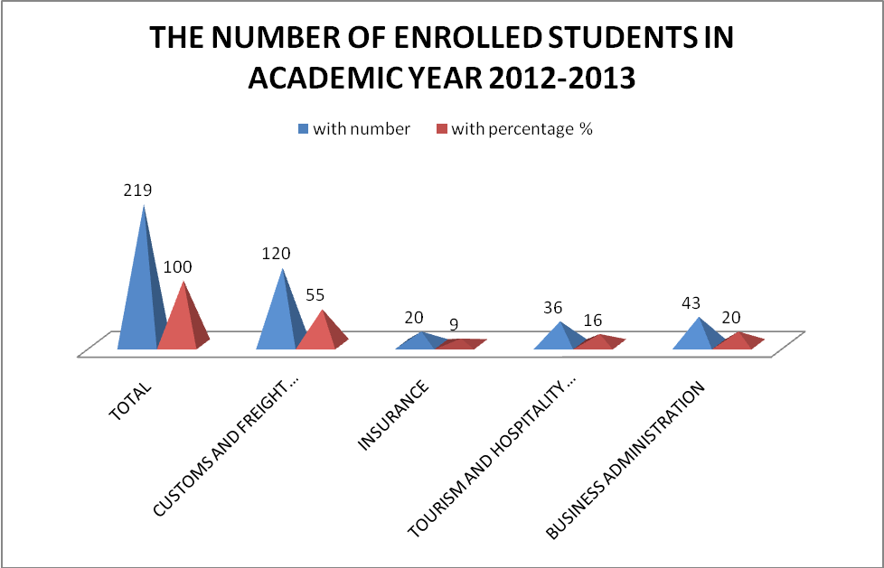

Based on the electronic database used by the College since its establishment, the total number of students’ enrollment from the academic year 2005-2006 until 2011-2012 is 959 students. From the total number, 539 students or 56% were registered in the program Customs and Freight Forwarding, 144 students or 15% were registered in the program Insurance, 66 students or 7% were registered in the program Human Resources, 113 students or 12% were registered in the program Tourism and Hospitality Management and 97 students or 10% were registered in the program Business Administration. Following will be presented the enrollment number for each program in Bachelor and Master level.
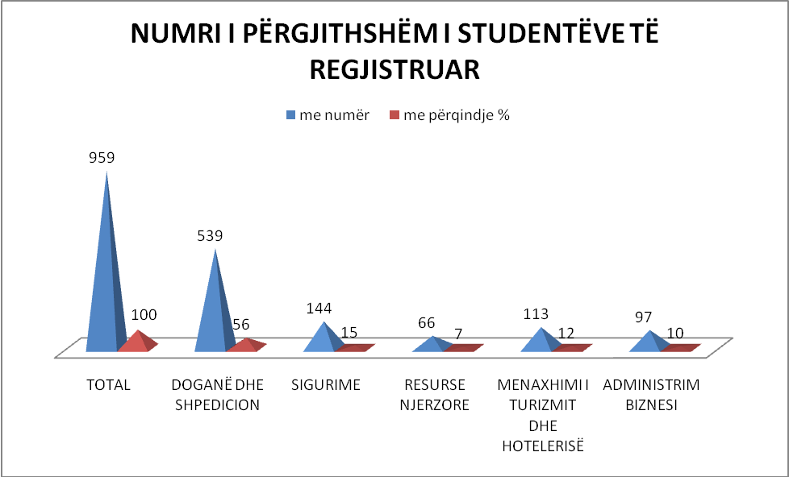

In the program Customs and Freight Forwarding from academic year 2005-2006 until 2011-2012 were registered in total 539 students from them 506in Bachelor level and 33 students in Master level. From the total students’ in Bachelor level, 53or10%were registered in academic year 2005/2006, 47 students or9%were registered in academic year 2006/2007, 87 studentsor17%were registered in academic year 2007/2008, 130 studentsor26%in academic year 2009/2010 and80 studentsor16%in academic year 2011/2012.
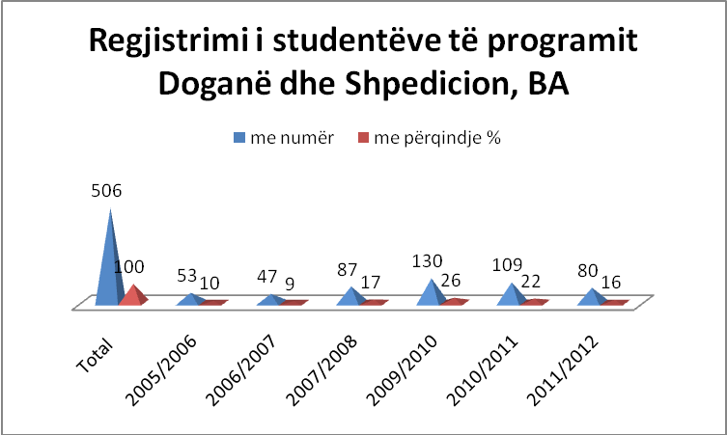

In the program Customs and Freight Forwarding, Master level, in total were registered 33 students. From them22 students or67%were registered in academic year 2010/2011 and11studentsor33%in academic year 2011/2012.
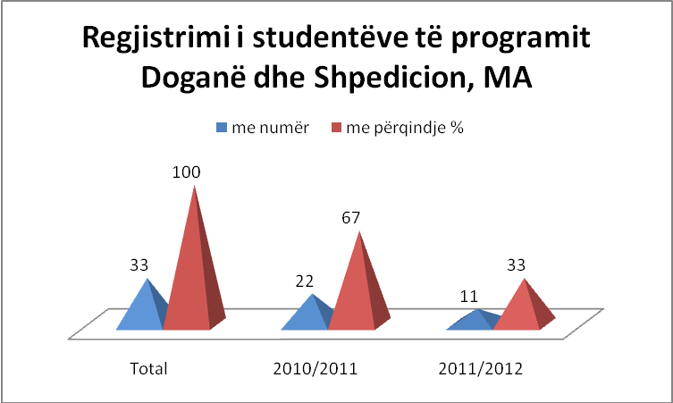

In the program Insurance from the academic year 2006/2007 until 2011/2012 were registered 144 students. From them 116in Bachelor level and28 students in Master level. From the students’ of Bachelor level, 40 students or35%were registered in academic year 2006/2007, 43 studentsor37%were registered in academic year 2007/2008, 13 studentsor11%were registered in academic year 2010/2011 and20studentsor17%were registered in academic year 2011/2012.
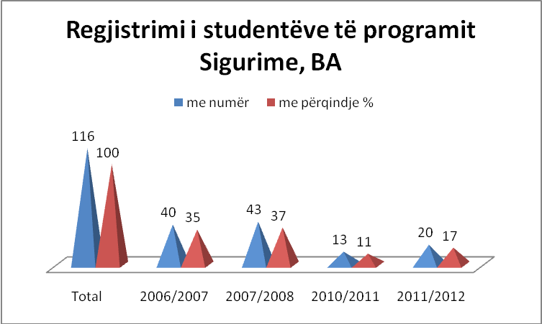

In the program Insurance, Master level in total were registered 28 students. From them 14 students or50%were registered in academic year 2006/2007 and14 studentsor50%in academic year 2007/2008.
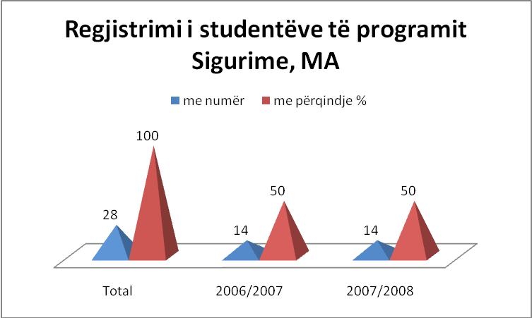

In the program Human Resources students were enrolled in two academic years, in 2006/2007 and 2007/2008 and in total were registered 66 students. From them55were registered in Bachelor level and 11 students were registered in Master level. From the students registered in Bachelor level,27 students or49% were registered in academic year 2006/2007 and28or51%were registered in academic year 2007/2008.
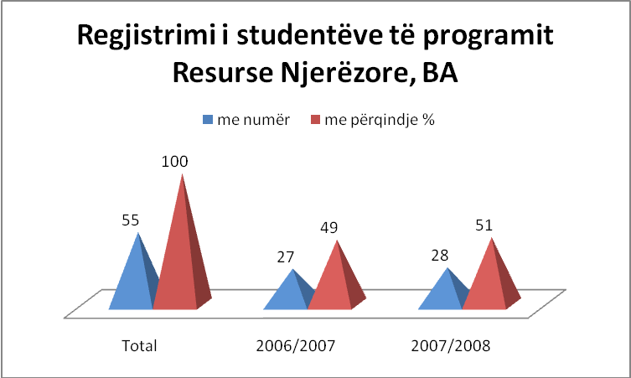

In the program Human Recourses, Master level were registered 11 students. From them 5 studentsor45%were registered in academic year 2006/2007 and6 students or55%were registered in academic year 2007/2008.
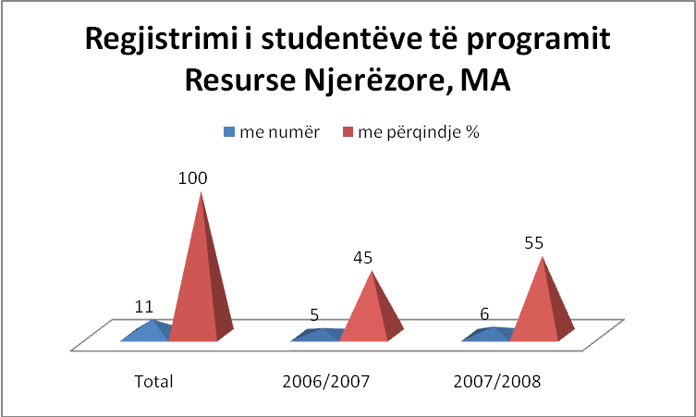

In the program Tourism and Hospitality Management started the enrollment of the students from the academic year 2006/2007 and until 2011/2012 in total were registered 113 students, from them110in Bachelor level and3 students were registered in Master level.From the number of students registered in Bachelor level, 13 students or12%were registered in academic year 2006/2007, 20 students or18%were registered in academic year 2007/2008, 27 studentsor25%were registered in academic year 2009/2010, 21 studentsor19% were registered in academic year 2010/2011 and29 studentsor26%were registered in academic year 2011/2012.
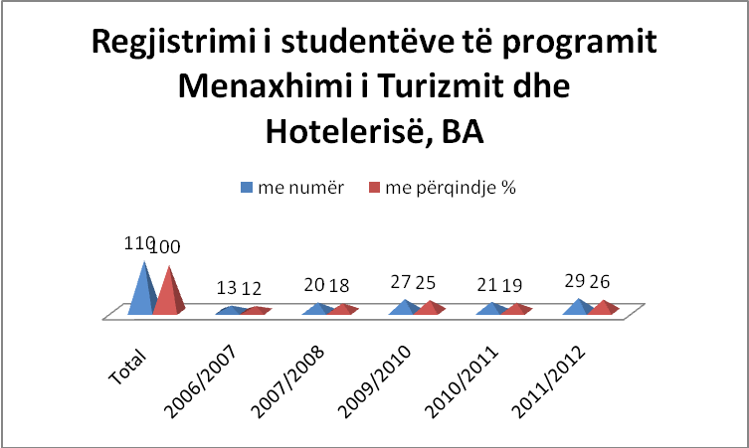

In the program Tourism and Hospitality Management in Master level were registered 3 students in academic year 2007/2008.
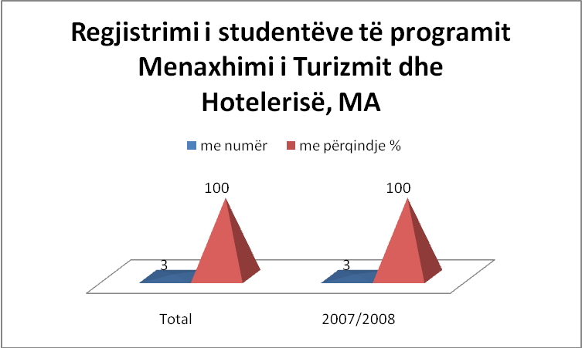

In the program Business Administration students started their enrollment from academic year 2010/2011 and until 2011/2012 were registered 97 studenta all in Bachelor level. From them 31 students or32%were registered in academic year 2010/2011 and66 studentsor68%were registered in academic year. 2011/2012.
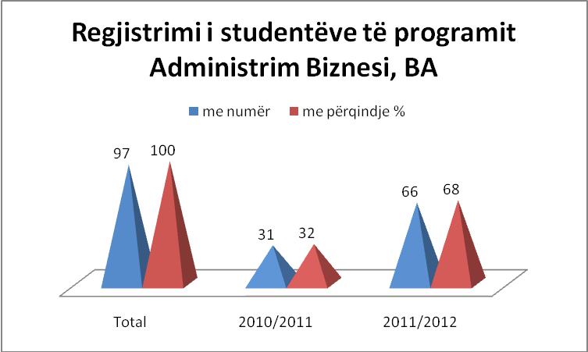

- Graduated Students Bachelor – BA
In the College “Pjetër Budi”, the total number of the graduated students is 232 students. In the program Customs and Freight Forwarding graduated 103 students, in the program Insurance graduated 60 students, in the program Human Resources graduated 46 students and in the program Tourism and Hospitality Management graduated 23 students.
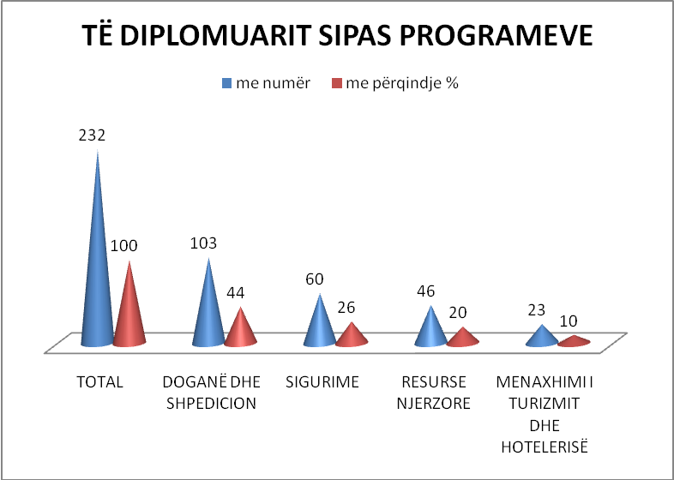

- Employment of the graduated students
From total number of the graduated students 232, 193are employed or showed in percentage83%. 39 of the graduated students or 17% are not employed.
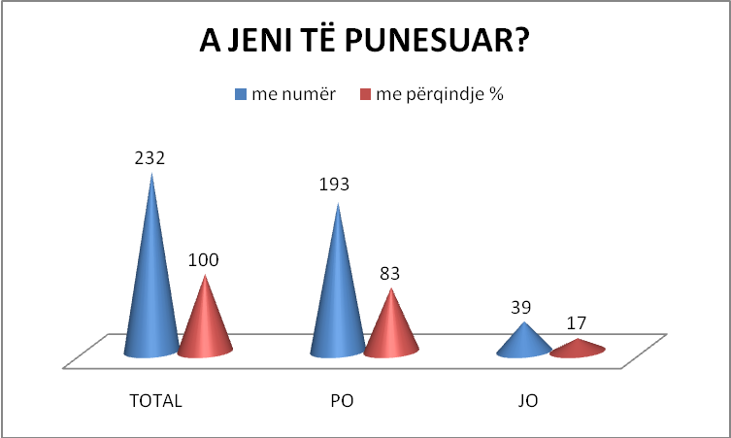

From the total number of employed graduated students193, 121or 63%work in private sector and 72or 37%work in public sector.
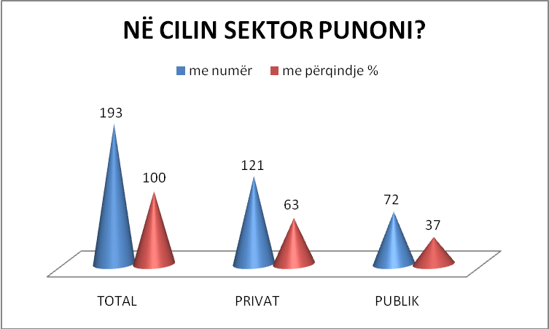

From the total number of employed graduated students193, 154or80%work in profession and 39or20%do no work in profession.
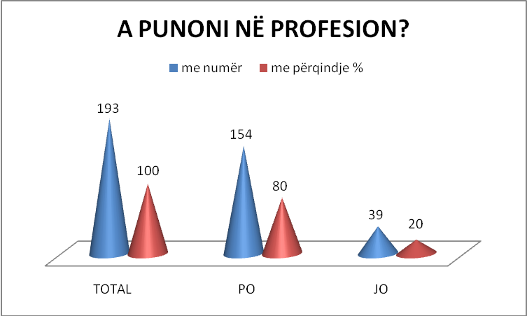

- Graduated students’ services
Career Office within the “Pjetër Budi” College helps students in managing their careers. In this office, students are informed about the basic facts that are important for them to be prepared for a competition-driven market of employment and ideas.

This office also provides information and suggestions for further education, organization of different job and education fairs etc., as well as advises students.

To the special attention of this office is the professional development and career of each graduate, by offering technical assistance and various courses, in partnership with the partners of the College “Pjetër Budi”.

Career Office also helps in making each student aware for their capacities. It informs them about different job vacancies, helps them in filling in and completing the required documentation, as well as directs them towards best choices related with their professions.

As part of this office other activities are organized, such as: publication of student magazine with their selected works, visits in different institutions, trainings, various researches – as part of the practical work, etc.

Furthermore, Career Office assists the academic staff of the College in their research work and its publication.

- Academic staff / student for each unit and the institution in general
In institutional level, College Pjeter Budi has one academic staff for 13students.
In the program Customs and Freight Forwarding, one academic staff is available for 17 students.
In the program Tourism and Hospitality Management, one academic staff is available for 5 students.
In the program Insurance, one academic staff is available for 4 students.
In the program Business Administration, one academic staff is available for 9 students.

- Students’ fee:
According to the regulation for finances students pay a certain amount of fee for their studies.

Bachelor:
- Study program Customs and Freight Forwarding – 1. 890 euro
- Study program Insurance – 1. 480 euro
- Study program Tourism and Hospitality Management – 1. 395 euro
- Study program Business Administration – 995 euro

Master:
- Study program Customs and Freight Forwarding – 1980 euro
- Management – 1600 euro

- Scholarships
With the purpose of raising the level of qualitative studies and with the intention of supporting and stimulating exceptional students, College “Pjetër Budi” has provided in the past and continues to provide scholarships for students. Up until now, “Pjetër Budi” has offered scholarships for students in dire economic need, excellent students, children of fallen fighters and ex-members of Kosovo Protection Corps. In addition, “Pjetër Budi” has also given scholarships in conjunction with KFOR.

“Pjetër Budi” supports students in their requests for scholarships in other institutions as well. Moreover, the College provides discounts for various categories of students: excellent students receive 10% discounts, while students enrolled in groups or in family relation receive a discount of 5%.

- Student services (tutorials, advising, individual advising etc.)
In “Pjetër Budi” we consider as especially important and provide special attention to the contemporary concept of education, by which we understand the student to be at the center.
The Office of Vice-Dean for Students is in charge for organizing student services. In addition to the engagement with the supervision of the course of studies, this office also helps in organizing student life in the College, as well as other extracurricular activities.
Also active in “Pjetër Budi” is a student organization, “Student for Student”, which works in supporting and advancing student rights and organizing student life.

Student Organization together with the Office of the Vic-Dean for Students organize, supervise and assist in different activities, such as exchange of experiences and study visits in and out of the country, organization of practical work in institutions, as well as of other courses and lectures inside of the College.
Requests and complaints made by students with respect to the overall course of studies are also managed by this office, including requests for the organization of recreational activities.
The Office also helps in bringing to a concrete shape different projects that benefit students and the College, as well as assists those students who are struggling financially during their studies.
Tutorials with students are made possible in different ways.

Each professor has regular tutoring time at his disposal to receive students, either in groups or individually. If there are requests, professors are encouraged to hold additional tutoring hours with students.
With the purpose of keeping the student at the center of all processes in “Pjetër Budi”, they are included in different committees, so that they can be part of important decisions in the institution where they study.

Furthermore, aiming at an ever higher quality of services, “Pjetër Budi” plans to develop additional services for students, wider inclusion of students in various activities, such as courses and practical work, as well as in different research projects of the College.

- Other offers for students
“Pjetër Budi” has organized in the past and continues to organize additional courses for students with the sole intent of providing a more comprehensive understanding of the taught subjects. The need for organizing additional courses is based on the analysis that has been made to the achieved results from each student and each subject.

- Research, Co-operation and Evolution

The research of market needs, contacts with small and medium enterprises, as well as with relevant public institutions (Customs, Ministries) are conducting and intensifying in order to adopt future student’s Bachelor Thesis to the needs of the market. In addition, in coordination with ECTS Coordinator and teachers in general, is investigating the possibility to start to apply the recommendation that Bachelor Thesis to be conducted even in group, not only individually. This practice will commence when the recent enrolled generation of students will come to the semester were the Bachelor Thesis will be conducted.

“Pjetër Budi” has continued to publish the scientific magazine “Logos” and will not stop this practice. The third edition is already published in January 2010, and is expecting the fourth edition to be published in April 2011. “Logos” contains researches from the foreign and domestic authors. The magazine is published in English and Albanian.

In addition, we will continue to organize the regional conferences. As well as with the organizing of seminars and discussions from which can gain benefit the students, as well as the academic staff itself. Since time when the recommendations are obtained, in “Pjetër Budi” are organized three thematic round tables where the topics such as Tourism and Hospitality in Kosovo, than the need for reform in Public Administration and similar, were discussed by practitioners, academics and field experts.

As known, in its up today’s evolution, the College “Pjetër Budi” has achieved obvious results in many fields. Within the Institution we have published activities that so far have been concentrated in the publishing of literature for the needs of the students. About 85 percent of modules have resulted with publishing of the professional literature fabricated by lecturers itself. During academic year 2010-2011 is planned to cover 95 percent of the study program by the prepared literature from the lecturing staff.

- Training Center

“Pjetër Budi” college during academic year 2010-2011 continued the tradition of providing trainings in variety of topics by naming it Training Center. This center operates with inside trainers from the College and from outside professionals as well.
The Training Center fulfills students’ needs and staff needs of the College, while offering trainings of different topics. Some of the trainings realized until now are:
- Conducting a research paper
- Public Speaking
- English for specific purposes

The Training Center plans to realize those trainings with the academic staff:
- Using the updated computer software: the role of the teacher in electronic grading of the students
- Physical and electronic library resources
- The role of the academic staff in promoting the college

The training topics provided for the students are decided based on their needs their opinions are collected from the questionnaires and focus groups. Some of the topics that are on their interest are:
- How to write a CV and motivation letter
- How to apply for a job and how to ask for recommendation letters

The Training Center gives certificates to the participants that complete the training successfully. Trainings are offered for the outside audience as well.

- WORK & STUDY

This service is offered for full time students of the college. The positions are offered in the beginning of each semester and the places are limited. The decision is merit based and financial situation of the student. The College distributes the students in many department as: Financial Department, The General Secretary Department, The Office for Student Services, Quality Assurance Office, The Office of Communication and PR. In the end of their work, the students get a certificate of completion.

- DEBATE CLUB!

The Debate Club organizes debates with different topics with people representatives of the politics, art, civil society etc. Every Thursday, the guest communicates and debates with the students for different topics. The debates will continue each semester and the best debaters will organize a debate hour in front of a bigger audience.

- PROFESSIONAL DEBATES
In the summer semester of academic year 2010/11 are planed to realize professional debates in topics related to each study program.

- Kosovo with great tourist potential - and investment promotion
Kosovo has great tourist potential, but to still not invested as much as it needs and is not promoted enough. And he said on Friday, as part of the international scientific conference on "Trends in the development of tourism and hospitality," which was held in Pristina.

Conference organized by the University College "Peter Budi", with the support of the Ministry of Trade and Industry brought together researchers in the field from home and abroad, as well as institutional representatives from Kosovo and Albania.

Cuneyd Ustaibo, Deputy Minister of Trade and Industry of Kosovo spoke of the country's institutions are making efforts to develop turtizmin, as one of the important branches of the economy. Meanwhile Hado Abbas, Deputy Minister of Tourism, Culture and Sports of Albania brought facts and figures for tourism development in Albania. He also spoke about the need for greater institutional cooperation in this field.

Sofronija Miladinoski, College Board Member "Budi Peter" presented an overview on the state of tourism development in the region, while the speaker in "Peter Budi" Hysen Sogojeva, referred on contemporary trends of tourism development in Kosovo, completion of legal and institutional mentioned as a very important factor in the development and advancement of this field of interest.

In the morning plenary session, academics and tourism scholars were presented with scientific papers. Ibish Mazreku from Kosovo referred to the harmonization of the legal regulations in line with contemporary trends in the tourism market, Zija Zimeri Macedonian border barriers that influence the development of tourism in the Balkans transistor, while Ilija Iliev from Bulgaria for controls and sanctions for tourism. Vjollca Bakiu Albania referred to alternative tourism, as a necessity for sustainable development, and in the afternoon session was referred to and discussed e-Tourism, integrated tourist product as a condition for the development of tourism in the region, factors affecting the Albanian tourism attraction of foreign investments in Kosovo in the field of tourism and tourist infrastructure in Kosovo.

Conference "Trends in the development of tourism and hotel" was organized in the context of scientific and academic contributions to University College "Peter Budi" gives in areas in which it offers undergraduate, customs and freight, insurance, hotel and tourism business administration

- Tempus Project
College "Peter Budi" has been the beneficiary of the project TEMPUS by WUS Autrisë. All activities organized by WUS Austria ended. Their project "Development and Advancement of Quality Office" ended in January 2012. Several activities are implemented by the WUS Austria were:
- Information Day, organized at our institution from October 11-15 2010. During this day, students and staff participated in presentations WUS but Budi Peter Quality Office (where I presented I). This has provided the opportunity for students to ask questions directly to officials of the Kosovo Accreditation Agency (Ferdi Zhushi and Basri Muja), in order to clarify their questions and concerns regarding the licensing of software.
- Questionnaire / Evaluation by Prof. Eckle, also WUS project partner University of Salzburg has carried out a questionnaire to assess and identify strengths and weaknesses that may have quality office.
- External expert Vjosa Mullatahiri is committed by WUS Austria to assess the success of the project. It has carried out a questionnaire to assess the Quality Office benefits from our TEMPUS project.
- 3 study visits:
  - At the University of Salzburg.
  - The College Cork in Ireland and
  - Technical University of Bucharest. During this visit, there were presentations on private and state universities in Bucharest. Also held a meeting with representatives of the Romanian Agency for accreditation. Some suggestions have been applied in our institution, we have also printed materials.
- Training for management, administration, teachers, students and officials of quality 26, 27 and 28 January 2011. As quality official, I have taken part in three days of training. Presentations were made by the partner of the project, Prof. Dr. Norma Ryan, Prof. Dr. Peter Eckle, Prof. Dr. Mariana Mocanu; MEST; Kosovo Accreditation Agency and by WUS Austria: Mr. Sc. But Dedaj and Cygnus Carabregu.
- Workshop on Quality officials on 5 and 6 July 2011. This workshop / training was organized by the office of WUS Austria and Accreditation Agency. I have participated in two training days. The main goal was to get to know the latest trends in higher education quality but also for the creation of a manual for Quality Office.
- Preparation of Quality Manual is designed.
In addition to these activities, Peter Budi as beneficiaries of the project has also received -
- Help in technology. In the table you can see which ones were given to us by the project. It is worth mentioning that one of the laptops had faulty and is returned to "ILIR Kosovo", who were the winners of the tender. Because the tools were still under warranty, the laptop is sent to the destination from where it was purchased (Slovenia) and are expected to behave in a month. ILIR Kosovo have received confirmation that I left there original laptop will leave here and when the alert can go get.

Nr | Explanation | #
1. | Lap top 14” | 2
2. | Multifunctional color photocopy | 1
3. | Projector | 1
4 | Screen for projector | 1
5 | USB 4 BG | 2
6 | External Hard disk HDD 320 GB | 2
7 | Flit chart | 1
8 | Power Point prezenter | 1
9 | Server | 1

- Recommendations of the experts team from the last accreditation procedure

Comments: The draft evaluation report has been presented to the staff working at College “Pjeter Budi” the same day when it was received. Evaluation of the situation at the College and in particular suggestions and recommendations that came from the members of the evaluation teams are appreciated and welcomed by the staff.
We are very thankful for encouraging suggestions and recommendations, in particular with clear recommendations where review team members express their stance that all submitted academic programmes for bachelor degree should be accredited starting this academic year, including here a number of master degrees, such as the master level of Customs and Freight forwarding, Human Resources, etc. The clear suggestions given for revision and restructuring of certain subjects are of enormous help and significantly helped for programmes improvement.
Management and academic staff currently working at “Pjeter Budi” consider the outcome of the evaluation fair and correct. There is clear recognition of our efforts to meet the Kosovo development needs as there is clear recognition of our desire to prepare young generations to develop further Kosovo society, and to bring their professional expertise, knowledge and understanding needed in both, public and private sector.
It is overall conclusion of the staff working at the College “Pjeter Budi” that in general description of the academic programmes more emphasize should be paid to the description of the outcome competencies based on a concrete model. It is overarching agreement that when subjects of each programme is analyzed it can be seen that the existing students competencies are stretched out across the various subjects, but the same ones are not reflected clearly and in a structured manner in the general description of the programme. Working groups are already engaged to correct this weakness.
The same as above, although we are speaking about two completely different academic programmes - BA and MA- that are distinguished through the subjects and their contents, the differences has not been emphasized clearly in the general description of each programme. Dublin descriptors will be used in order to further explain the existing differences and this is a task which working groups and coordinators of the programme are already working on.

R1.1: Reformulate the mission to answer the question: why is PB there for each group of their stakeholders (customer organizations, students, employees and the owner)?
R1.2: In order for mission to become widely communicated (and not solely appropriated by the management team), you might think of implementing Colleges’ short slogan.
R1.3: Think about the joint vision (desired image of the organization in long-term future).
R1.4: Decide upon a strategy (the way of reaching the goals) to answer this mission and vision. Judging by our impression from talking to students, teaching staff, and to some extent also management, the specialized courses seem to be one of the strongest points of current programmes, which means that niche strategy is the one to follow. In addition, there are strong aspirations for growth. Hence, we recommend a thorough strategic analysis and planning.

Comments: Nurturing the PB mission and short slogan is an idea welcomed by both, teaching staff and current students of PB. The decision is taken to bring together all, the teaching staff, students, management and the owner in order to establish mixed working groups which will discuss emphasized issues and bring their inputs in enriching the mission, joint vision and strategy on how to achieve PB goals in mid and long run. Regarding the strategy, decision has been taken to hire two experts, one for capacity building in line with ISO standards and second one to assess existing strategies and revise them in the spirit of recommendations given by the members of review team and suggestions that will come out of the working groups.

R2.1: With regard to research and academic freedom, we believe that there maybe even too much of individual freedom. Should the PB wish to strengthen their position in research (and hence be able to offer programmes leading to higher academic level than merely BAs), they should direct the research of their academic staff to their priority areas. Currently, there seem to be several individuals working on research fields that are quite difficult to relate to the PBs’ study programmes.
Comments: As in most Kosovo academic institutions, including here the public university, the research projects and policies are still remaining an issue that is far behind the desires and needs. We appreciate that evaluation team noticed this and we are welcoming their suggestion mentioned above as well as later in this report. The teaching and management staff is working to provide the concrete inputs regarding this recommendation. The person in charge for academic issues and development will finalize a new research plan and emphasize more its priorities.
________________________________________________________________________
R.3.1.: Programme coordinators should engage in support with Quality Assurance Office in interaction with their customer organizations and students to define true competences they wish to develop in their graduates (e.g. using Bloom’s taxonomy or some other competency model that differentiate between knowledge, skills and attitudes).
R.3.2.: The levels of Bachelor and Master Studies have to be in accordance with the Dublin Descriptors (www.jointquality.org):
E.g. Bachelor level: knowledge and understanding, apply knowledge, gather and interpret relevant data, communicate information, ideas, problems and solutions
E. g. Master level: knowledge and understanding founded upon and extends and/or enhances Bachelor level, apply knowledge and understanding and problem solving abilities in new or unfamiliar environments, integrate knowledge and handle complexity and formulate with incomplete or limited information, communicate conclusions, learning skills to allow continue to study.
Comments: Even prior to the evaluation the teaching staff of the College “Pjeter Budi” in a number of meetings has discussed an issue of the competency models that should be applied in our academic programmes. Under the guidance of the Quality and Assurance Office two drafts has been circulated regarding this issue, and the coordinators are working to finalize it.
While designing academic programmes for bachelor and master degree working groups had in mind Dublin descriptors and tried to roughly design them based on general descriptors. Since we were not aware that this will be part of criterias of evaluation we did not emphasize them enough in self evaluation report, but according to the plan, in our internal documents we had in mind to stress out more Dublin descriptors for the upcoming academic year. We are pleased to hear that evaluators mentioned Bloom taxonomy, because this is one of the most discussed model among the coordinators and teaching staff, as well amongst the representatives of the Office for the Quality and Assurance. Across the modules and syllabus some of the competencies are already on the place, and we agree with evaluators that we should pay more attention and include all of them as structured in the Bloom’s taxonomy scale. These recommendations confirmed that we are working in the right directions in order to have a good start for the academic year 2010/2011.
_______________________________________________________________________
R.3.a.1.: Define more precisely the expected outcome of competences after having completed the programme.
R.3.a.2.: Distinguish clearly the bachelor level from the master level according to the Dublin Descriptors.
Comments: The evaluation of the programme and recommendation to reaccredit it is appreciated by the entire staff of “Pjeter Budi”.
Through the description of the obligatory and optional subjects of this programme it can be seen that the bachelor level is focused to develop students knowledge and understanding on customs and freight forwarding. When they receive bachelor degree, students will be able to apply knowledge they gained, to gather and interpret relevant data, as well as to communicate information, ideas, problems and solutions. People in charge for overall academic programme will try to present in a clearer manner, outcome of competencies that students will be capable of when they complete the programme.
The master level programme is distinguished from the bachelor level, but the difference has not been reflected in overall description of the programme, a weakness that will be corrected before the start of the new academic year.
_______________________________________________________________________
R 3.b.1.: Define more precisely the expected outcome of competences after having completed the programme.
R 3.b.2.: Distinguish clearly the bachelor level from the master level according to the Dublin Descriptors.
R 3.b.3.: Prove that accounting is covering financial accounting, cost accounting and controlling.
R 3.b.4.: Ensure, that social competences are sufficiently developed; this means to offer separate trainings either as a special part of relevant subjects or to create special subjects related to social competencies.
R 3.b.5.: Offer entrepreneurship as optional subject.
Comments: College “Pjeter Budi” welcomes positive evaluation of the academic programme and recognition that bachelor program in Tourism and Hospitality Management is on the level of comparable bachelor courses in Tourism and Hospitality Management in Europe. When evaluation report has been presented the staff realized that this academic programme as it has been presented to the evaluators does not reflect clear and well structured outcome of the competencies that students will have after completing the programme. They also realized that in general description of the programme required attention has not been paid to better distinguish the bachelor level from the master level. However, in both above mentioned cases, academic program is quite well developed, therefore descriptions of what already exists within syllabis and courses, will be reformulated in order to reveal to some extend “hidden” or weakly articulated outcome competencies and existing differences between various levels of the programme.
Concern of the team of evaluators regarding the lack of the clarity on how students will develop social competencies staff emphasized that it is again matter of the vague description but not a result that it is missing. For the sake of clarification, we should stress out that bachelor level of the Tourism and Hospitality Management has three subjects with strong emphasis on social competencies such as communication, presentation techniques, rhetoric, project management and teamwork. The subjects through which students will develop competencies such as communication, rhetoric and presentation techniques are Communication in Tourism, than Animations in Tourism and Marketing in Tourism. Two first subjects are developed solely to strengthen communication skills: oral and visual. Throughout the semesters where this subjects are placed in, students are taught on how to communicate, than how to develop and communicate messages, how to use body language, etc. When it comes to writing and presentation skills, it is part of almost every subject, because in almost each of them students are required to prepare issue based seminars which they are obliged to present in front of their colleagues and defend same ones by answering the questions raised throughout presentation. Besides this, there is third subject which also leads towards stronger communication skills and it is Tourism in Marketing that implies one entire chapter that tackles importance of communication skills and means and importance of public and media relations as well as advertisement. On other hand competencies such as project management and teamwork are gained mainly through the subjects such as Research Marketing, where students are obliged to design their own research project and conduct surveyes (field work) and focus groups while working as a team. This is later on strengthened through Strategic Management and internship that is compulsory for every student.

Overall, teaching staff also noticed that it missed out the chance to present in an appropriate manner the lot of work and activities conducted quite often at the College – a work that is conducted outside of the regular teaching process. On regular basis “Pjeter Budi” organizes training sessions and workshops on various issues and topics that are of interest for students. We tried our best to put mechanism in place, and create broad range of opportunities for our students and we are working hard to motivate them and increase their participation in such events. In addition to this, teaching staff and management of the College is available and obliged to respond to the students request. If ten students come with their own request for the training session, special lecture or work shop that is relevant to expand their knowledge, understanding and other competencies important for their development, College is obliged to facilitate this process. This practice exists at the College since its very beginning.

Regarding the concerns for Accounting subject, it should be emphasized that this subject covers financial accounting, cost accounting and controlling. These topics expand further on later on through the Financial Management that is taught in the last semester of bachelor level of Tourism and Hospitality Management. Part of a lesson units of the subject Accounting is auditing or controlling, cost accountability and finance accountability. This can be seen also from the existing syllabus of the subject Accountability that is applied in Customs and Freight Forwarding programme as well.

We appreciate recommendation to include a subject Entrepreneurship, and coordinator of the programme already is working on its inclusion.
_______________________________________________________________________
R3.f.1: In order to decrease the obvious gap between planned and actual workload (and answering student request), add at least one hour of in-class exercises to each course. These recommendations have been accepted and included.
R3.f.2: Nurture the existing high culture of teacher-student which could become endangered should there be too quick growth of student/teacher ratio due to new programmes. This is continuous task because we cannot allow relations between students and teaching staff to deteriorate. We appreciate that review team emphasized out their findings that show as strongest side of PB the satisfaction of the students with the professors.
R3.f. 3: Quality assurance office should regularly (once or twice a year) organize such focus groups with students (moderated by external trust-worthy person and anonymity guaranteed) to get objective indication of possible improvements. This is already three year old practice in College “Pjeter Budi”. The aim of such surveys and focus groups was the need to keep an eye on gaps and eventual weaknesses identified or that caused dissatisfaction among student. Such findings than were used as a point of reference while strategizing thing on what should be placed among priorities, what should be changed, and what should be rewarded ,etc. This practive will continue in future as well.
R3.f.4: In short-term invest in library knowledge base in accordance to your teaching and research specialisations. This is also one of continuous tasks considered always as a priority tasks of the College “Pjeter Budi”.
R3.f.5: When forming the mission and strategy, do interact with students to get their opinion about your strengths and weaknesses (such as specialisation mentioned).We will have in mind this extremely important point and students will be included in the process of designing the mission and strategy.
R3.f.6: Student vice-dean and PB should regularly organize events to socialize students, staff and Alumni (which we believe should become formalized in future).We are doing our best to facilitate any of the students activities and motivate students organization and Student Vice Dean to be more pro-active regarding the various students initiatives and the activities overall.
R.3.f.7: Nonetheless all the difficulties, PB should actively engage in internationalization of student activities. If student mobility opportunities are currently limited, PB should consider e.g. offering one course per semester in English lectured (at least partially) by international professors. This could also mean that some courses would be organized on a modular instead of semester basis. However, no promises are better than false promises.Suggestion has been accepted and more efforts will be placed on them to be fully incorporated.
_______________________________________________________________________
R4.1: Assign a vice-dean responsible for research and development. This person would be responsible to 1) approve conference and other research-based expenses; 2) coordinate development of new products (connecting PB expertise to trainings, life-long learning etc.); 3) be editor of LOGOS; 4) guide research policy of PB toward key priority areas of the school (given limited research resources). While this is currently a domain of Quality Assurance Office and it is not a decision-making body, this might be a change which would contribute to the PB research performance. We already have a person assigned for this task. It is Vice Dean for Academic Issues and Development. A person holding this position is in charge to design new products and coordinate research and publication activities. At the current stage we are awaiting the end of the accreditation process in order to develop research strategy and design new research projects accordingly.
R4.2: Assign some individual budget for research which could be used solely for purposes of international publications (conference, journals and scientific monographies) in predominantly international journals. Award best researchers in previous year with extra available funding and assign some additional funds for vice-dean to have at his disposition. The funds faced enormous limitations during the ongoing academic year due to limitations imposed by the accreditation process which ended with cut of a number of academic programmes and all master degree programmes. Also the climate created regarding non public academic institutions caused decline in the interest of the students to study in such institutions. Regardless of this constraints “Pjeter Budi” continue to pay attention and take very seriously the need to improve the research activities.
R4.3: Connect more tightly research of your faculty to your mission, strategy and study programmes.
R4.4: Establish a Best researcher (Best scientific journal article) award.
R4.5: Significantly strengthen the knowledge base of the library (1) by adding new e-databases e.g. ScienceDirect, ProQuest, Web of Science and 2) by expanding and updating specialized literature in English language (again connected to your fields of expertise).
R4.6: When recruiting new professors, give adequate emphasis on their research achievements and potential for internationally recognized journal and monographies publications.
R4.7: Strengthen your involvement in international research networks by e.g. regularly inviting recognized international scholars to give research seminars and invited lectures in English (as lingua franca of modern academia).
All suggestions regarding the research activities are welcomed and will be taken seriously into consideration during the academic year 2010/11.
_______________________________________________________________________
R5.1: Build up a network with partner universities which also include English speaking colleges.
R5.2: Establish academic staff mobility projects, for staff exchange and international research programmes
R5.3: Prepare long-term students’ mobility programmes, also allowing students international research for their Master Thesis.
All recommendations are accepted and the management and teaching staff of College “Pjeter Budi” will ensure that they will be reflected in the daily work of this academic institution.
________________________________________________________________________
R6.1: Improve the ratio between full-time teachers and part-time teachers.
R6.2: Involve the part-time teachers in the continuous communication.
R6.3: Work out a strategy for regeneration of staff to ensure future teaching quality.
R6.4: Start a programme for didactic further training of the staff.
As noticed by the members of the review team, the ratio between full-time teachers and part-time teachers has been improved significantly in comparison to the past. Pjeter Budi will continue to keep this ratio in line with existing legal obligations .It will also continue to involve the part-time teachers in the continuous communication.

“Pjeter Budi” college will also work out a strategy for regeneration of staff to ensure future teaching quality, although the current staff, including management is quite young if compared with those working in public university. The staff is happy to start a programme for didactic further training of the staff and as envisaged in the last meeting, it will be already in place before the beginning of the new academic year. ________________________________________________________________________
R7.1: Consider and regulate participation of students’ and teachers’ representatives in the decision making processes related to academic matters.
Good point. We will ensure to increase students representatives participation in the direct decision making process as well.
________________________________________________________________________
R8.1: Given their applicative orientation, PB is encouraged to work towards developing new products (beyond teaching) in order to create additional sources of revenues. Potential products could be consulting, training and life-long education in specialised areas, where PB would offer their experts administrative and marketing support in exchange to part of their revenues.
R8.2: PB should also establish an Alumni association with fundraising being one of its’ purposes.
College “Pjeter Budi” agrees that new products should continue to develop beyond a teaching activities in order to create new additional sources and revenues. There are already a number of the projects awaiting to be activated as times come.

Alumni will be established as well.
________________________________________________________________________
R8.2: The student information system should allow to electronically collecting responses to student survey about the teachers and their courses.
R8.3: Career services should be also involved as a part of student information system.
R8.4: It is recommended to use fixed (rolling) white boards, while beamers projecting to the wall do make it rather difficult for the students at the back to see to the front of the classroom.
R8.5: The lecture halls are too narrow and long. If and when changing the premises, the management should take this into consideration.
R8.6: There is a lack of space and rooms for student teamwork (just two rooms) and socializing (sport, canteen, atrium etc.).
R8.7: The library should invest more and expand in terms of recent international literature in the specific study programmes as well as research specializations under the domain of PB.
Comments: The fixed (rolling) white boards will replace video beamers projecting to the wall by the beginning of September. Career services will become integral part of the students information system. We will make sure that student information system will allow electronically collecting responses to student survey about the teachers and their courses.
_______________________________________________________________________
R9.1: The PB QAO is encouraged to engage in knowledge transfer activities with a business school from European country with well developed quality assurance and learning centres. This will allow PB to have an insight intro possible activities that QAO can undertake in future: a) several direct and indirect measures of both programme and course quality, b) human resource development activites – training for academic and non-academic staff.
R9.2: While the ‘sticks’ (e.g. title promotions) and quite externally determined, the management of the PB should develop some ‘carrots’ to support teaching and research excellence. a) Reviewers recommend introducing annual Best researcher award, which should be connected to internationally recognized standards (e.g. publication in 1) Social Science Citation Index, 2) International Bibliography of Social Sciences or 3) Econlit journal). b) The reviewers suggest also introducing Best teacher award (awarded by students), based on the criteria such as using innovative teaching methods, connecting concurrent research with teaching etc.
Most of the mentioned recommendations have been discussed in the past by “Pjeter Budi” employees, and some of them are already implemented. For example it a third year in the raw that students elect best teacher of the year and College awards him/her We appreciate suggestions for the Best researcher award as well as those regarding International Bibliography of Social Sciences or Econlit journal, etc. We will make sure for this ideas to be applied as soon as this is possible.

Addition:

C U R R I C U L U M V I T A E

PERSONAL INFORMATION’S

First name |  |  | IMER
Surname |  |  | MUSHKOLAJ
Address |  |  | Ulpiana, P+3/13, nr. 51, 10 000 Prishtinë
Telephone |  |  | +377 (44) 116-730, +386 (49) 116 730
Fax |  |  | /
E-mail |  |  | imermushkolaj@gmail.com
Nationality |  |  | Kosovan
Date / Month / Year of birth |  |  | 29.03.1977, Deçan
WORK EXPERIENCE
 |  |  |  | June 12, 1998 – September 1, 1999
• Date (from - to)
• Name and address of employer |  |  |  |  | “Bota e re”, “Gazetashqiptare”, Kosovë
• Occupation or position held |  |  |  | Journalist/correspondent
• Main activities and |  |  |  | ▪   Reporting from border strip Albania-Kosova during the war, reports from Austria
responsibilities |  |  |  |  | and Germany.
 |  |  |  | 15 September 1999 – 15 December 1999
• Date (from - to)
• Name and address of employer |  |  |  | “KohaDitore”, Kosova
• Occupation or position held |  |  |  | Journalist
• Main activities and |  |  |  | Journalist of internal affairs, reports, news translations
responsibilities
 |  |  |  | 16 September 1999 – 1 January 2000
• Date (from - to)
• Name and address of employer |  |  |  | IWPR, London/Prishtina
• Occupation or position held |  |  |  | Investigative journalist
• Main activities and |  |  |  | • | Investigative reports. News articles published at international press.
responsibilities
 |  |  |  | 1 January 2000 – 1 January 2004
• Date (from - to)
• Name and address of employer |  |  |  | “Epoka e re”, Prishtina
• Occupation or position held |  |  |  | Editor in Chief
• Main activities and |  |  |  | • | Work manager, Staff manager of editors and journalists.
responsibilities
 |  |  |  | 1 March 2000 – 1 June 2000
Date (from - to)
• Name and address of employer |  |  |  | “Intervista”, Prishtinë
• Occupation or position held |  |  |  | Editor in Chief
• Main activities and |  |  |  | • |  | Work manager, Staff manager of editors and journalists
responsibilities
 |  |  |  | 1February 2000 – 1 December 2000
Date (from - to)
• Name and address of employer |  |  |  | Association of Kosovo Journalists “Shoqata e GazetarëvetëKosovës” (SHGK)
• Occupation or position held |  |  |  | Board Member
• Main activities and |  |  |  | • |  | Protection of journalists’ rights.
responsibilities
 |  |  |  | 1 October 2000 – 1 June 2003
Date (from - to)
• Name and address of employer |  |  |  | Faculty of Journalism “Faik Konica” Prishtina
• Occupation or position held |  |  |  | Lecturer
• Main activities and |  |  |  | • |  | Lecturing the lessons in Journalism Practicum
responsibilities
 |  |  |  | 1 March 2004 – 1 September 2004
Date (from - to)
• Name and address of employer |  |  |  | “Java”, Prishtina
• Occupation or position held |  |  |  | Cooperator
• Main activities and |  |  |  | • |  | Investigative Journalism
responsibilities
 |  |  |  | 1 September 2004 – 1 June 2007
Date (from - to)
• Name and address of employer |  |  |  | “Lajm”, Prishtina
• Occupation or position held |  |  |  | Deputy Editor-In -Chief, redactor
• Main activities and |  |  |  | • Managing the work of journalists, cooperating and guiding work with
responsibilities |  |  |  | journalists.
 |  |  |  | 1 June 2007 – continues
Date (from - to)
• Name and address of employer |  |  |  | “Pjetër Budi”, Prishtina
• Occupation or position held |  |  |  | Lecturer / Pro Rector for Academic Affairs and Public Affairs
• Main activities and |  |  |  | • Lecturing Academic Writing, pro-Rector for Academic Affairs and Public
responsibilities |  |  |  | Affairs.
 |  |  |  | 1 June 2009 – 31 Decembre 2010
Date (from - to)
• Name and address of employer |  |  |  | “Profil” Newspaper
• Occupation or position held |  |  |  | Editor-In -Chief
• Main activities and |  |  |  | • Managing the work of journalists, cooperating and guiding work with
responsibilities |  |  |  | journalists.
EDUCATION

Date (from - to) |  |  | 15 September 2007 - continues
• Name and the type of |  |  | “Pjetër Bud”, Faculty of Human Resources, European Integrations and
Institution of offering Education |  |  | International Relations (MA)
and Training
• Form of Diploma or |  |  | Master Studies, candidate
Certification
Date (from - to) |  |  | 1May 1998-15 June 2007
• Name and the type of |  |  | Faculty of Journalism “Faik Konica”, Prishtina
Institution of offering Education
and Training
• Form of Diploma or |  |  | Journalist Diploma
Certification
Date (from - to) |  |  | 1 May 1995 - 15 June 1998 (in preparation for Diploma)
• Name and the type of |  |  | Acting Studio, Prishtina
Institution of offering Education
and Training
• Form of Diploma or |  |  | Actor
Certification
Date (from - to) |  |  | 1 September 1991 - 15 June 1995
• Name and the type of |  |  | Gymnasium “VëllezëritFrashëri”, Deçan
Institution of offering Education
and Training
• Form of Diploma or |  |  | High School Diploma
Certification
TRAINING AND COURSES
Date (from - to) |  |  | 10 February 1999 – 10 May 1999
• Name and the type of |  |  | Newspaper “Hamburger Abendblatt”, Hamburg
Institution of offering Education
and Training
• Form of Diploma or |  |  | Certificate for training in journalism course
Certification
Date (from - to) |  |  | 15 October 2000 – 1 November 2000
• Name and the type of |  |  | Newspaper “Kurier”, Vienna
Institution of offering Education
and Training
• Form of Diploma or |  |  | Certificate for training in journalism course
Certification
Date (from - to) |  |  | 1 July 2003 – 1 August 2003
• Name and the type of |  |  | Poynter Institute, USA (Studing Visit)
Institution of offering Education
and Training
• Form of Diploma or |  |  | Certificate for training in Investigative journalism
Certification
Date (from - to) |  |  | 20 April 2007-1 May 2007
• Name and the type of |  |  | DCAF, Geneva

Institution of offering Education
and Training
• Form of Diploma or |  |  |  |  | Certificate for training in insurance policy
Certification
Date (from - to) |  |  |  |  | 22 April 2008-3 May 2008
• Name and the type of |  |  |  |  | OFAJ, Strasburg and Berlin
Institution of offering Education
and Training
• Form of Diploma or |  |  |  |  | European Integrations (studying visit)
Certification
COMPUTER SKILLS |  |  |  | MS Windows, MS Word, MS Excel, PowerPoint, Internet
Personal skills
MOTHER TONGUE |  |  |  | ALBANIAN
OTHER LANGUAGES
 |  |  |  | ENGLISH |  | GERMAN | SERBIAN
• Reading |  |  |  | Very good |  | Good | Fluently
• Writing |  |  |  | Very good |  | Good | Fluently
• Speaking |  |  |  | Very good |  | Good | Fluently



The University of “Pjetër Budi”

Nr. ____ date __________

P r ish t i n a

Based upon the UNMIK Regulation nr. 2001/27, Articles 9 and 10 on the principle law on labour in Kosova, date October, 08, 2001, it is contracted this

W O R K C O N T R A C T

Between:

Employer: the University of Organizational Sciences “Pjetër Budi” from Prishtina, thebusiness registration number 70271425date.27.05.2005represented by the founder – BesimAjeti from Prishtina.

And:

Employee: ___________, born on ___________ . in ___________

Article 1

This contract determines the rights, duties, and mutual responsibilities of the employer and employee in compliance with the law provisions in power, the Statute of the University “Pjetër Budi”, the institute for studies, as well as by this contract.

Article 2
Both the employer and employee agree to set up a work contract with a time _____________,

starting from the date __________

Article 3
Based on this contract, the employer is appointed in the position of ________________

which are:

MAIN DUTIES :

- to prepare and offer lessons, seminars, exercises, and other classes’ forms according to the University curricula.,

- to set up the texts for bachelor and post graduate studies, as well the proper and necessary text books concerning studies within the subject structure,

- to supervise the scientific seminary works, graduation theses, the master and doctorate theses, as well the other students’ scientific and research works,

- To be engaged on regularly supervision of the student,

- To assure that exams are free of charge during a certain term of exams,

- To keep regularly evidences about the students participation, as well as classes;

- To hand over monthly and semester report about the overall process of classes, exercises, as well the exams and colloquiums results in the exams terms about respective subjects,

- To hand over the syllabus and textbooks of a respective subject.

HE IS RESPONSIBLE:
- to achieve his works on time, accurately, and up to date,
- to keep safe and to take care about the work’s tools,
- to apply and carry out the protection measures on the work.

Article 4
The employee has the obligation to respect the University autonomy, freedom, scientific and research creativity, the university’s acts and the decisions based upon it, the principles of professional and scientific honour, the courtesy code, as well as the other rules based on the University statute.

Article 5

In cases of eventual absence of the teaching staff in classes – exercises, the professor has the obligation to inform the employer about his absence at least in a deadline of 48 hours, so that the employer should find another teacher as a substitution, in order to assure the attendance of classes and exercises during his absence.

Article 6

None of the appointed and chosen members form the academic staff who have a full-time work contract can do any other job outside the institution without the permission of the Educational- Scientific Council based upon the University statute.

Article 7

The work-time is from 5 to 8 hours per a week, while the payment between the employer and employee is arranged by a special annex.

Article 9

Annual leave for an employee is 18 working days for each calendar year, and the annual leave is counted 1.5 days after each calendar year of employment.
Article 10
The employee has the right to be absent of his work with reward – payment in these cases:

- the religious and official leave,
- the family related cases leave
- the parental leave

Article 11

The employee has the right and possibility to use an unpaid leave by his own demand, whereas according to the medical assertion and his medical leave, he has to inform his employer within 48 hours.

Article 12
This contract may be dissolved in case of:

- Resignation;
- Dismissing from his duty;
- Health reasons;
- Punishment for a penal act;
- Death;
- According to the Statute and power of law of the University “Pjetër Budi”
Article 13

Apart from the article 12 of this contract, the contracting parties may unilaterally dissolve this contract every time, but they have to inform beforehand each-other in written way in a deadline of 30 days.

Article 14

This contract was contracted through a free will and voluntarily, with no violence impact, threat, or deceives. When the contracting parties were informed about its content, law provisions upon which this contract was based and compiled, they accept all the rights, duties, and certain responsibilities determined by this contract.

Article 15

The contracting parties agree that eventual disputes concerning this contract shall be solved by the relevant court in Prishtina.

Article 16

The contract was drafted into 3 (three) identical copies. One copy belongs to the contracting party, and two copies belong to the University of “Pjetër Budi”.

Prishtina, on ________________________

CONTRACTING PARTIES

Employee:
______________ Employer:

The University of “Pjetë Budi


BesimAjeti
College “PJETËR BUDI” - PRISHTINË

COURSE SYLLABUS

Course: |  |  | Customs Recognition of Stock
Program: |  |  | Customs and Freight Forwarding
Code: |  |  |  |  | Credits: 6
Type of the course |  |  | Mandatory
ECTS:
Lecturer |  | Phone
Office |  | E-mail

Duration |  |  | Semester III
Students’ overload |  |  | Under the supervision | Lecture  Exercises
 |  |  | Individual | Essay
 |  |  | Individual | Field work
 |  |  | Individual | Exam preparation
 |  |  | Total
Preconditions: |  |  | Candidates have knowledge of key techniques, technology, knowledge of goods, chemistry, biology, physics, customs, law and other key terms of the other subjects related to the case
Ways of realization: |  |  | Lectures, interactive learning exercises, projects, presentations, visits customs terminals, practical learning
Goals: |  |  | The goal is for students to learn to recognize the goods and their customs classification of goods under the Harmonized System and their distribution and the possibility of customs duties under the Customs Tariff
Description of the curriculum: |  |  | Course program includes key terms for recognition of good customs, then the classification of goods under the sections and chapters of the Harmonized System, the main features of all custom goods
Hours realization of subject content
Weekly calendar |  | Title / topic |  |  |  | Preliminary Preparation
OCTOBER | First week | Introduction, Section I, Section II, to chapter 8 (fruit eating) to p. 48 |  |  |  | GordanaReckoska: "Customs Recognition of goods" - University Book
OCTOBER | Second week | Chapter 8 and chapter 19 (products based on wheat) to p. 96 |  |  |  | GordanaReckoska: "Customs Recognition of goods" - University Book
OCTOBER | Third week | From chapter 19 to Section VI - up to chapter 28 inorganic chemical products, p. 144 |  |  |  | GordanaReckoska: "Customs Recognition of goods" - University Book
OCTOBER | Fourth week | Chapter 28 to the junction with aldehydes to form p. 192 |  |  |  | GordanaReckoska: "Customs Recognition of goods" - University Book
NOVEMBER | First week | Chapter 28 to the junction with function ketonik and hinonik of Chapter 37 (for products Photographic or cinematographic purposes) p. 241 of the book |  |  |  | GordanaReckoska: "Customs Recognition of goods" - University Book
NOVEMBER | Second week | MIDTERM EXAM WEEK
NOVEMBER | Third week | From chapter 37 to the end of chapter 44 (wood and wood products), p. 288 |  |  |  | GordanaReckoska: "Customs Recognition of goods" - University Book
NOVEMBER | Fourth week | From chapter 45 to chapter 64 (footwear, sheshinat, hats and other head coverings) to Chapter 76 (aluminum and aluminum products) p. 384 |  |  |  | GordanaReckoska: "Customs Recognition of goods" - University Book
DECEMBER | First week | From chapter 76 to 84, respectively, p agricultural products. 432 |  |  |  | GordanaReckoska: "Customs Recognition of goods" - University Book
DECEMBER | Second week | By chapter 84, p 432, section 85, dynamo machines, p. 480 |  |  |  | GordanaReckoska: "Customs Recognition of goods" - University Book
DECEMBER | Third week | By dynamo machines, p 481 to p copying apparatus. 528 |  |  |  | GordanaReckoska: "Customs Recognition of goods" - University Book
DECEMBER | Fourth week | MIDTERM EXAM WEEK
JANUARY | First week | By copying apparatus p. 528, by the end of the material, section XXI, Chapter 27, p old money. 563 |  |  |  | GordanaReckoska: "Customs Recognition of goods" - University Book
JANUARY | Second week | Two-hour film for the recognition of customs goods from certain areas and their customs |  |  |  | GordanaReckoska: "Customs Recognition of goods" - University Book
Grading: |  |  | In one semester held two midterms. Midterms test will contain 30 questions. A query considered a point. In specific cases (where the test set tasks or other forms of written assessment) depends on the professor of the course in what form evaluates tasks (questions), provided that all the test to have 30 points.  Midterms: (max. 2 х 30 points) - 60 points;  The remaining 40 points can be earned from the following activities:  Active participation in class: 10%  Presence in hours: 10 percent  Mid-semester test (midterm): 30%  Essays, seminar works, research projects and homework: 20%  The test at the end of the semester (midterm): 30%  exam  Student passes the exam if he wins more than 50 points  For the final last exam earned max. 100 points.  Depending on the number of points earned, gained adequate grades:  51 - 60 points - 6  61 - 70 points - 7  of 71 - 80 points - 8  of 81 - 90 points - 9  of 91 - 100 points - 10  (Note: All details are included in the assessment form Rules for midterm).
Kohadhevendiimbajtjessëprovimitpërfundimtar |  |  | Provimisipaskalendaritmbahetnëafatin e caktuartëprovimeve.
Rezultatet e pritura: |  |  | Pritetqëstudentëttëjenëtëaftëtinjohin mallrat, tëdinëtiklasifikojnësaktësipasSistemittëharmonizuar, tinjohinseksionetnëtëdhekapitujtnëtëcilëtklasifikohen mallrat me numratariforadekuat
Elementet e obligueshëm: |  |  | Kollokuiumi, respektivishtnotimiibërëkonsiderohetsipozitiv, nësestudentifiton minimum 20 pikëngatestiprej 30 pikëve.  Nëkuadërtënotimittëvazhdueshëmstudentikalondykollokuiume. Studenti ka tëdrejtët’inënshtrohetkollokuiumittëdytënëse e ka kaluarkollokuiumin e parë.
Kufizime: |  |  | Studenti ka mundësi ta kalojproviminvetëmnëafatet e caktuaratëprovimeve. Nësestudentinuk e kalonproviminështëiobliguarqëpërsëri ta regjistrojatëlëndë.
Literaturabazë |  |  | G. Reckoska: Njohjadoganore e mallit-libriuniversitar, Ohër, 1997  G. Reckoska: Njohja e mallrave-metodatpëranalizimin e mallit, Ohër, 2008-libri iushtrimeve
-literaturashtesë |  |  | G. Reckoska: “:Vetitëteknologjiketëmallravegjatëtransportit”-libëruniversitar, Ohër, 2006  D. Gramatikov: Njohja e mallrave, Shkup, 2000
Institucionetpërbashkëpunim |  |  | - Drejtoriadoganore e RepublikëssëMaqedonisë  - Terminalidoganor – Strugë  - Terminalidoganor – Manastir



